Practical-1

**1(A).Create an application that obtains four int values from the user and displays the product**

**Default.aspx**

<%@ Page Language="C#" AutoEventWireup="true" CodeFile="Default.aspx.cs" Inherits="_Default" %>

<!DOCTYPE html>

<html xmlns="http://www.w3.org/1999/xhtml">

<head runat="server">

<title></title>

</head>

<body>

<form id="form1" runat="server">

<div>

Enter A:<asp:TextBox ID="TextBox1" runat="server"></asp:TextBox>

<br />

Enter B:<asp:TextBox ID="TextBox2" runat="server"></asp:TextBox>

<br />

Enter C:<asp:TextBox ID="TextBox3" runat="server"></asp:TextBox>

<br />

Enter D:<asp:TextBox ID="TextBox4" runat="server"></asp:TextBox>

<br />

<asp:Button ID="Button1" runat="server" OnClick="Button1_Click" Text="Result" />

<asp:Button ID="Button2" runat="server" OnClick="Button2_Click" Text="Reset" />

<br />

<asp:Label ID="Label1" runat="server" Text="Label"></asp:Label>

</div>

</form>

</body>

</html>

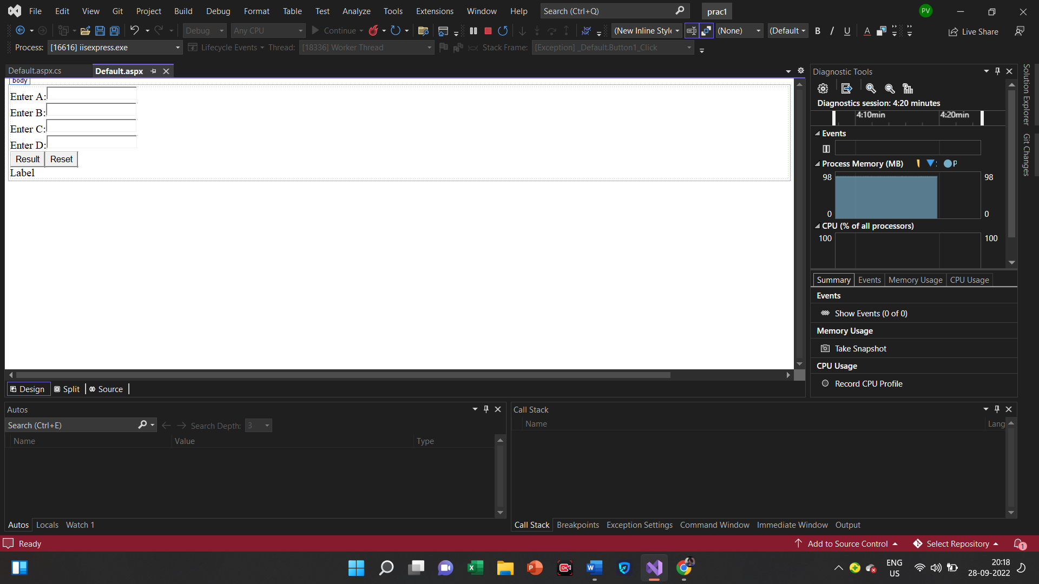

**Default.aspx.cs**

using System;

using System.Collections.Generic;

using System.Linq;

using System.Reflection.Emit;

using System.Web;

using System.Web.UI;

using System.Web.UI.WebControls;

public partial class _Default : System.Web.UI.Page

{

protected void Page_Load(object sender, EventArgs e)

{

}

protected void Button1_Click(object sender, EventArgs e)

{

int r;

r = Convert.ToInt32(TextBox1.Text)*Convert.ToInt32(TextBox2.Text)*Convert.ToInt32(TextBox3.Text)*Convert.ToInt32(TextBox4.Text);

Label1.Text = "Result:" + r.ToString();

}

protected void Button2_Click(object sender, EventArgs e)

{

TextBox1.Text = "";

TextBox2.Text = "";

TextBox3.Text = "";

TextBox4.Text = "";

Label1.Text = "";

}

}

**Output**

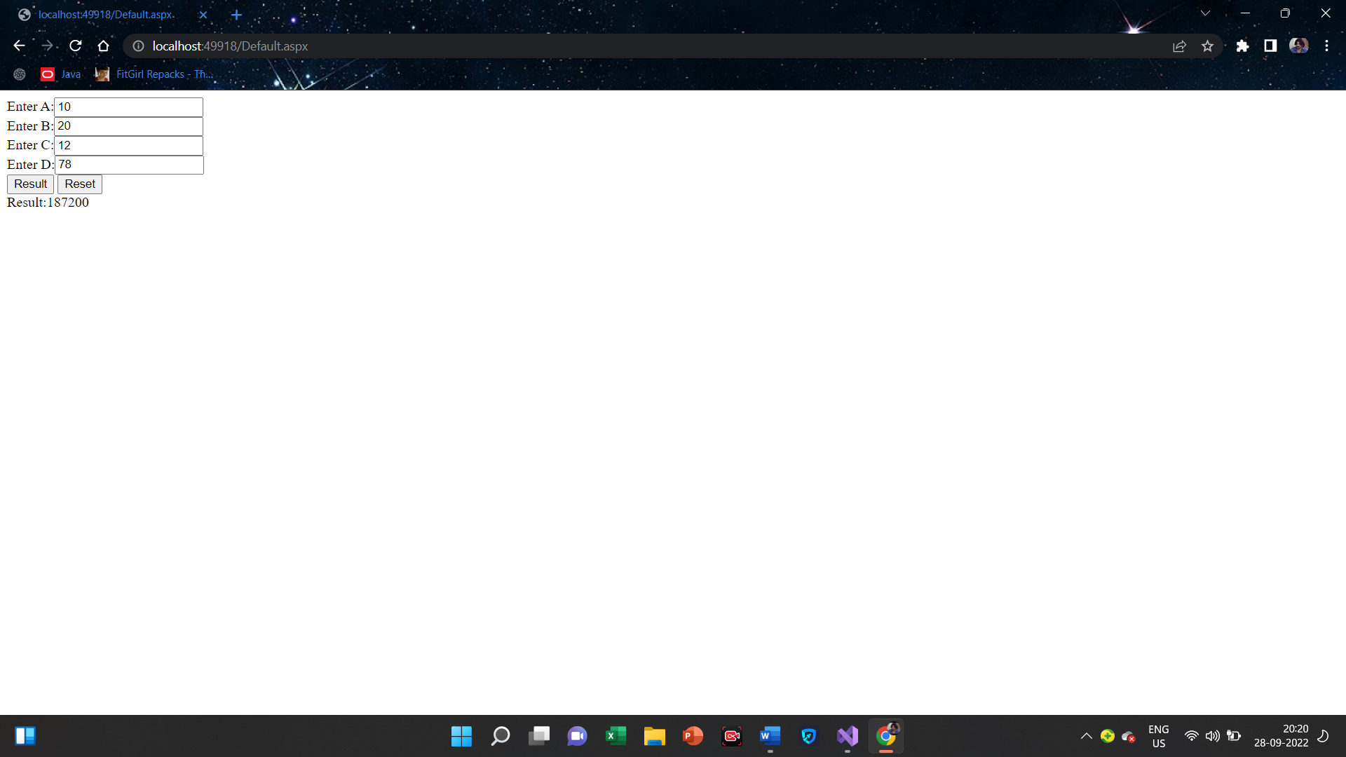

**1(B).Create an application to demonstrate string operations.**

**Default.aspx**

<%@ Page Language="C#" AutoEventWireup="true" CodeFile="Default2.aspx.cs" Inherits="Default2" %>

<!DOCTYPE html>

<html xmlns="http://www.w3.org/1999/xhtml">

<head runat="server">

<title></title>

</head>

<body>

<form id="form1" runat="server">

<div>

Enter String:<asp:TextBox ID="TextBox1" runat="server"></asp:TextBox>

<br />

<asp:Button ID="Button1" runat="server" OnClick="Button1_Click" Text="Result" />

<asp:Button ID="Button2" runat="server" OnClick="Button2_Click" Text="Reset" />

<br />

<asp:Label ID="Label1" runat="server" Text="Label"></asp:Label>

<br />

<asp:Label ID="Label2" runat="server" Text="Label"></asp:Label>

<br />

<asp:Label ID="Label3" runat="server" Text="Label"></asp:Label>

<br />

<asp:Label ID="Label4" runat="server" Text="Label"></asp:Label>

<br />

<asp:Label ID="Label5" runat="server" Text="Label"></asp:Label>

<br />

<asp:Label ID="Label6" runat="server" Text="Label"></asp:Label>

<br />

<asp:Label ID="Label7" runat="server" Text="Label"></asp:Label>

<br />

<asp:Label ID="Label8" runat="server" Text="Label"></asp:Label>

<br />

<asp:Label ID="Label9" runat="server" Text="Label"></asp:Label>

<br />

<asp:Label ID="Label10" runat="server" Text="Label"></asp:Label>

</div>

</form>

</body>

</html>

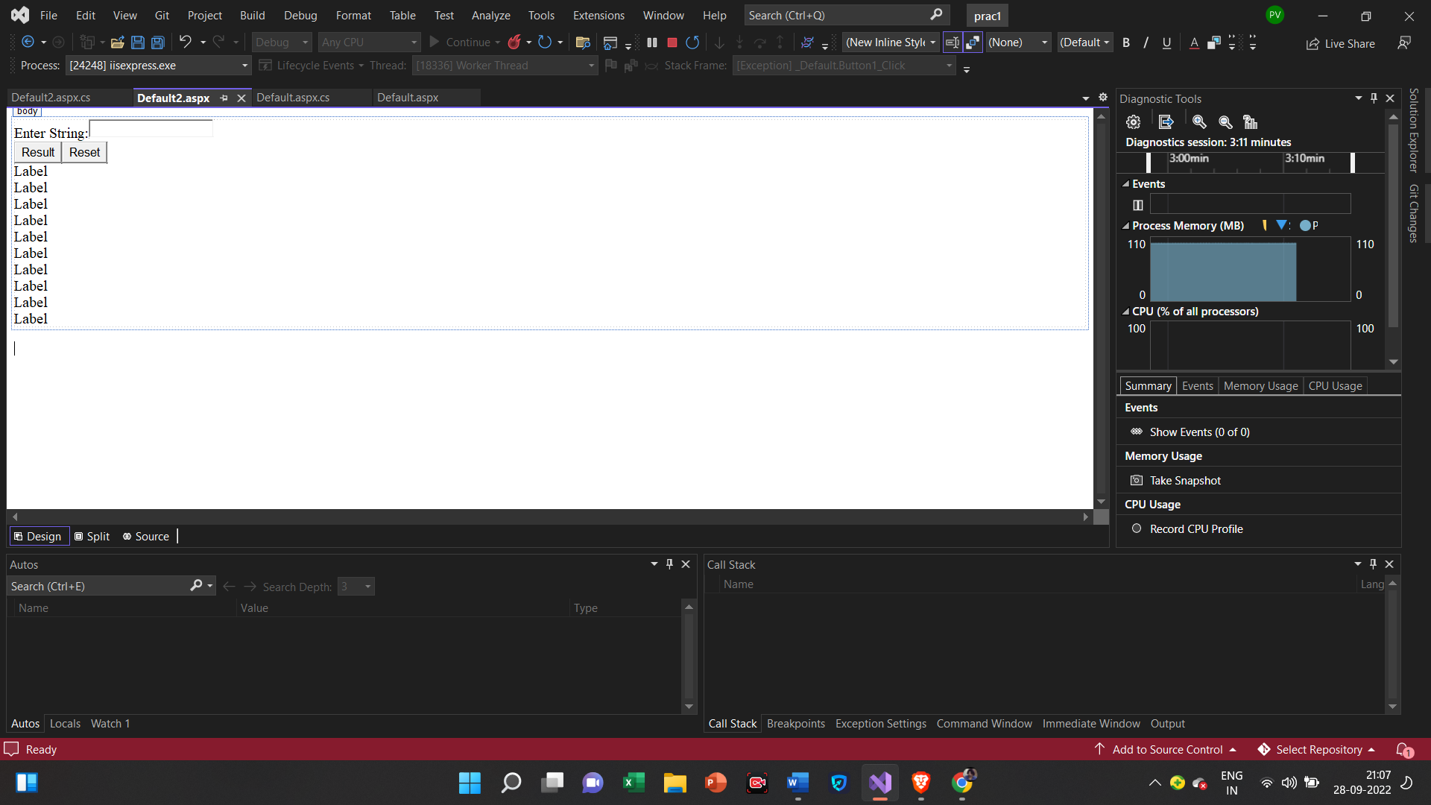

**Default.aspx.cs**

using System;

using System.Collections.Generic;

using System.Linq;

using System.Reflection.Emit;

using System.Web;

using System.Web.UI;

using System.Web.UI.WebControls;

public partial class Default2 : System.Web.UI.Page

{

protected void Page_Load(object sender, EventArgs e)

{

}

protected void Button1_Click(object sender, EventArgs e)

{

string s=TextBox1.Text;

Label1.Text = "String length: " + s.Length;

Label2.Text = "Substring: " + s.Substring(4,3);

Label3.Text = "Upper String: " + s.ToUpper();

Label4.Text = "Lower String: " + s.ToLower();

string rev = "";

for (int i = s.Length - 1; i >= 0; i--)

{

rev = rev + s[i];

}

Label5.Text = "Reverse String: " + rev.ToString();

Label6.Text = "Replace's' by 't' in String: " + s.Replace('s', 't');

Label7.Text = "Insert 'u' in String: " + s.Insert(3, "u");

Label8.Text = "String Truncate: " + s.Trim();

Label9.Text = "Remove String: " + s.Remove(4);

Label10.Text = "Index of String: " + s.IndexOf('e');

}

protected void Button2_Click(object sender, EventArgs e)

{

Label1.Text = "";

Label2.Text = "";

Label3.Text = "";

Label4.Text = "";

Label5.Text = "";

Label6.Text = "";

Label7.Text = "";

Label8.Text = "";

Label9.Text = "";

Label10.Text = "";

TextBox1.Text = "";

}

}

Output

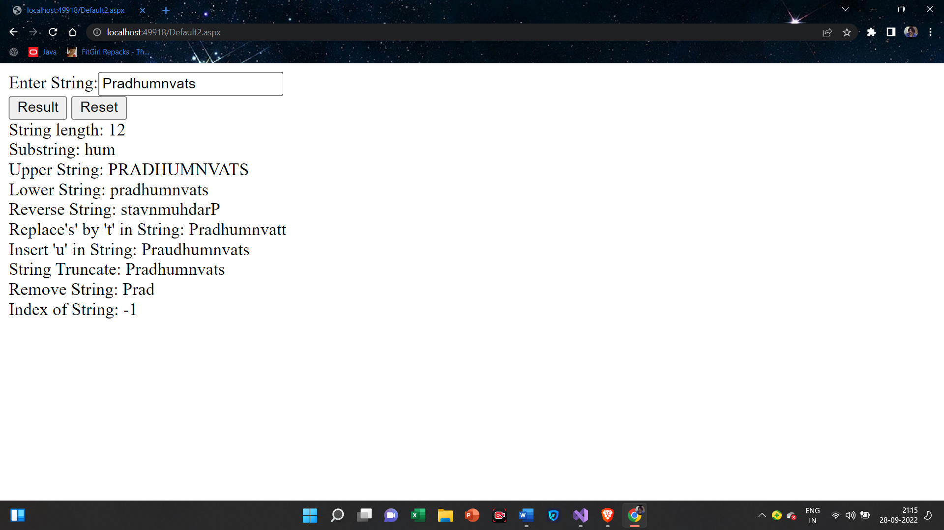

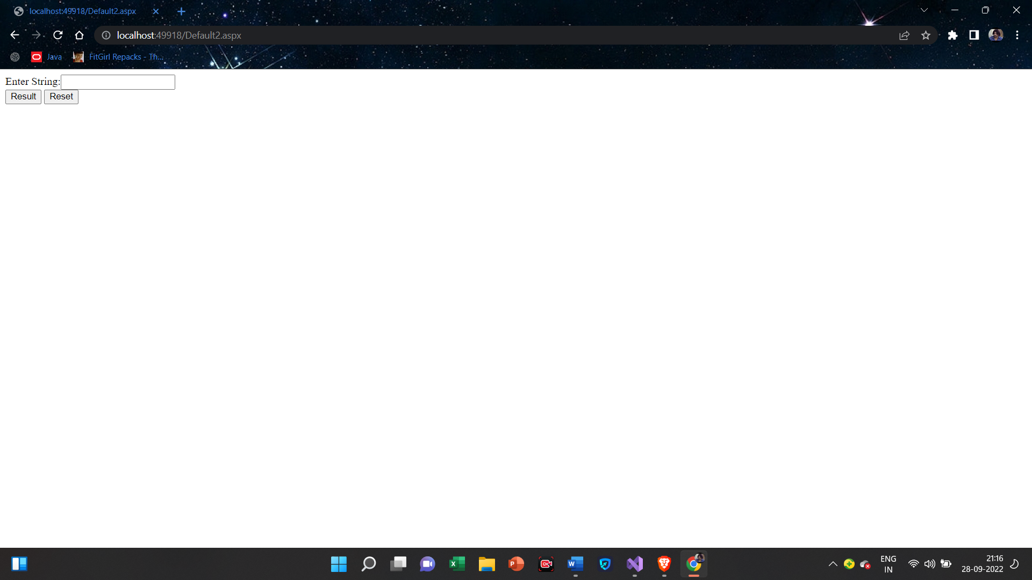

**1(C).Create an application that receives the information from a set of students. The application should also display the information of all the students once the data entered**

**Default.aspx**

<%@ Page Language="C#" AutoEventWireup="true" CodeFile="Default3.aspx.cs" Inherits="Default3" %>

<!DOCTYPE html>

<html xmlns="http://www.w3.org/1999/xhtml">

<head runat="server">

<title></title>

</head>

<body>

<form id="form1" runat="server">

<div>

Student Id:<asp:TextBox ID="TextBox1" runat="server"></asp:TextBox>

<br />

Student Name:<asp:TextBox ID="TextBox2" runat="server"></asp:TextBox>

<br />

Course Name:<asp:TextBox ID="TextBox3" runat="server"></asp:TextBox>

<br />

Date Of Birth:<br />

<asp:Calendar ID="Calendar1" runat="server"></asp:Calendar>

<br />

<asp:Button ID="Button1" runat="server" OnClick="Button1_Click" Text="Show" />

<asp:Button ID="Button2" runat="server" OnClick="Button2_Click" style="height: 29px" Text="Reset" />

<br />

You Entered:<br />

Student Id:<asp:Label ID="Label1" runat="server" Text="Label"></asp:Label>

<br />

Student Name:<asp:Label ID="Label2" runat="server" Text="Label"></asp:Label>

<br />

Course Name:<asp:Label ID="Label3" runat="server" Text="Label"></asp:Label>

<br />

Date Of Birth:<asp:Label ID="Label4" runat="server" Text="Label"></asp:Label>

</div>

</form>

</body>

</html>

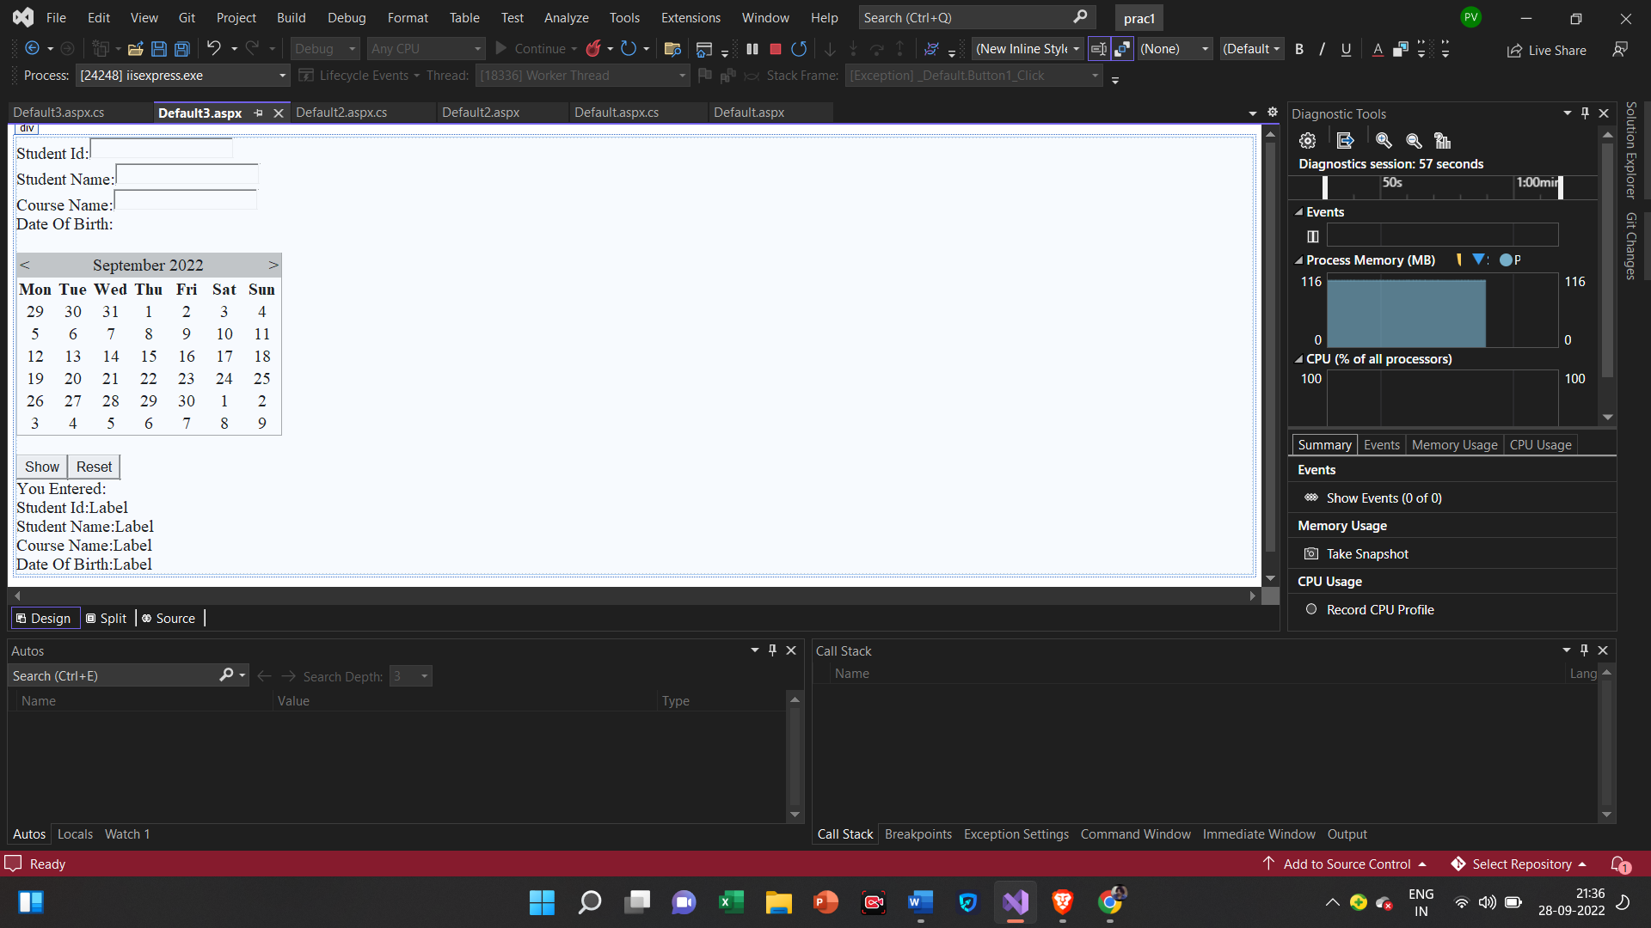

**Default.aspx.cs**

using System;

using System.Collections.Generic;

using System.Globalization;

using System.Linq;

using System.Reflection.Emit;

using System.Web;

using System.Web.UI;

using System.Web.UI.WebControls;

public partial class Default3 : System.Web.UI.Page

{

protected void Page_Load(object sender, EventArgs e)

{

}

protected void Button1_Click(object sender, EventArgs e)

{

Label1.Text = "Student Id:" + TextBox1.Text;

Label2.Text = "Student Name:" + TextBox2.Text;

Label3.Text ="Course Name:" +TextBox3.Text;

Label4.Text = "Date of Birth: " + Calendar1.SelectedDate.ToShortDateString();

}

protected void Button2_Click(object sender, EventArgs e)

{

Label1.Text = "";

Label2.Text = "";

Label3.Text = "";

Label4.Text = "";

TextBox1.Text = "";

TextBox2.Text = "";

TextBox3.Text = "";

Calendar1.SelectedDates.Clear();

}

}

**Output**

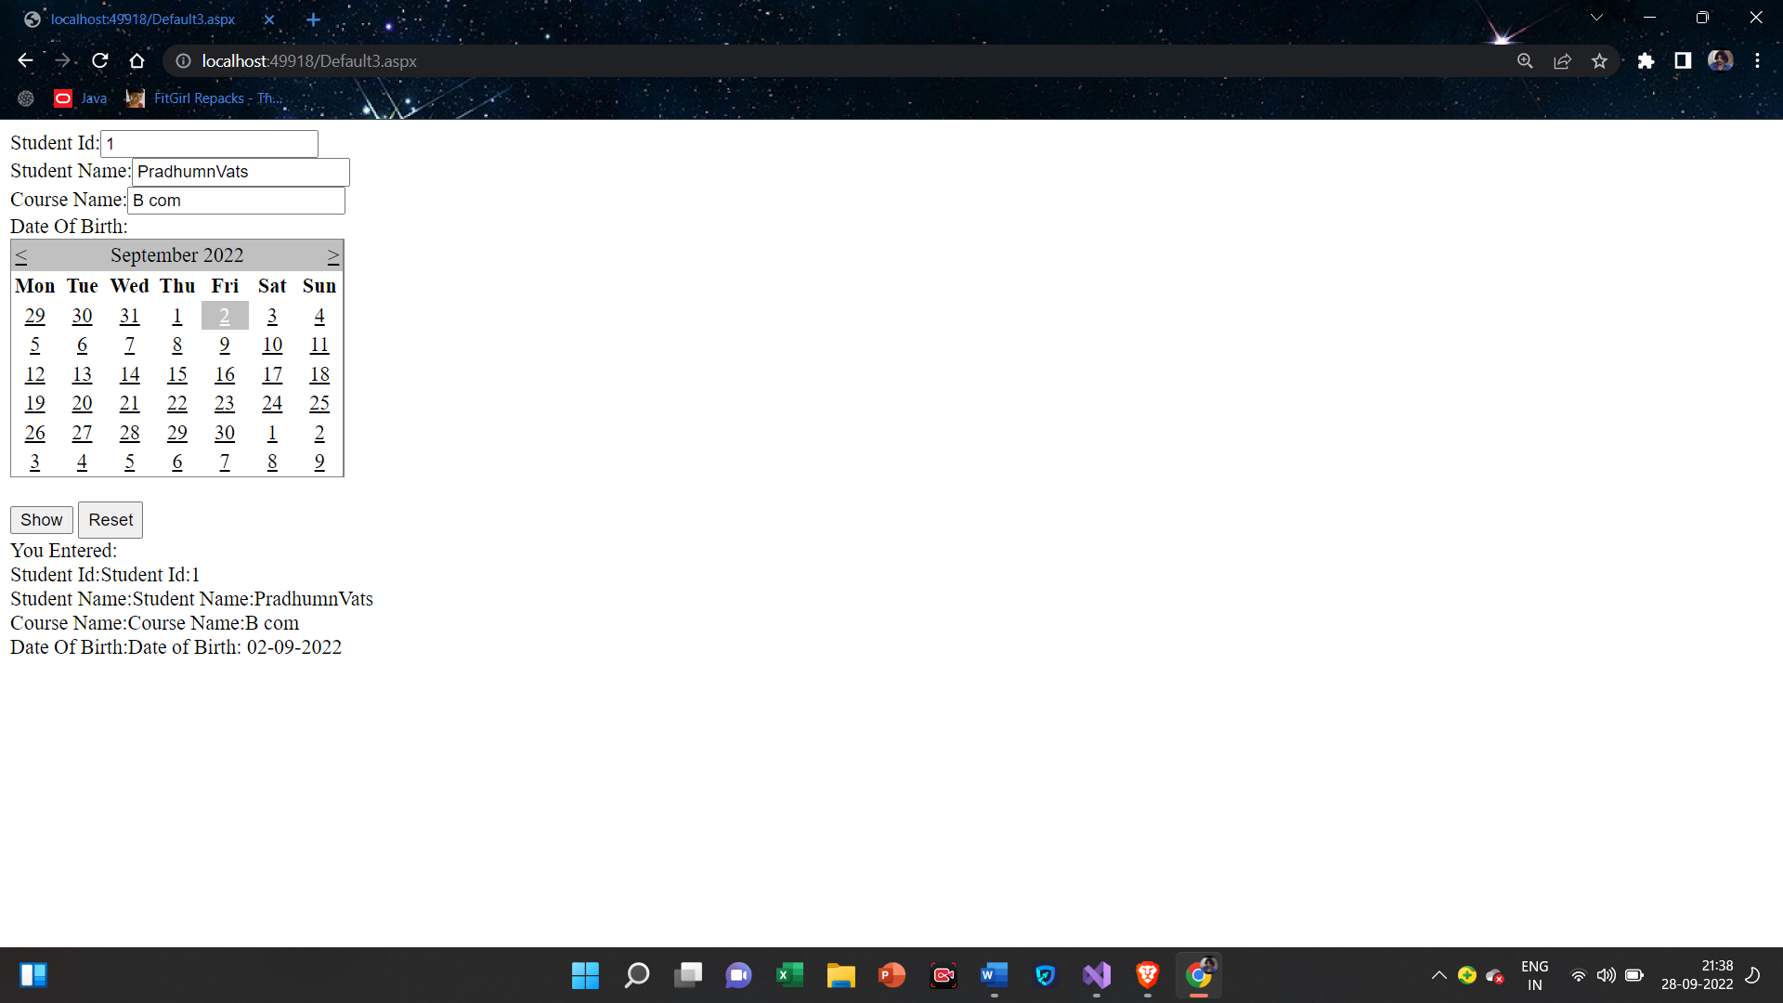

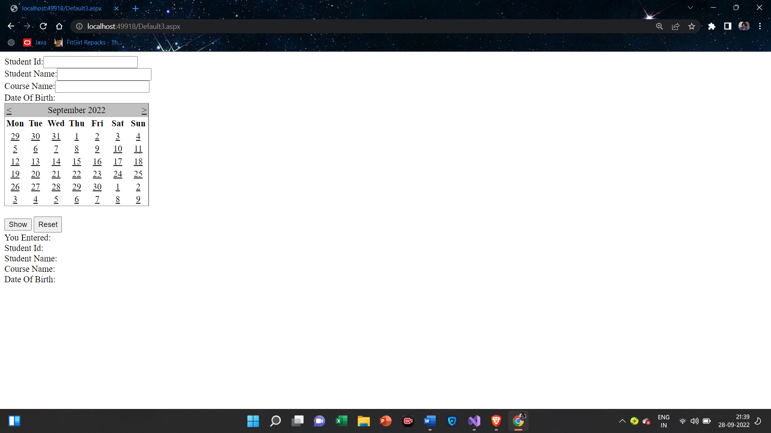

**1(D).Create an application to demonstrate following operations:**

1. **Generate Fibonacci series.**
2. **Test for prime numbers**
3. **Test for vowels**
4. **Use of foreach loop with arrays**
5. **Reverse a number and find sum of digits of number**

**Default.aspx**

<%@ Page Language="C#" AutoEventWireup="true" CodeFile="Default4.aspx.cs" Inherits="Default4" %>

<!DOCTYPE html>

<html xmlns="http://www.w3.org/1999/xhtml">

<head runat="server">

<title></title>

</head>

<body>

<form id="form1" runat="server">

<div>

Enter Number:<asp:TextBox ID="TextBox1" runat="server"></asp:TextBox>

<asp:Button ID="Button1" runat="server" OnClick="Button1_Click" Text="Fibonacci Series" />

<asp:Label ID="Label1" runat="server" Text="Label"></asp:Label>

<br />

Enter Number:<asp:TextBox ID="TextBox2" runat="server"></asp:TextBox>

<asp:Button ID="Button2" runat="server" OnClick="Button2_Click" Text="Check Prime Number" />

<asp:Label ID="Label2" runat="server" Text="Label"></asp:Label>

<br />

Enter Number:<asp:TextBox ID="TextBox3" runat="server"></asp:TextBox>

<asp:Button ID="Button3" runat="server" OnClick="Button3_Click" Text="Reverse Number" />

<asp:Label ID="Label3" runat="server" Text="Label"></asp:Label>

<br />

Enter Number:<asp:TextBox ID="TextBox4" runat="server"></asp:TextBox>

<asp:Button ID="Button4" runat="server" OnClick="Button4_Click" Text="Sum Of Digit Of Number" />

<asp:Label ID="Label4" runat="server" Text="Label"></asp:Label>

<br />

Enter Character:<asp:TextBox ID="TextBox5" runat="server"></asp:TextBox>

<asp:Button ID="Button5" runat="server" OnClick="Button5_Click" Text="Check Vowel or Not" />

<asp:Label ID="Label5" runat="server" Text="Label"></asp:Label>

<br />

<br />

Reading array by using foreach loop:<br />

<asp:Label ID="Label6" runat="server" Text="Label"></asp:Label>

</div>

</form>

</body>

</html>

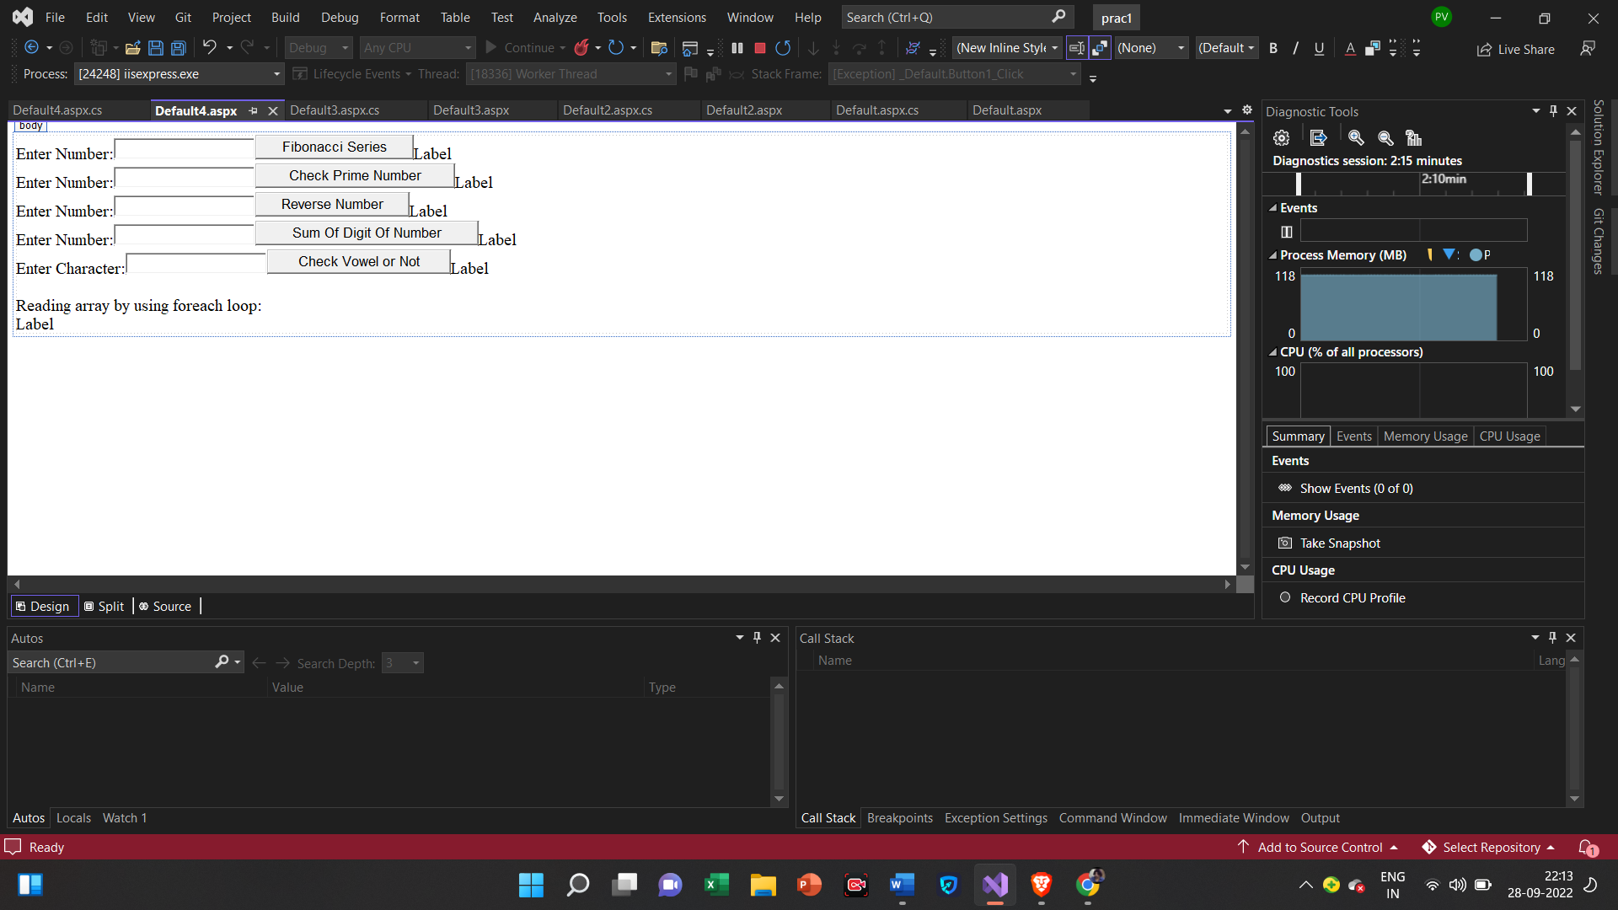

**Default.aspx.cs**

using System;

using System.Collections.Generic;

using System.Linq;

using System.Reflection.Emit;

using System.Web;

using System.Web.UI;

using System.Web.UI.WebControls;

public partial class Default4 : System.Web.UI.Page

{

protected void Page_Load(object sender, EventArgs e)

{

Label6.Text = "";

string[] ColorNames = new string[] { "Red", "Yellow", "Black", "Green", "Blue", "Pink" };

foreach (string ColorName in ColorNames)

Label6.Text = Label6.Text +" "+ColorName.ToString();

}

protected void Button1_Click(object sender, EventArgs e)

{

int a, b, c, i, n;

a = 0;

b = 1;

Label1.Text = a.ToString() + b.ToString();

n = Convert.ToInt32(TextBox1.Text);

for (i = 1; i < n; ++i)

{

c = a + b;

Label1.Text = Label1.Text + c.ToString();

a = b;

b = c;

}

}

protected void Button2_Click(object sender, EventArgs e)

{

int i, c=0,j, num;

num = Convert.ToInt32(TextBox2.Text);

for (j = 1; j <= num; j++)

{

i = num % j;

if (i == 0)

{

c = c + 1;

}

if (c == 2)

Label2.Text = "The given number is prime";

else

Label2.Text = "The given number is not prime";

}

}

protected void Button3_Click(object sender, EventArgs e)

{

long num, i, sum=0;

num = Convert.ToInt32(TextBox3.Text);

while (num > 0)

{

i = num % 10;

sum = i + sum * 10;

num = num / 10;

}

Label3.Text=sum.ToString();

}

protected void Button4_Click(object sender, EventArgs e)

{

long num, i, sum = 0;

num=Convert.ToInt32(TextBox4.Text);

while (num > 0)

{

i = num % 10;

sum = i + sum * 10;

num = num / 10;

}

Label4.Text = sum.ToString();

}

protected void Button5_Click(object sender, EventArgs e)

{

char c = Convert.ToChar(TextBox5.Text);

switch (c)

{

case 'a':

Label5.Text = "a is vowel";

break;

case 'e':

Label5.Text = "e is vowel"; break;

case 'i':

Label5.Text = "i is vowel";

break;

case 'o':

Label5.Text = "o is vowel";

break;

case 'u':

Label5.Text = "u is vowel";

break;

default:

Label5.Text = "It is not vowel"; break;

}

}

}

**Output**

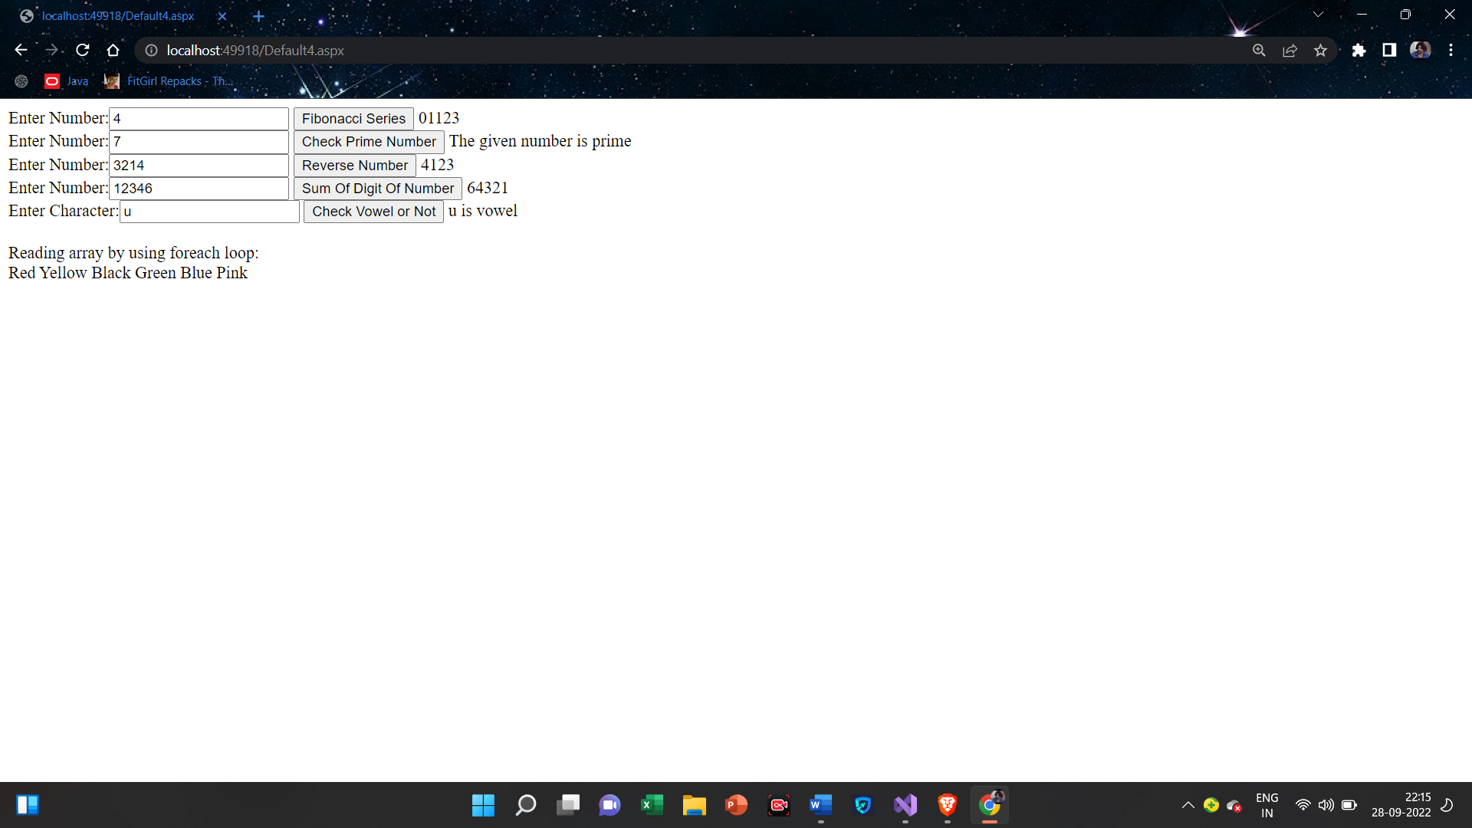

**Practical-2**

**2(a)Create simple application to perform following operations:**

1. **Finding Factorial Value**

**Default.aspx**

<%@ Page Language="C#" AutoEventWireup="true" CodeFile="Default.aspx.cs" Inherits="_Default" %>

<!DOCTYPE html>

<html xmlns="http://www.w3.org/1999/xhtml">

<head runat="server">

<title></title>

</head>

<body>

<form id="form1" runat="server">

<div>

Enter a Number:<asp:TextBox ID="TextBox1" runat="server"></asp:TextBox>

<br />

<asp:Button ID="Button1" runat="server" OnClick="Button1_Click" Text="Calculate Factorial" />

<br />

Result:<asp:Label ID="Label1" runat="server" Text="Label"></asp:Label>

</div>

</form>

</body>

</html>

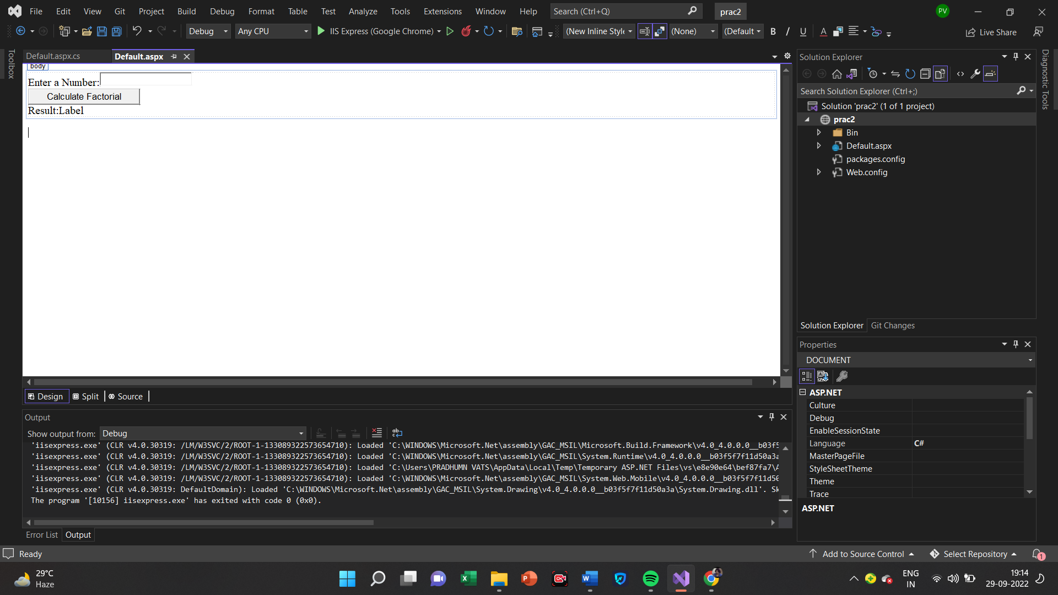

**Default.aspx.cs**

using System;

using System.Collections.Generic;

using System.Linq;

using System.Web;

using System.Web.UI;

using System.Web.UI.WebControls;

public partial class _Default : System.Web.UI.Page

{

protected void Page_Load(object sender, EventArgs e)

{

}

protected void Button1_Click(object sender, EventArgs e)

{

int i, fact = 1, n;

n = Convert.ToInt32(TextBox1.Text);

for (i = 1; i <= n; i++)

{

fact = fact * i;

}

Label1.Text = fact.ToString();

}

}

**Output**

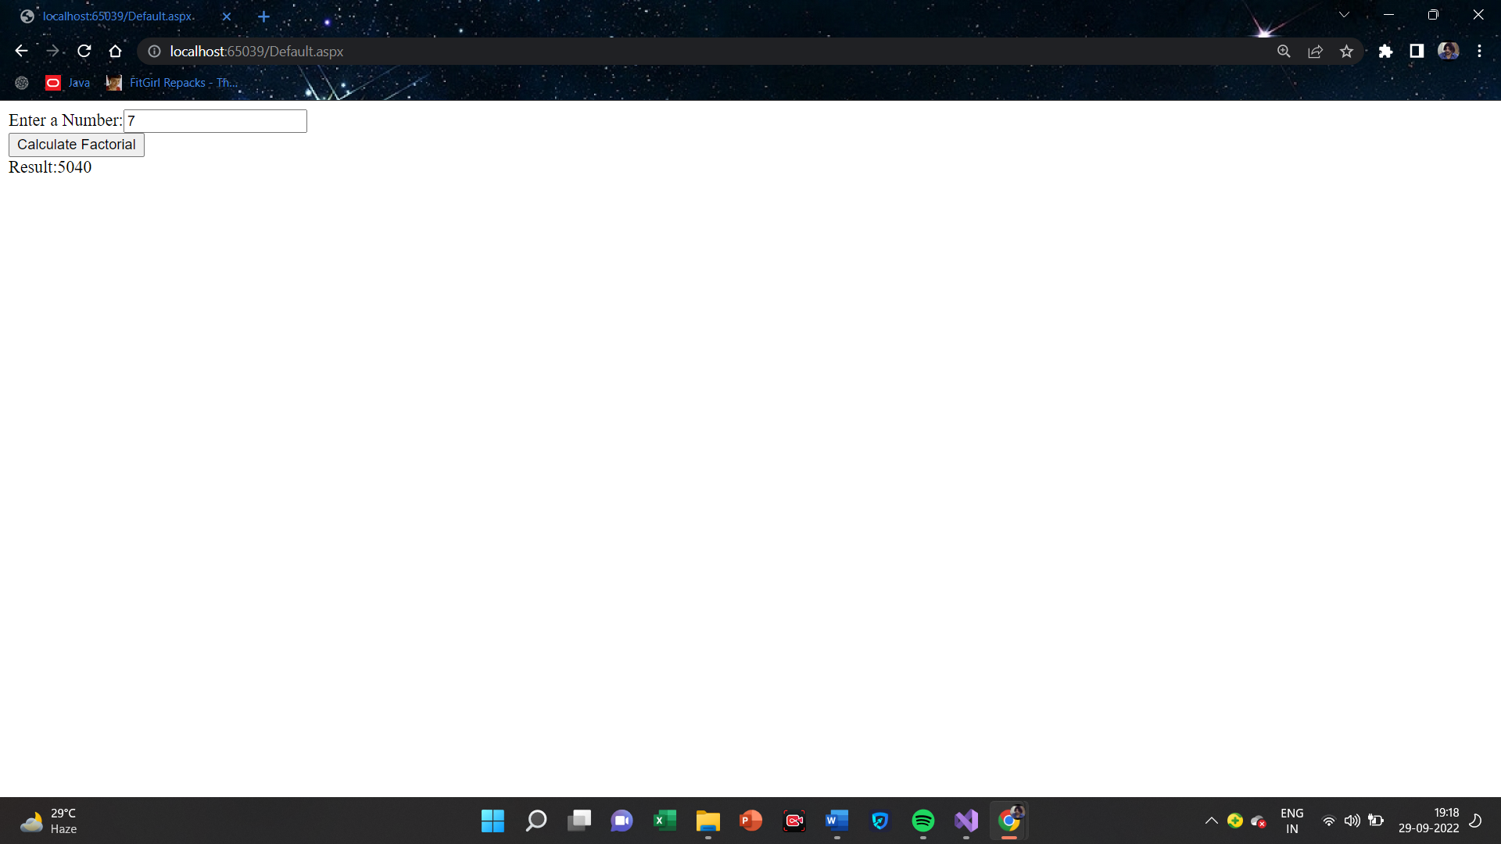

**(ii)Money Conversion**

**Default.aspx**

<%@ Page Language="C#" AutoEventWireup="true" CodeFile="Default2.aspx.cs" Inherits="Default2" %>

<!DOCTYPE html>

<html xmlns="http://www.w3.org/1999/xhtml">

<head runat="server">

<title></title>

</head>

<body>

<form id="form1" runat="server">

<div>

Enter Amount In Rupees:<asp:TextBox ID="TextBox1" runat="server"></asp:TextBox>

<br />

</div>

<asp:Button ID="Button1" runat="server" OnClick="Button1_Click" Text="US DOLLARS" />

<asp:Label ID="Label1" runat="server" Text="Label"></asp:Label>

<br />

<br />

<asp:Button ID="Button2" runat="server" OnClick="Button2_Click" Text="EUROS" />

<asp:Label ID="Label2" runat="server" Text="Label"></asp:Label>

<br />

<br />

<asp:Button ID="Button3" runat="server" OnClick="Button3_Click" Text="BRITISH POUNDS" />

<asp:Label ID="Label3" runat="server" Text="Label"></asp:Label>

<br />

<br />

<asp:Button ID="Button4" runat="server" OnClick="Button4_Click" Text="JAPANESE YEN" />

<asp:Label ID="Label4" runat="server" Text="Label"></asp:Label>

</form>

</body>

</html>

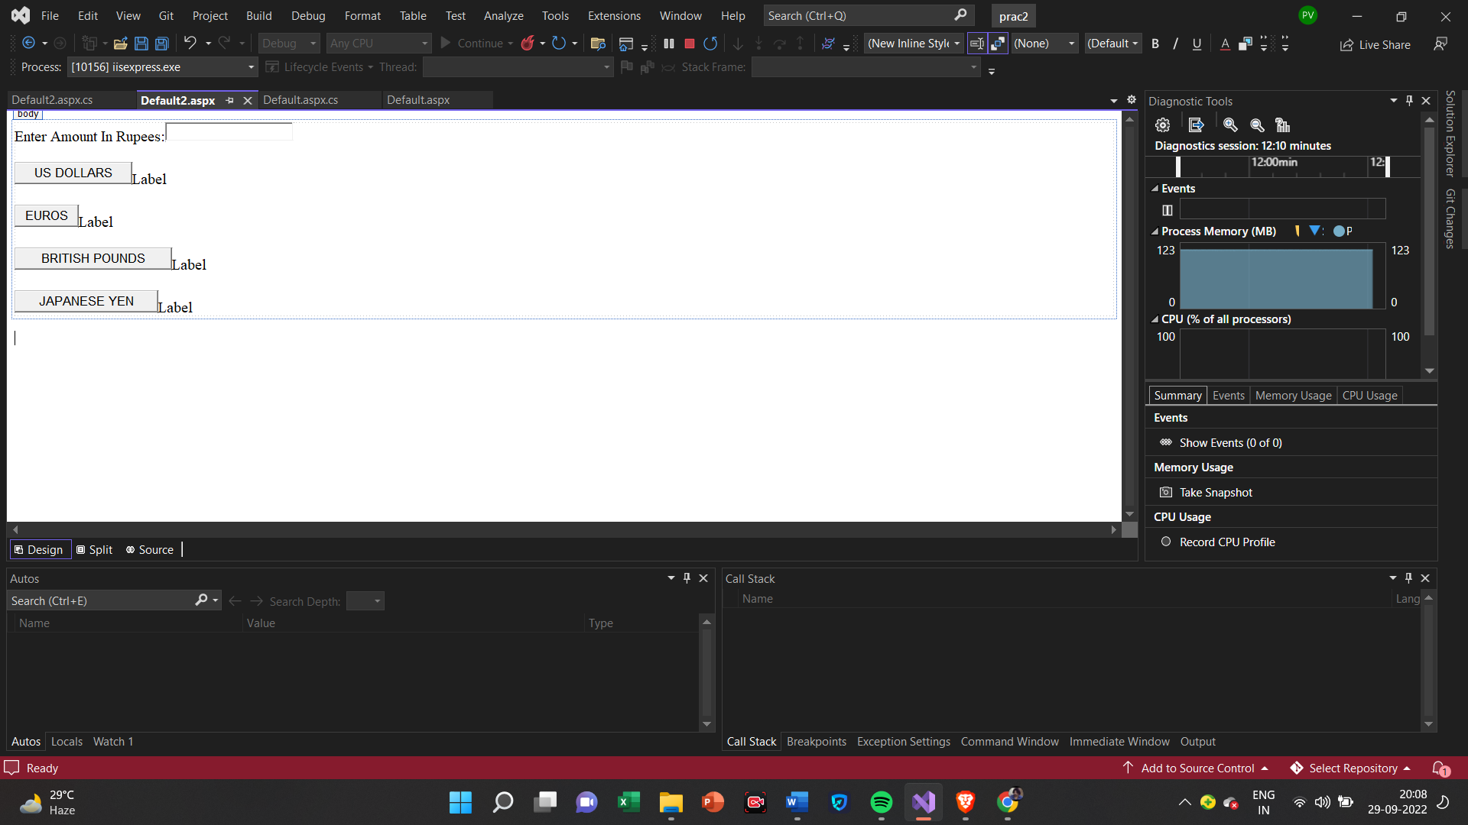

**Default.aspx.cs**

using System;

using System.Collections.Generic;

using System.Linq;

using System.Reflection.Emit;

using System.Web;

using System.Web.UI;

using System.Web.UI.WebControls;

public partial class Default2 : System.Web.UI.Page

{

protected void Page_Load(object sender, EventArgs e)

{

}

protected void Button1_Click(object sender, EventArgs e)

{

double r = Convert.ToDouble(TextBox1.Text);

double rate = r /79.8635;

Label1.Text = rate.ToString();

}

protected void Button2_Click(object sender, EventArgs e)

{

double r = Convert.ToDouble(TextBox1.Text);

double rate = r /81.344 ;

Label2.Text = rate.ToString();

}

protected void Button3_Click(object sender, EventArgs e)

{

double r = Convert.ToDouble(TextBox1.Text);

double rate = r / 89.62;

Label3.Text = rate.ToString();

}

protected void Button4_Click(object sender, EventArgs e)

{

double r = Convert.ToDouble(TextBox1.Text);

double rate = r / 0.57;

Label4.Text = rate.ToString();

}

}

**Output**

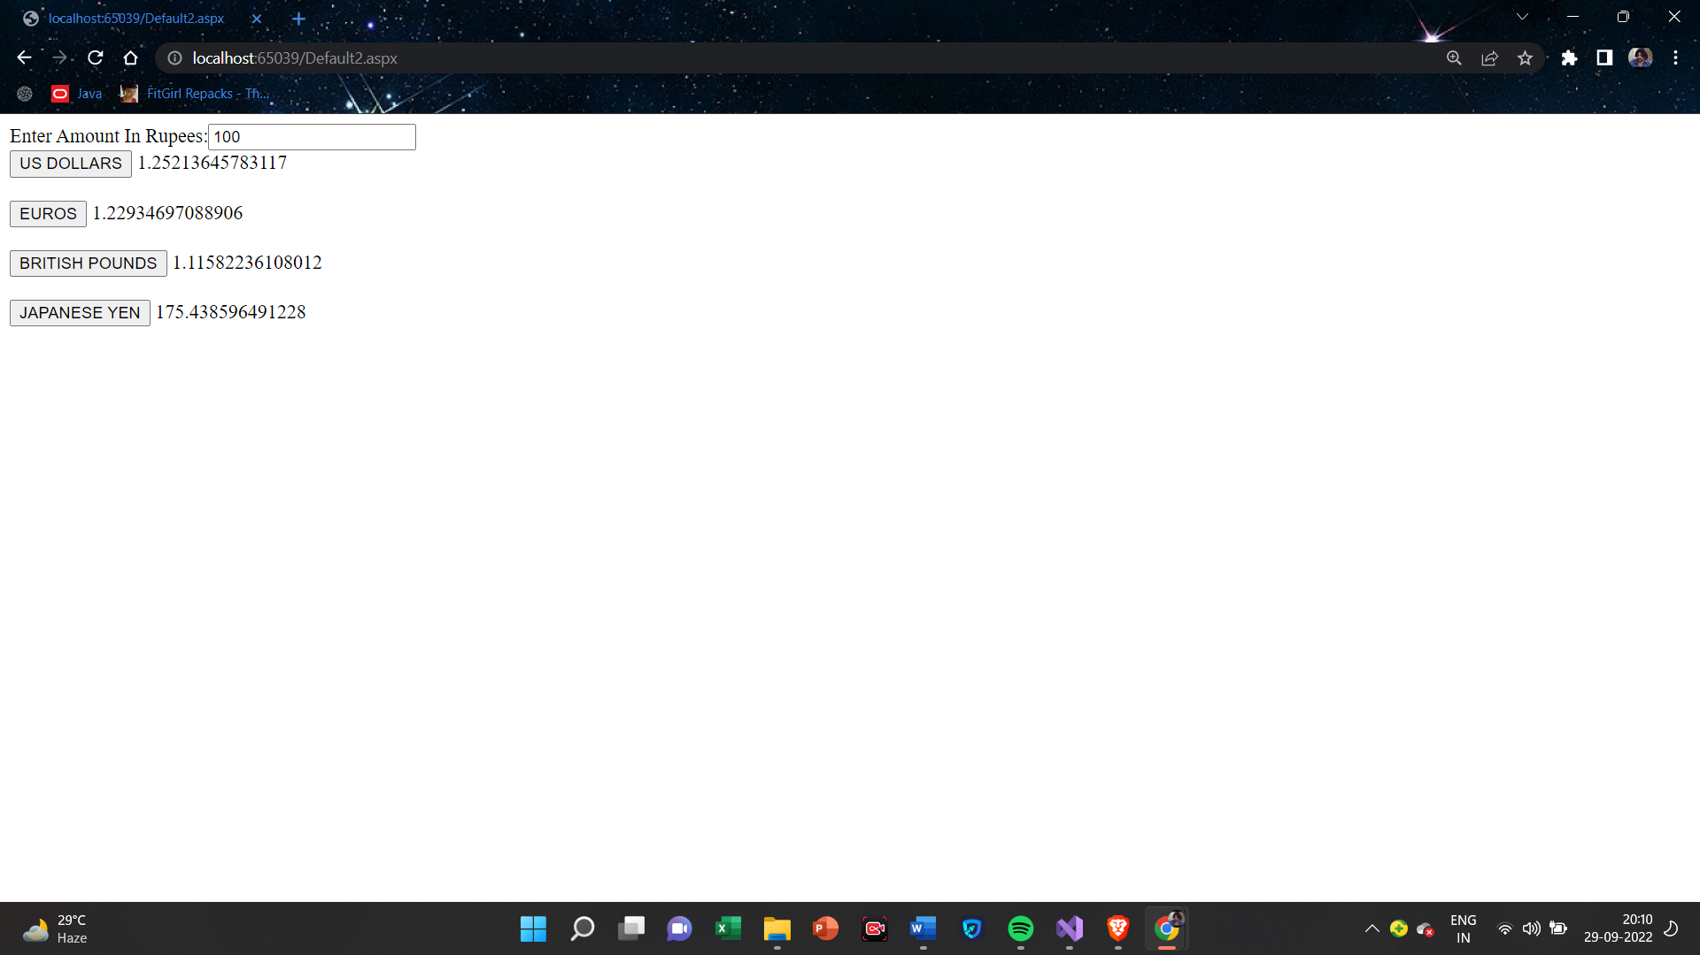

**(iii)Quadratic Equation**

**Default.aspx**

<%@ Page Language="C#" AutoEventWireup="true" CodeFile="Default3.aspx.cs" Inherits="Default3" %>

<!DOCTYPE html>

<html xmlns="http://www.w3.org/1999/xhtml">

<head runat="server">

<title></title>

</head>

<body>

<form id="form1" runat="server">

<div>

Enter A:<asp:TextBox ID="TextBox1" runat="server" Height="16px"></asp:TextBox>

<br />

<br />

Enter B:<asp:TextBox ID="TextBox2" runat="server" Height="16px"></asp:TextBox>

<br />

<br />

Enter C:<asp:TextBox ID="TextBox3" runat="server" Height="16px"></asp:TextBox>

<br />

<br />

<asp:Button ID="Button1" runat="server" OnClick="Button1_Click" Text="Result" />

&nbsp;

<br />

<br />

<asp:Label ID="Label1" runat="server" Text="Label"></asp:Label>

<br />

<asp:Label ID="Label2" runat="server" Text="Label"></asp:Label>

,<asp:Label ID="Label3" runat="server" Text="Label"></asp:Label>

</div>

</form>

</body>

</html>

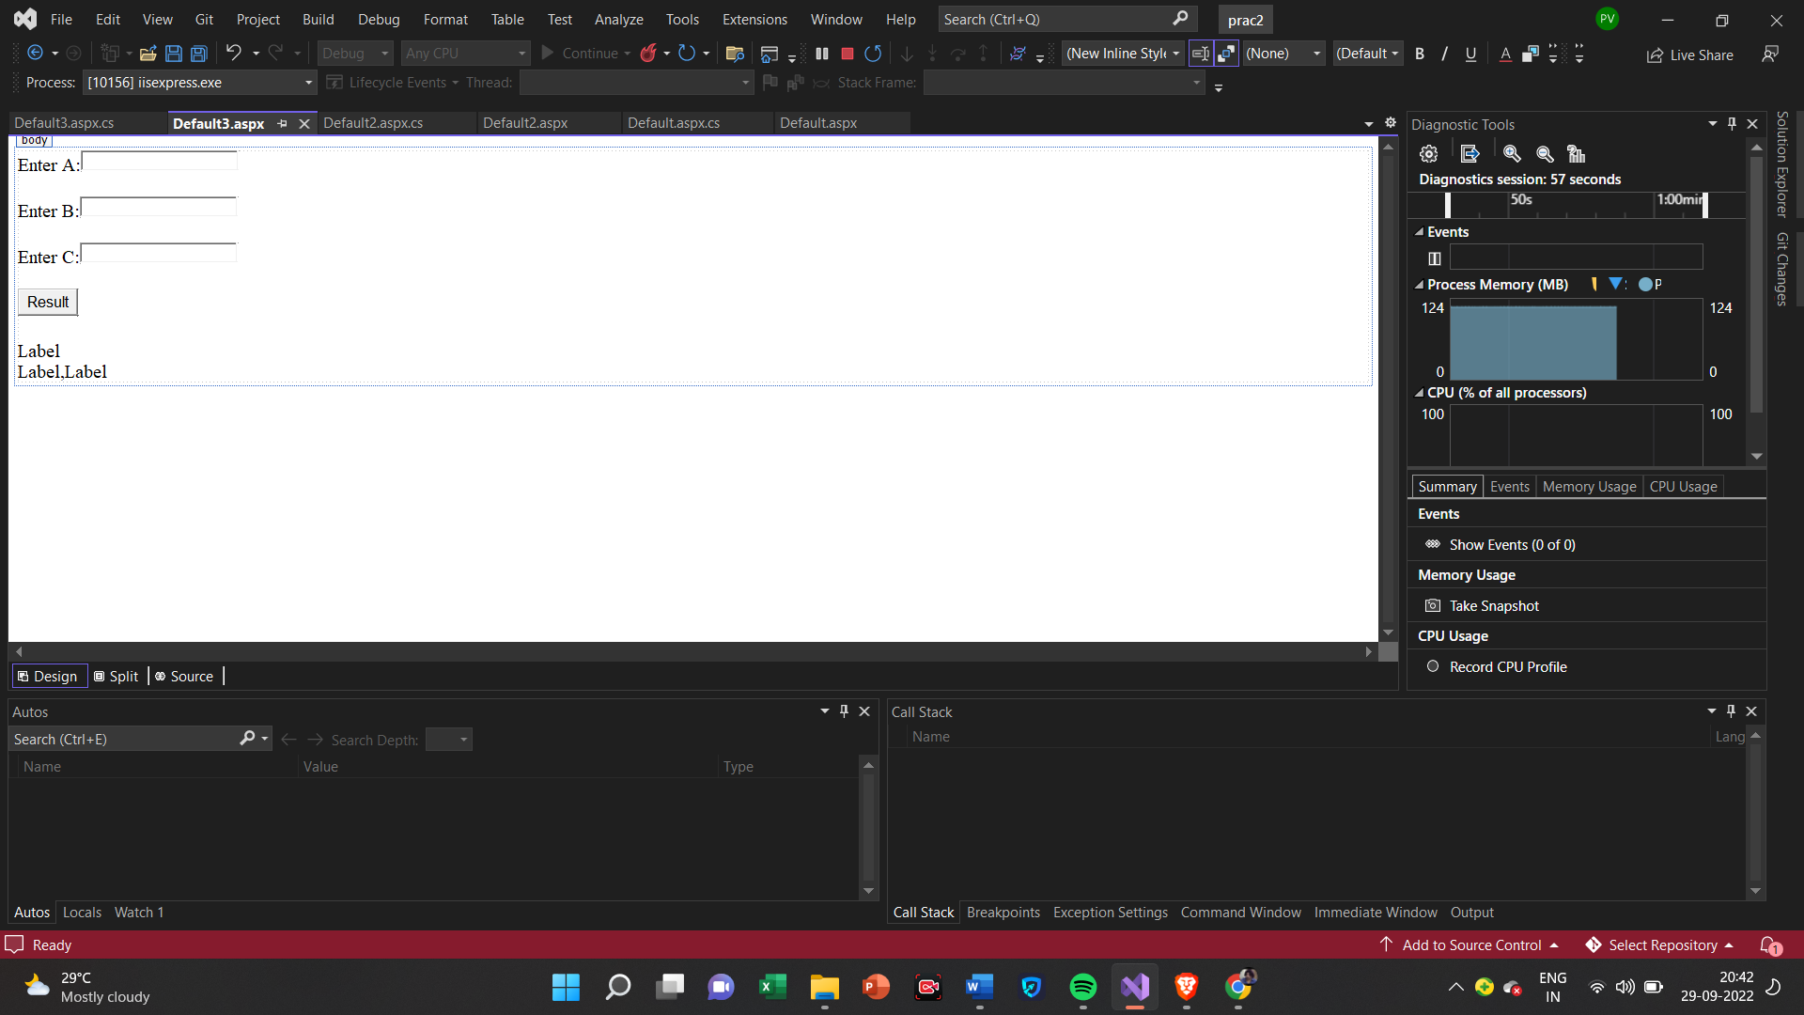

**Default.aspx.cs**

using System;

using System.Collections.Generic;

using System.Linq;

using System.Reflection.Emit;

using System.Web;

using System.Web.UI;

using System.Web.UI.WebControls;

public partial class Default3 : System.Web.UI.Page

{

protected void Page_Load(object sender, EventArgs e)

{

}

protected void Button1_Click(object sender, EventArgs e)

{

double a, b, c, r1, r2, x;

double det;

a = Convert.ToInt32(TextBox1.Text);

b = Convert.ToInt32(TextBox2.Text);

c = Convert.ToInt32(TextBox3.Text);

det = (b * b) - (4 * a * c);

if (det > 0)

{

x = Math.Sqrt(det);

r1 = (-b + x) / (2 * a);

r2 = (-b - x) / (2 * a);

Label1.Text = "There are two roots :: ";

Label2.Text = r1.ToString();

Label3.Text = r2.ToString();

}

else if (det == 0)

{

x = Math.Sqrt(det);

r1 = (-b + x) / (2 * a);

Label1.Text = "There is only one root ::";

Label2.Text = r1.ToString();

}

else

Label1.Text = "There is no root !!!";

}

}

**Output**

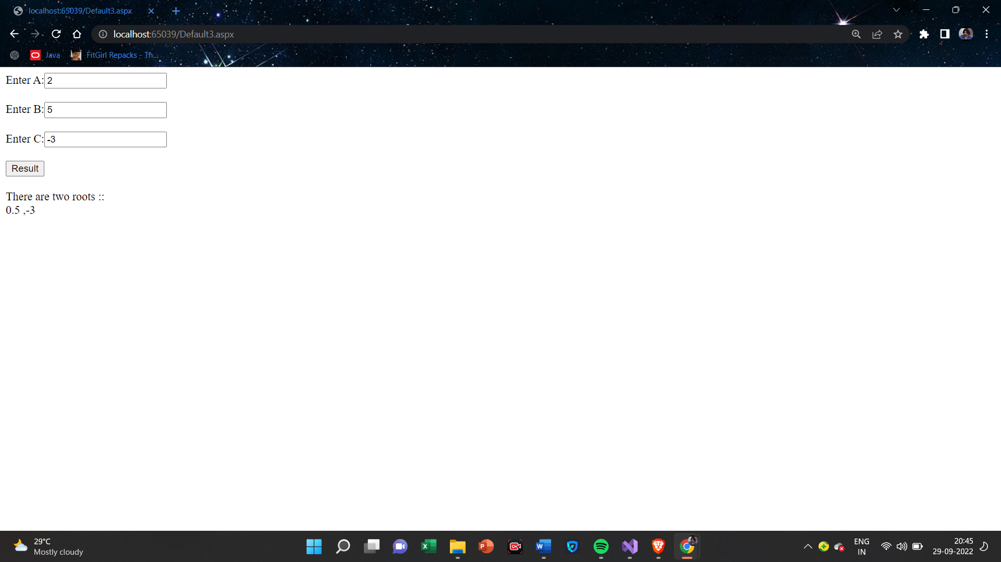

**(iv)Temperature Converter**

**Default.aspx**

<%@ Page Language="C#" AutoEventWireup="true" CodeFile="Default4.aspx.cs" Inherits="Default4" %>

<!DOCTYPE html>

<html xmlns="http://www.w3.org/1999/xhtml">

<head runat="server">

<title></title>

</head>

<body>

<form id="form1" runat="server">

<div>

Temperature Conversion<br />

<br />

Enter Value Celsius :

<asp:TextBox ID="TextBox1" runat="server"></asp:TextBox>

&nbsp;&nbsp;&nbsp;

<asp:Button ID="Button1" runat="server" OnClick="Button1_Click" Text="Celsius To Fahrenheit" />

&nbsp;&nbsp;&nbsp;

<asp:Label ID="Label1" runat="server" Text="Label"></asp:Label>

<br />

<br />

Enter Value Fahrenheit :

<asp:TextBox ID="TextBox2" runat="server"></asp:TextBox>

&nbsp;&nbsp;&nbsp;

<asp:Button ID="Button2" runat="server" OnClick="Button2_Click" Text="Fahernheit To Celsius" />

&nbsp;&nbsp;&nbsp;

<asp:Label ID="Label2" runat="server" Text="Label"></asp:Label>

</div>

</form>

</body>

</html>

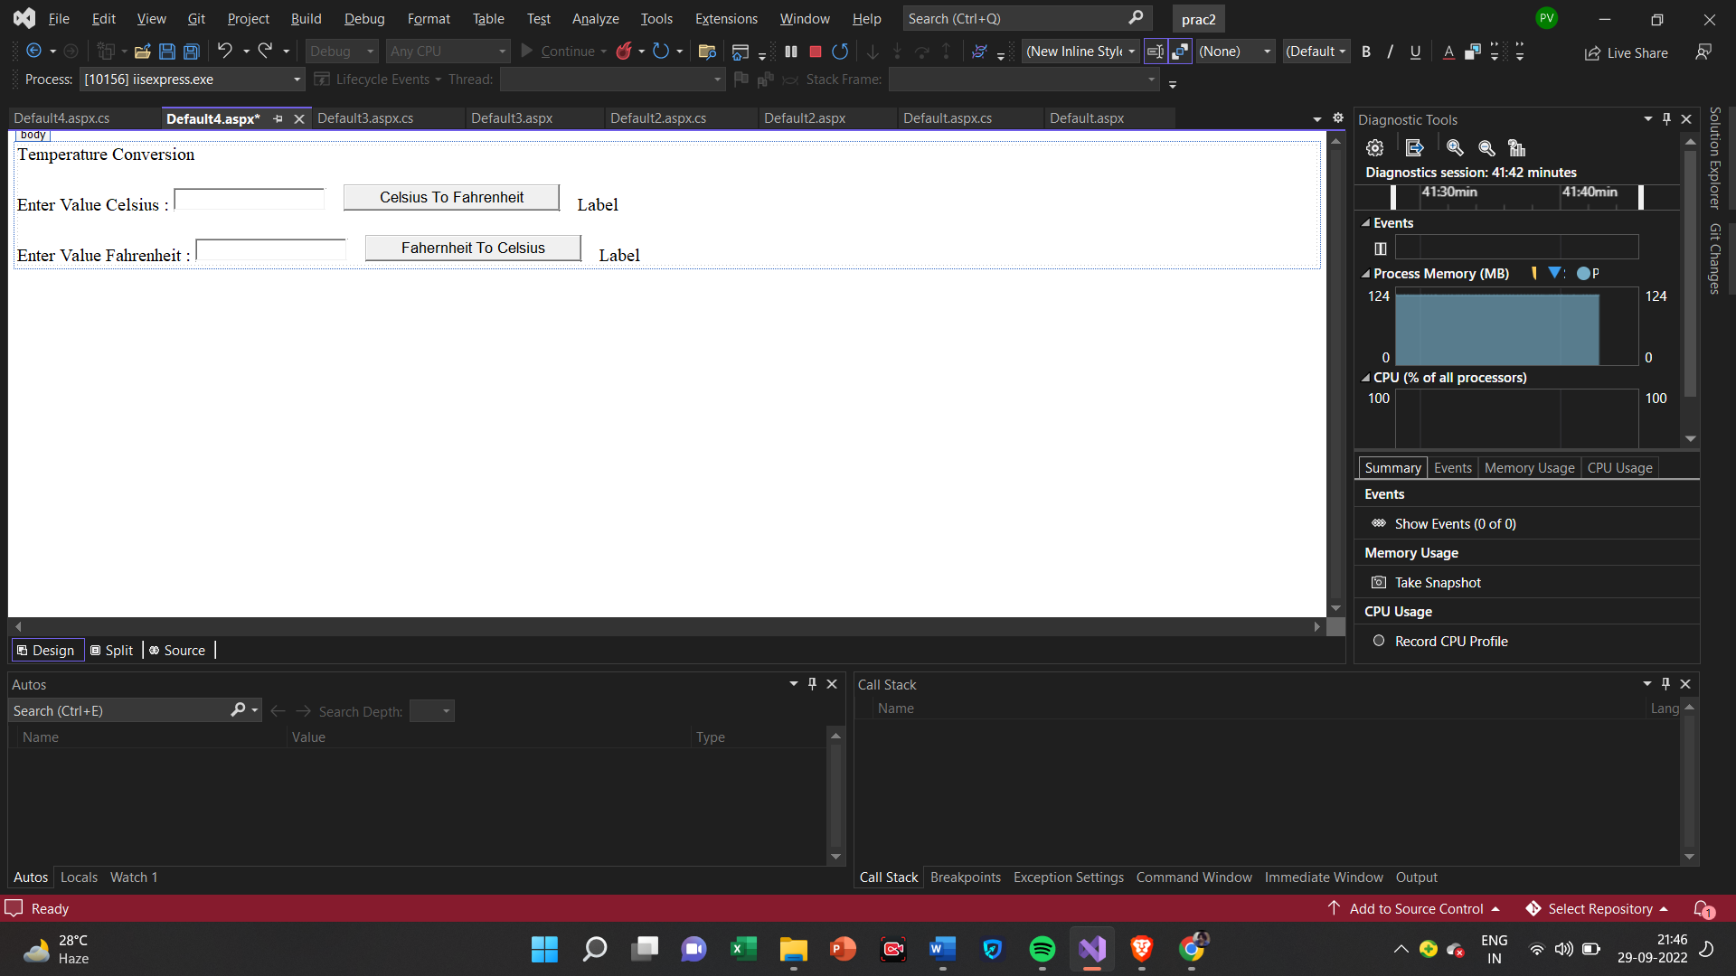

**Default.aspx.cs**

using System;

using System.Collections.Generic;

using System.Linq;

using System.Web;

using System.Web.UI;

using System.Web.UI.WebControls;

public partial class Default4 : System.Web.UI.Page

{

protected void Page_Load(object sender, EventArgs e)

{

}

protected void Button1_Click(object sender, EventArgs e)

{

tempConv s = new tempConv();

double n = Convert.ToDouble(TextBox1.Text);

double x = s.ctof(n);

Label1.Text = x.ToString();

}

protected void Button2_Click(object sender, EventArgs e)

{

tempConv s = new tempConv();

double n = Convert.ToDouble(TextBox2.Text);

double x =s.ftoc(n);

Label2.Text = x.ToString();

}

}

public class tempConv

{

public double ctof(double temp)

{

temp = (9.0 / 5.0)* temp + 32;

return temp;

}

public double ftoc(double temp)

{

temp = (temp - 32) * 5 / 9;

return temp;

}

}

**Output**

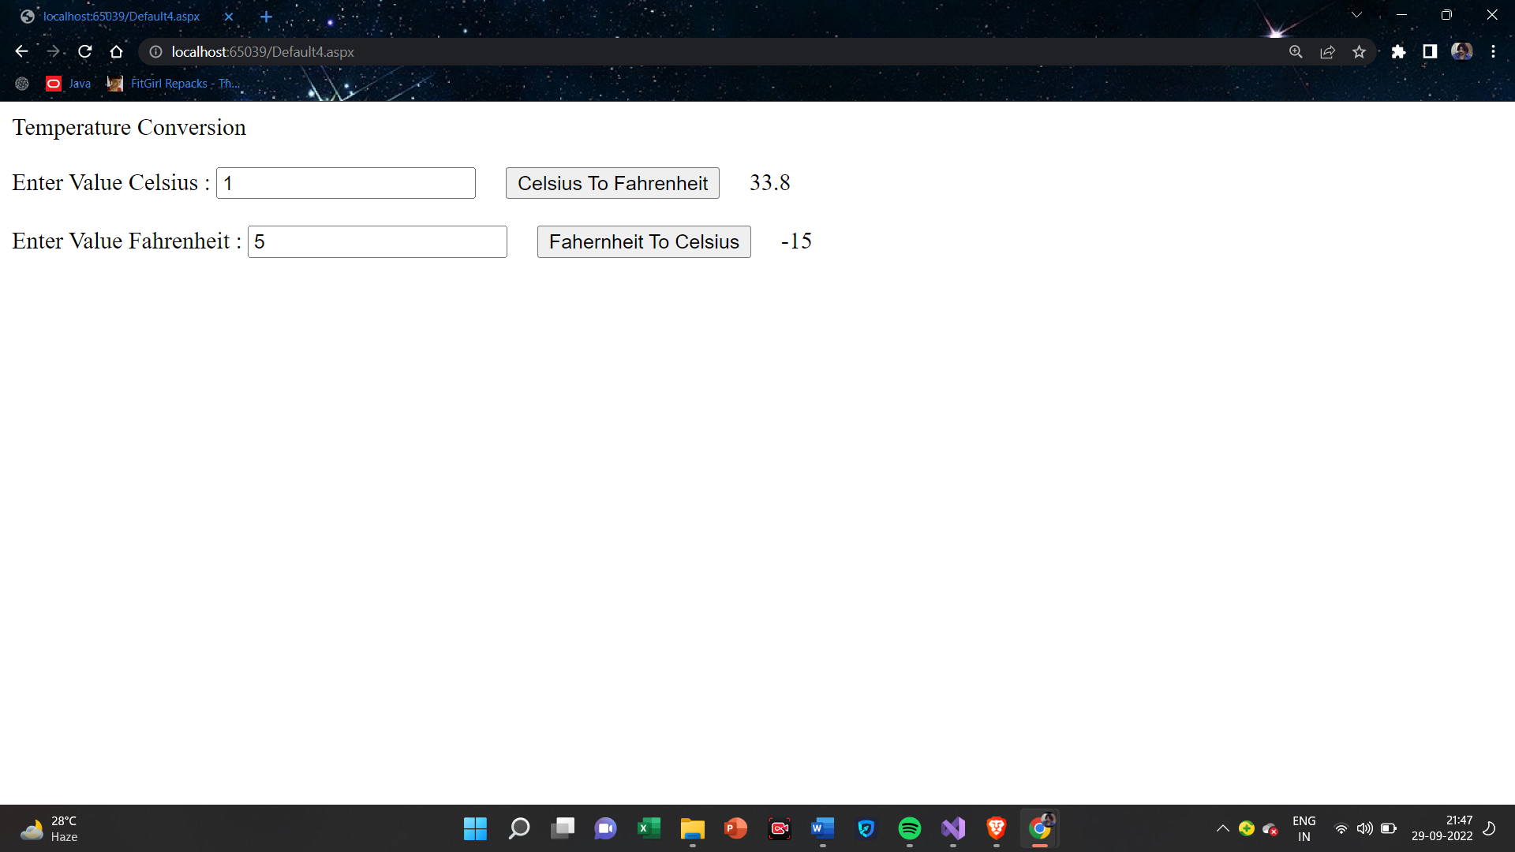

**2(b)Create simple application to Demonstrate use of following Concepts:**

1. **Function Overloading**

**Default.aspx**

<%@ Page Language="C#" AutoEventWireup="true" CodeFile="Default.aspx.cs" Inherits="_Default" %>

<!DOCTYPE html>

<html xmlns="http://www.w3.org/1999/xhtml">

<head runat="server">

<title></title>

</head>

<body>

<form id="form1" runat="server">

<div>

Function Overloading<br />

<br />

<asp:Label ID="Label1" runat="server" Text="Label"></asp:Label>

<br />

<br />

<asp:Label ID="Label2" runat="server" Text="Label"></asp:Label>

<br />

<br />

<asp:Label ID="Label3" runat="server" Text="Label"></asp:Label>

</div>

</form>

</body>

</html>

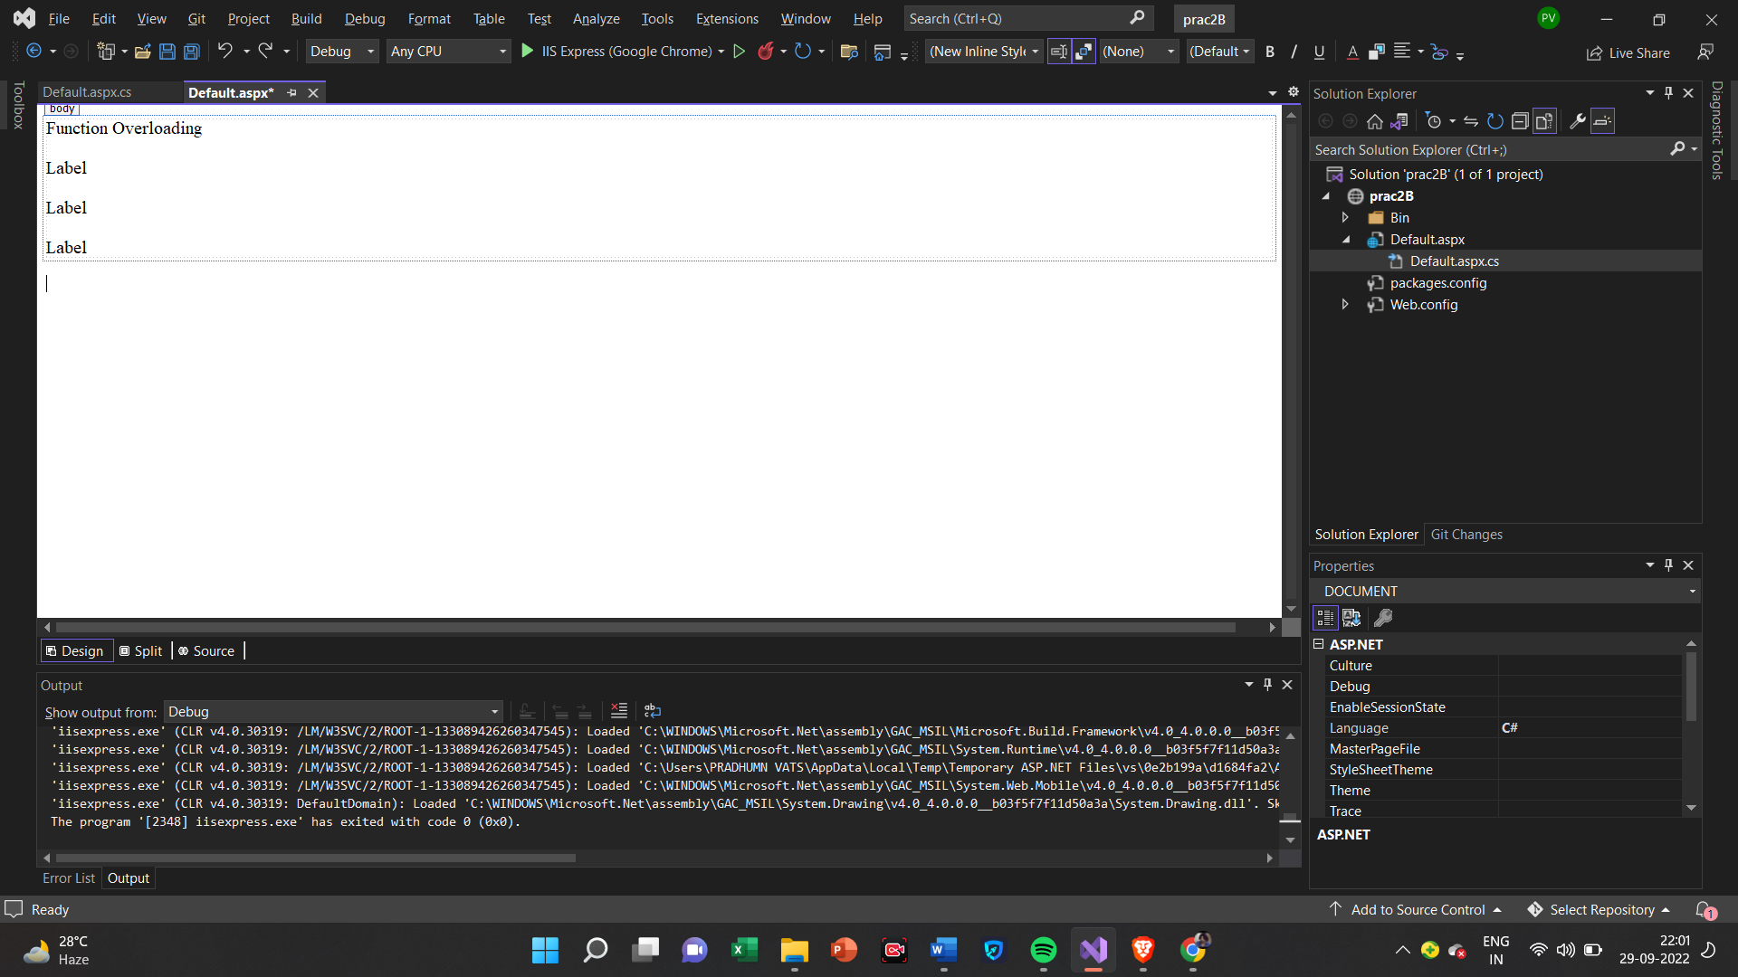

**Default.aspx.cs**

using System;

using System.Collections.Generic;

using System.Linq;

using System.Web;

using System.Web.UI;

using System.Web.UI.WebControls;

public partial class _Default : System.Web.UI.Page

{

public int add(int a)

{

return a + a;

}

public int add(int a, int b)

{

return a + b;

}

public int add(int a, int b, int c)

{

return a + b + c;

}

protected void Page_Load(object sender, EventArgs e)

{

int x, z, y;

x = add(2);

z = add(2, 3);

y = add(2, 3, 4);

Label1.Text = x.ToString();

Label2.Text = z.ToString();

Label3.Text = y.ToString();

}

}

**Output**

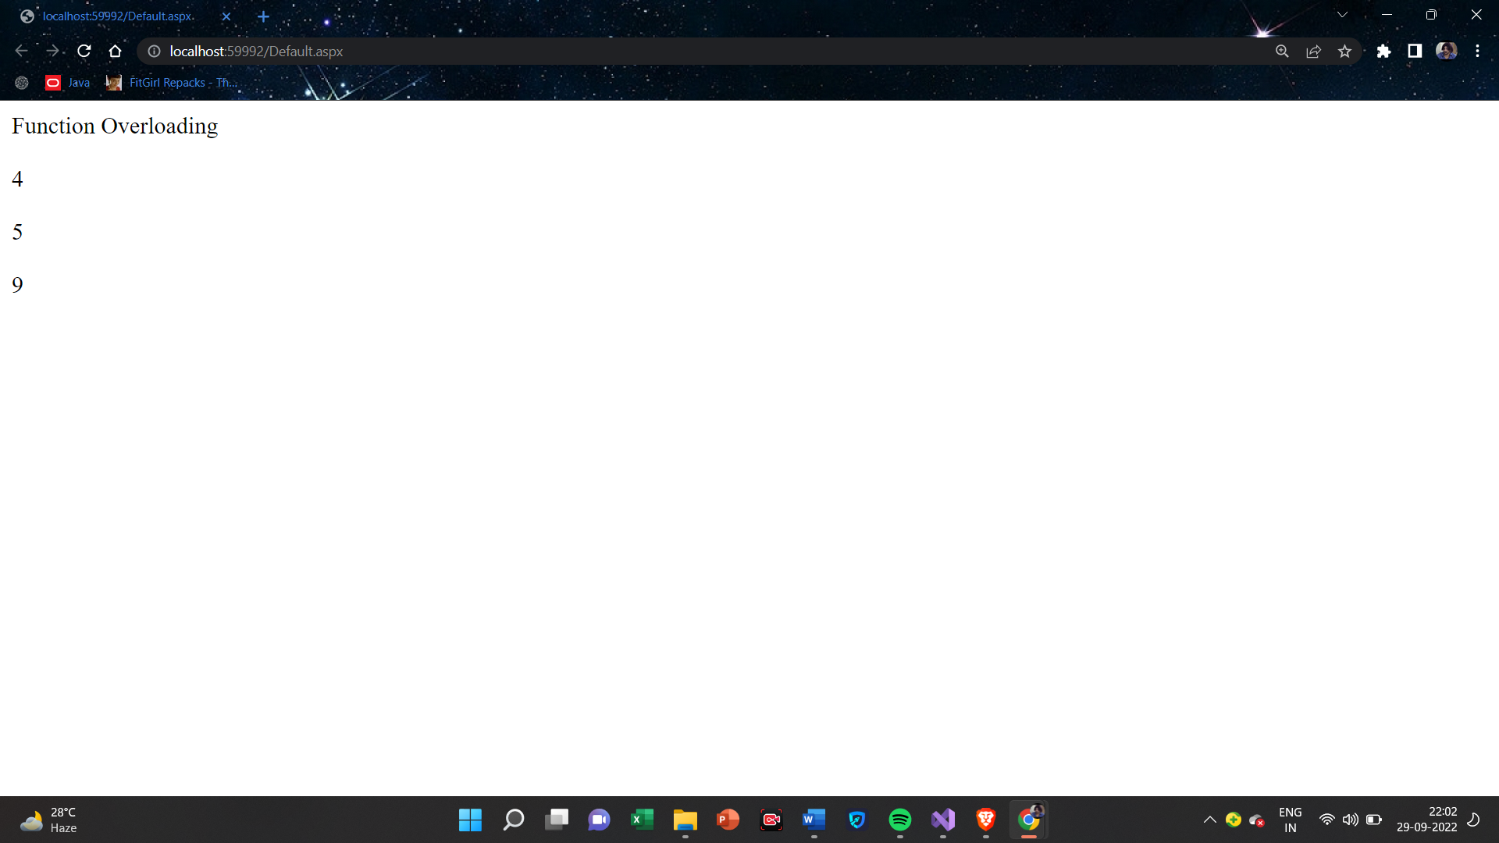

**(ii)Inheritance**

**1.Single Inheritance**

**Default.aspx**

<%@ Page Language="C#" AutoEventWireup="true" CodeFile="Default2.aspx.cs" Inherits="Default2" %>

<!DOCTYPE html>

<html xmlns="http://www.w3.org/1999/xhtml">

<head runat="server">

<title></title>

</head>

<body>

<form id="form1" runat="server">

<div>

Enter A Number:

<asp:TextBox ID="TextBox1" runat="server"></asp:TextBox>

&nbsp;&nbsp;&nbsp;

<asp:Button ID="Button1" runat="server" OnClick="Button1_Click" Text="Result" />

<br />

<br />

Square Of A Number: <asp:Label ID="Label1" runat="server" Text="Label"></asp:Label>

<br />

<br />

Cube Of A Number:<asp:Label ID="Label2" runat="server" Text="Label"></asp:Label>

</div>

</form>

</body>

</html>

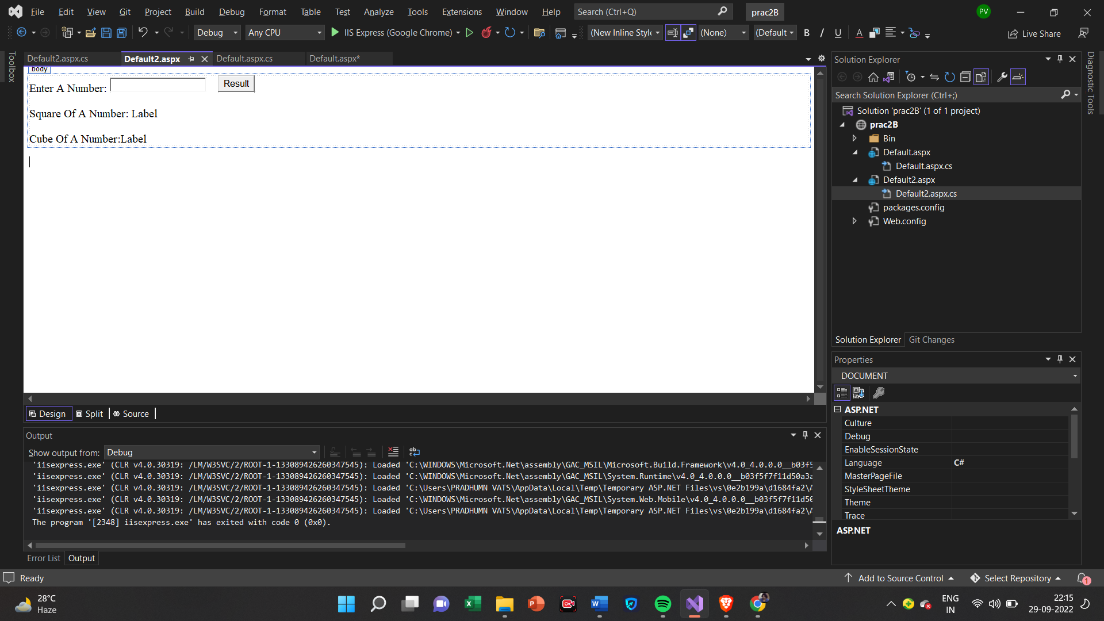

**Default.aspx.cs**

using System;

using System.Collections.Generic;

using System.Linq;

using System.Web;

using System.Web.UI;

using System.Web.UI.WebControls;

public partial class Default2 : System.Web.UI.Page

{

protected void Page_Load(object sender, EventArgs e)

{

}

protected void Button1_Click(object sender, EventArgs e)

{

B s = new B();

int n = Convert.ToInt32(TextBox1.Text);

int x = s.sqr(n);

int y = s.cub(n);

Label1.Text = x.ToString();

Label2.Text = y.ToString();

}

}

public class A

{

public int sqr(int Val1)

{

return Val1 * Val1;

}

}

public class B : A

{

public int cub(int Val1)

{

int v1 = sqr(Val1); return v1* Val1;

}

}

**Output**

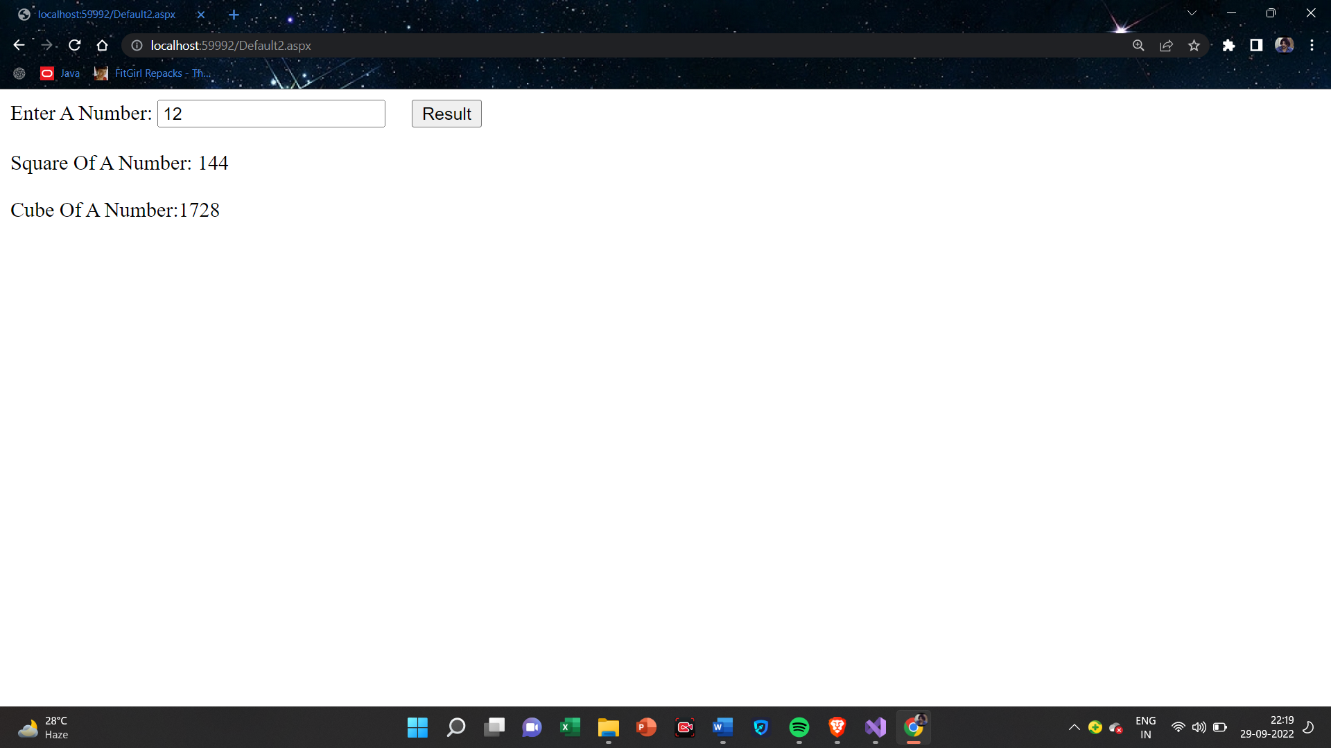

**2.Multilevel Inheritance**

**Default.aspx**

<%@ Page Language="C#" AutoEventWireup="true" CodeFile="Default3.aspx.cs" Inherits="Default3" %>

<!DOCTYPE html>

<html xmlns="http://www.w3.org/1999/xhtml">

<head runat="server">

<title></title>

</head>

<body>

<form id="form1" runat="server">

<div>

Enter A Number:

<asp:TextBox ID="TextBox1" runat="server"></asp:TextBox>

&nbsp;&nbsp;&nbsp;

<asp:Button ID="Button1" runat="server" OnClick="Button1_Click" Text="Result" />

<br />

<br />

Number is Power of 2: <asp:Label ID="Label1" runat="server" Text="Label"></asp:Label>

<br />

<br />

Number is Power of 3:<asp:Label ID="Label2" runat="server" Text="Label"></asp:Label>

<br />

<br />

Number is Power of 4: <asp:Label ID="Label3" runat="server" Text="Label"></asp:Label>

</div>

</form>

</body>

</html>

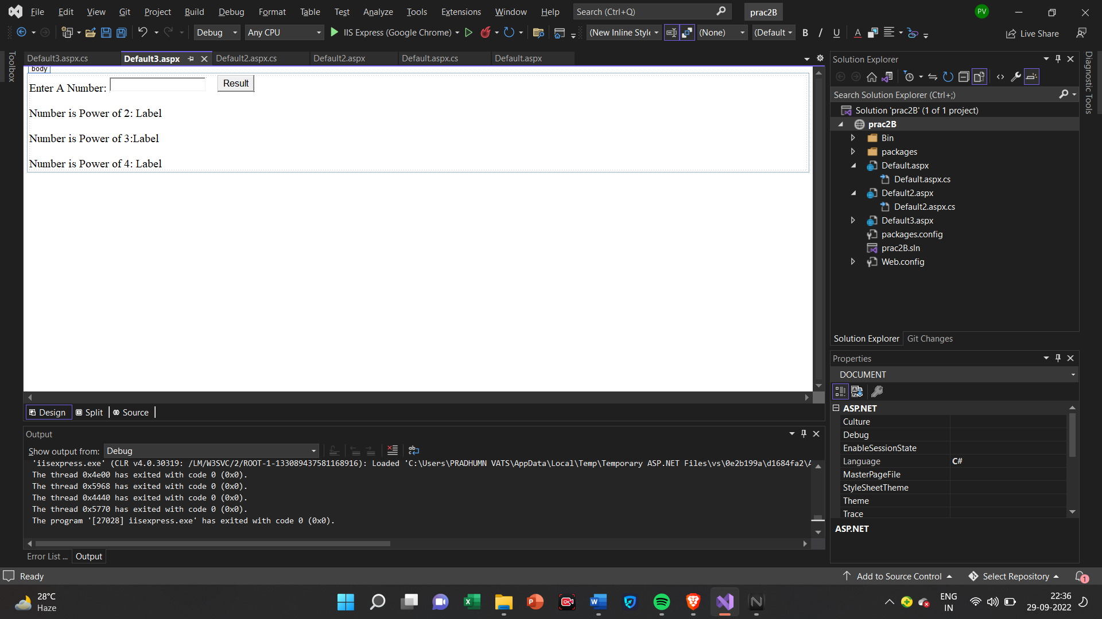

**Default.aspx.cs**

using System;

using System.Collections.Generic;

using System.Linq;

using System.Reflection.Emit;

using System.Web;

using System.Web.UI;

using System.Web.UI.WebControls;

public partial class Default3 : System.Web.UI.Page

{

protected void Page_Load(object sender, EventArgs e)

{

}

protected void Button1_Click(object sender, EventArgs e)

{

C s = new C();

int n = Convert.ToInt32(TextBox1.Text);

int x = s.pow2(n);

int y = s.pow3(n);

int z = s.pow4(n);

Label1.Text = x.ToString();

Label2.Text = y.ToString();

Label3.Text = z.ToString();

}

}

public class A

{

public int pow2(int Val1)

{

return Val1 * Val1;

}

}

public class B : A

{

public int pow3(int Val1)

{

int v1 = pow2(Val1);

return v1 * Val1;

}

}

public class C : B

{

public int pow4(int Val1)

{

int v1 = pow3(Val1);

return v1 * Val1;

}

}

**Output**

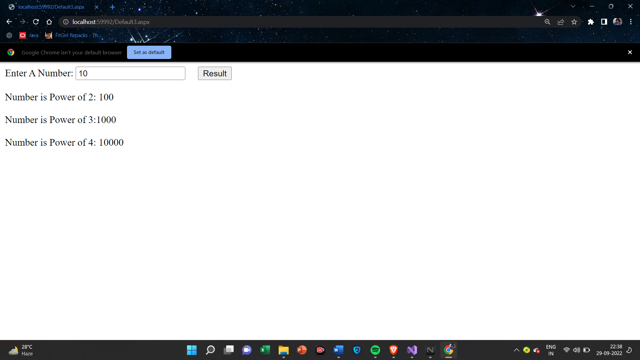

**3.Hierarchical Inheritance**

**Default.aspx**

<%@ Page Language="C#" AutoEventWireup="true" CodeFile="Default4.aspx.cs" Inherits="Default4" %>

<!DOCTYPE html>

<html xmlns="http://www.w3.org/1999/xhtml">

<head runat="server">

<title></title>

</head>

<body>

<form id="form1" runat="server">

<div>

Enter Number A:

<asp:TextBox ID="TextBox1" runat="server"></asp:TextBox>

&nbsp;<br />

<br />

Enter Number B:

<asp:TextBox ID="TextBox2" runat="server"></asp:TextBox>

<br />

&nbsp;<asp:Button ID="Button1" runat="server" OnClick="Button1_Click" Text="Result" />

<br />

<br />

A+B=<asp:Label ID="Label2" runat="server" Text="Label"></asp:Label>

<br />

<br />

A-B=<asp:Label ID="Label1" runat="server" Text="Label"></asp:Label>

</div>

</form>

</body>

</html>

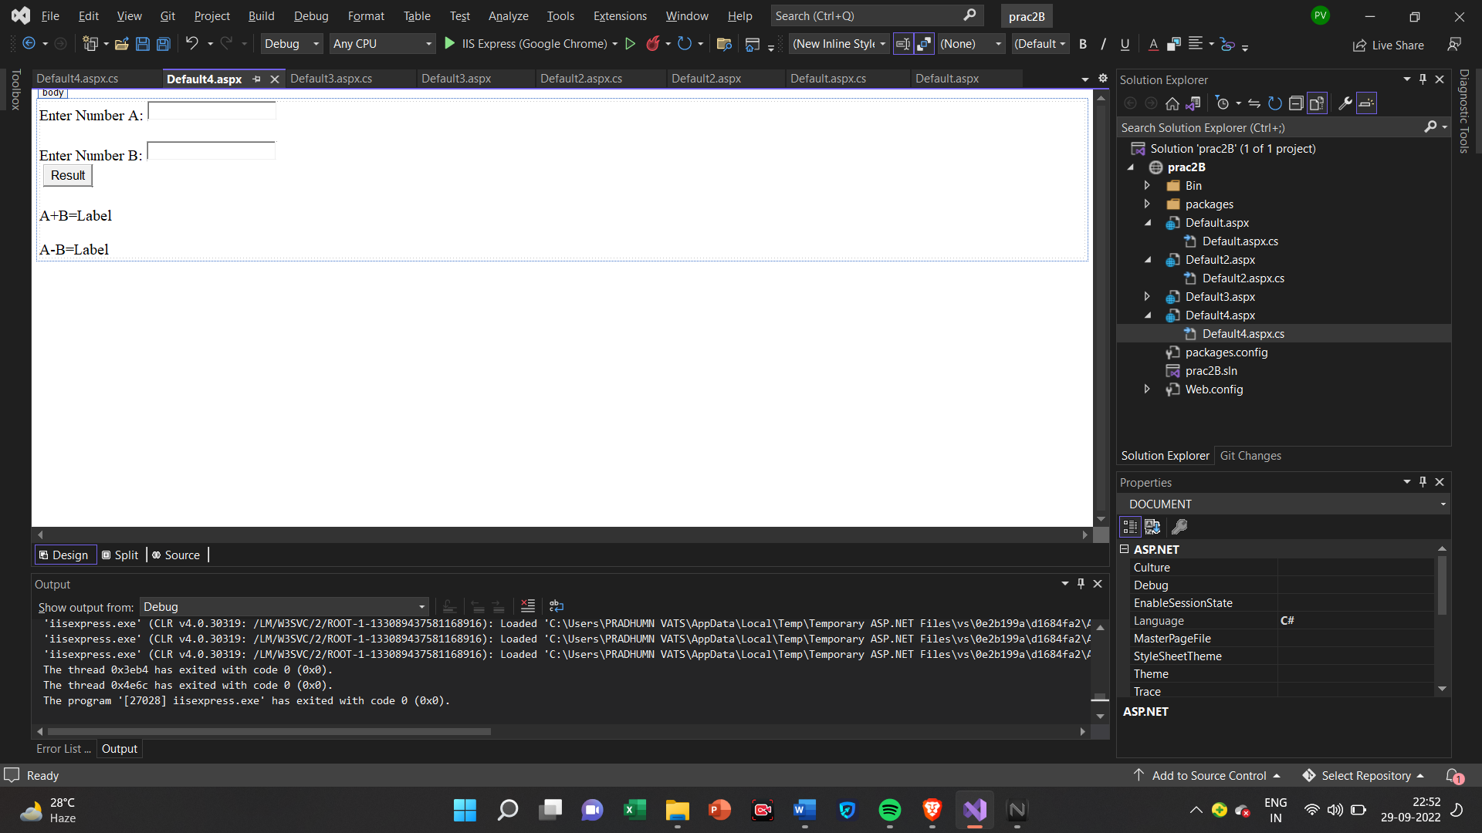

**Default.aspx.cs**

using System;

using System.Collections.Generic;

using System.Linq;

using System.Web;

using System.Web.UI;

using System.Web.UI.WebControls;

public partial class Default4 : System.Web.UI.Page

{

protected void Page_Load(object sender, EventArgs e)

{

}

protected void Button1_Click(object sender, EventArgs e)

{

B s1 = new B();

C s2 = new C();

int m = Convert.ToInt32(TextBox1.Text);

int n = Convert.ToInt32(TextBox2.Text);

int x = s1.add(m, n);

int y = s2.sub(m, n);

Label1.Text = y.ToString();

Label2.Text = x.ToString();

}

}

public class A

{

public int a;

public int b;

}

public class B : A

{

public int add(int Val1, int Val2)

{

a = Val1;

b = Val2;

return a + b;

}

}

public class C : A

{

public int sub(int Val1, int Val2)

{

a = Val1;

b = Val2;

return a - b;

}

}

**Output**

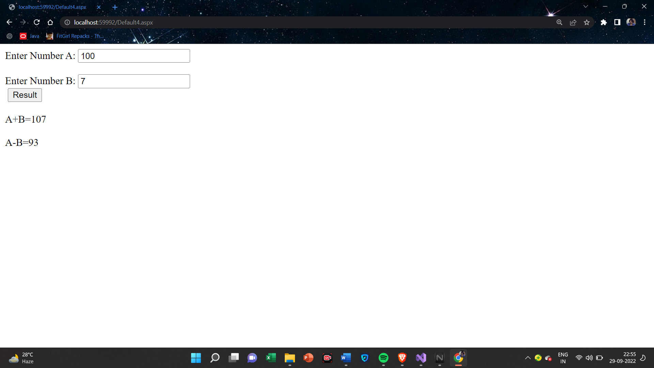

**(iii)Constructor Overloading**

**Default.aspx**

<%@ Page Language="C#" AutoEventWireup="true" CodeFile="Default5.aspx.cs" Inherits="Default5" %>

<!DOCTYPE html>

<html xmlns="http://www.w3.org/1999/xhtml">

<head runat="server">

<title></title>

</head>

<body>

<form id="form1" runat="server">

Constructor Overloading:<br />

<br />

<asp:Label ID="Label1" runat="server" Text="Label"></asp:Label>

<br />

<br />

<asp:Label ID="Label2" runat="server" Text="Label"></asp:Label>

<br />

<br />

<asp:Label ID="Label3" runat="server" Text="Label"></asp:Label>

</form>

</body>

</html>

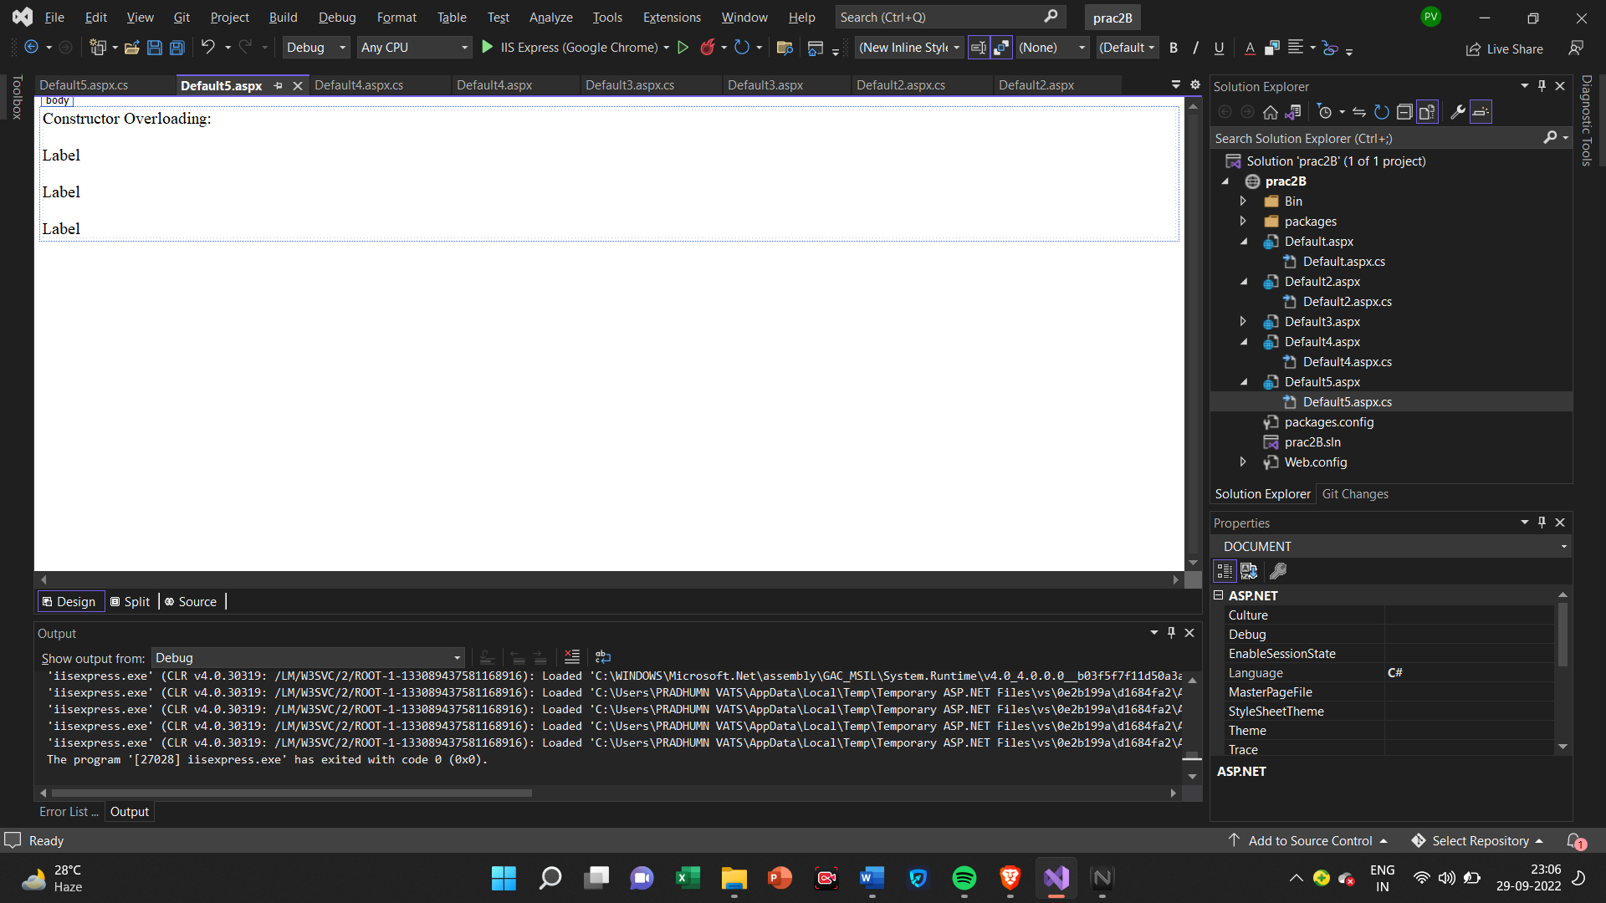

**Default.aspx.cs**

using System;

using System.Collections.Generic;

using System.Linq;

using System.Reflection.Emit;

using System.Web;

using System.Web.UI;

using System.Web.UI.WebControls;

public partial class Default5 : System.Web.UI.Page

{

protected void Page_Load(object sender, EventArgs e)

{

add obj1 = new add(2);

add obj2 = new add(2, 3);

add obj3 = new add(2, 3, 4);

Label1.Text = obj1.r.ToString();

Label2.Text = obj2.r.ToString();

Label3.Text = obj3.r.ToString();

}

}

public class add

{

public int r;

public add(int a)

{

r = a + a;

}

public add(int a, int b)

{

r = a + b;

}

public add(int a, int b, int c)

{

r = a + b + c;

}

}

**Output**

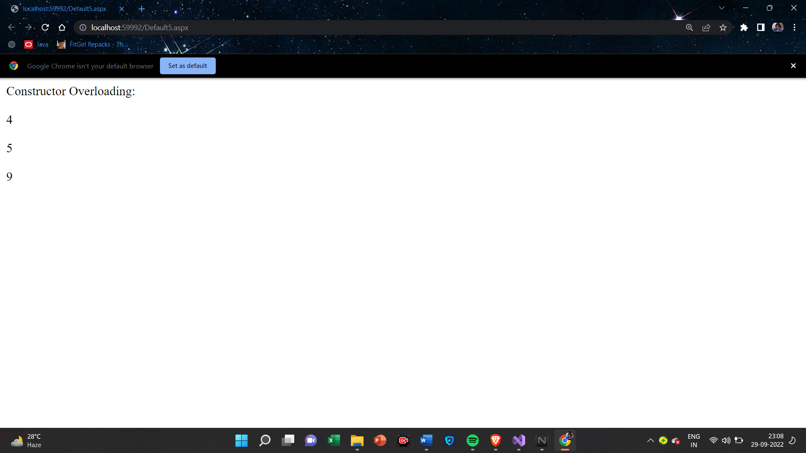

**(iv)Interfaces**

**Default.aspx**

<%@ Page Language="C#" AutoEventWireup="true" CodeFile="Default6.aspx.cs" Inherits="Default6" %>

<!DOCTYPE html>

<html xmlns="http://www.w3.org/1999/xhtml">

<head runat="server">

<title></title>

</head>

<body>

<form id="form1" runat="server">

<div>

Area Of Circle &amp; Rectangle Using Interface<br />

<br />

Area of a Circle:<asp:Label ID="Label2" runat="server" Text="Label"></asp:Label>

<br />

<br />

Area of a Rectangle:<asp:Label ID="Label1" runat="server" Text="Label"></asp:Label>

</div>

</form>

</body>

</html>

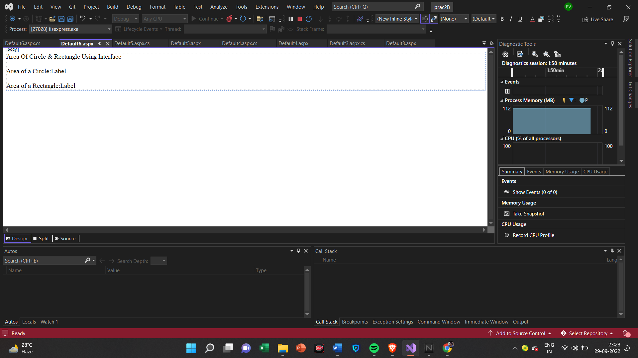

**Default.aspx.cs**

using System;

using System.Collections.Generic;

using System.Linq;

using System.Web;

using System.Web.UI;

using System.Web.UI.WebControls;

public partial class Default6 : System.Web.UI.Page

{

protected void Page_Load(object sender, EventArgs e)

{

Rect r1 = new Rect();

double x = r1.show(3, 4);

Circle c1 = new Circle();

double y = c1.show(3, 4);

Label1.Text = x.ToString();

Label2.Text = y.ToString();

}

}

interface Area

{

double show(double s, double t);

}

class Rect : Area

{

public double show(double s, double t)

{

return s * t;

}

}

class Circle : Area

{

public double show(double s, double t)

{

return (3.14 * s * s);

}

}

**Output**

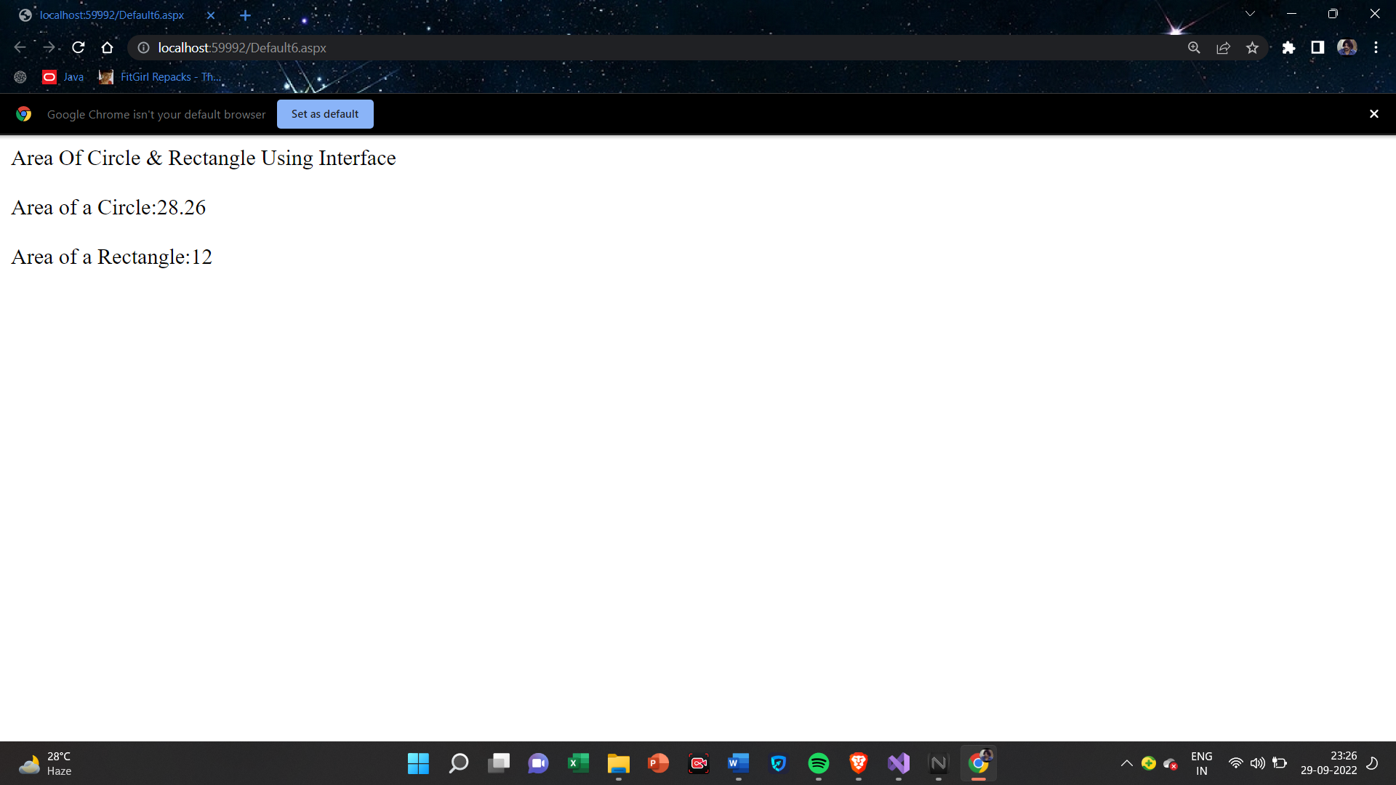

**2(C)Create simple application to Demonstrate use of following Concepts:**

**(i)Using Delegates and events**

**Default.aspx**

<%@ Page Language="C#" AutoEventWireup="true" CodeFile="Default.aspx.cs" Inherits="_Default" %>

<!DOCTYPE html>

<html xmlns="http://www.w3.org/1999/xhtml">

<head runat="server">

<title></title>

</head>

<body>

<form id="form1" runat="server">

<div>

<b><span style="font-size:12.0pt;line-height:107%;

font-family:&quot;Calibri&quot;,sans-serif;mso-ascii-theme-font:minor-latin;mso-fareast-font-family:

Calibri;mso-fareast-theme-font:minor-latin;mso-hansi-theme-font:minor-latin;

mso-bidi-font-family:&quot;Times New Roman&quot;;mso-bidi-theme-font:minor-bidi;

mso-ansi-language:EN-IN;mso-fareast-language:EN-US;mso-bidi-language:AR-SA">Using Delegates and events<br />

<br />

<asp:Label ID="Label1" runat="server" Text="Label"></asp:Label>

<br />

<br />

<span style="font-size: 12.0pt; line-height: 107%; font-family: &quot;Calibri&quot;,sans-serif; mso-ascii-theme-font: minor-latin; mso-fareast-font-family: Calibri; mso-fareast-theme-font: minor-latin; mso-hansi-theme-font: minor-latin; mso-bidi-font-family: &quot;Times New Roman&quot;; mso-bidi-theme-font: minor-bidi; mso-ansi-language: EN-IN; mso-fareast-language: EN-US; mso-bidi-language: AR-SA">

<asp:Label ID="Label2" runat="server" Text="Label"></asp:Label>

</span></span></b>

</div>

</form>

</body>

</html>

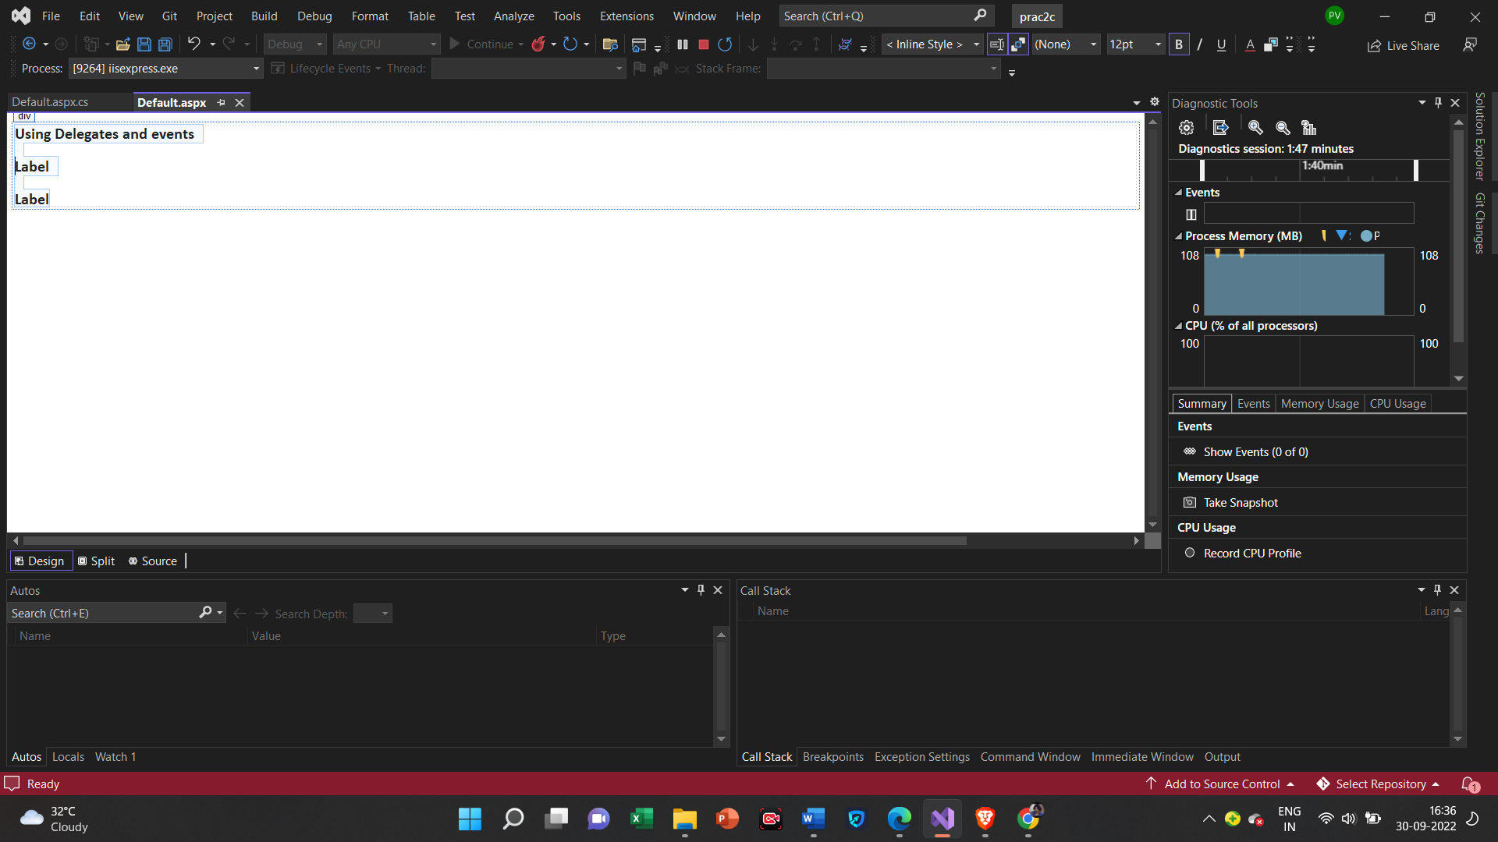

**Default.aspx.cs**

using System;

using System.Collections.Generic;

using System.Linq;

using System.Web;

using System.Web.UI;

using System.Web.UI.WebControls;

public partial class _Default : System.Web.UI.Page

{

public delegate string dele();

public static string display1()

{

string s1 = "Hema";

return s1;

}

public static string display2()

{

string s2 = "Nalawade";

return s2;

}

protected void Page_Load(object sender, EventArgs e)

{

dele d1 = new dele(display1);

d1();

dele d2 = new dele(display2);

d2();

Label1.Text = d1();

Label2.Text = d2();

}

}

**Output**

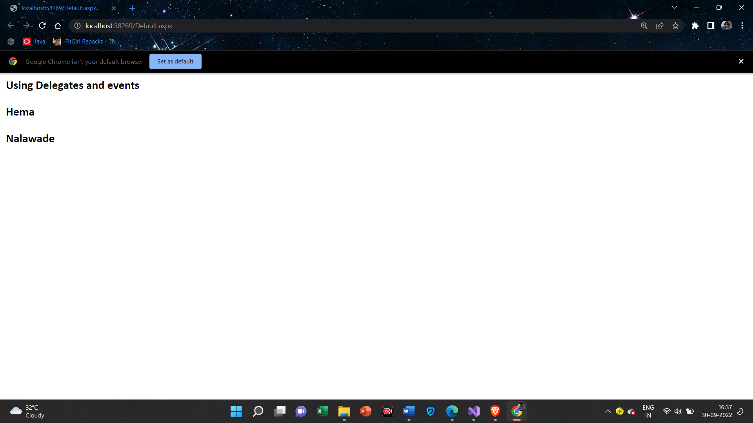

**(ii)Exception Handling**

**Default.aspx**

<%@ Page Language="C#" AutoEventWireup="true" CodeFile="Default2.aspx.cs" Inherits="Default2" %>

<!DOCTYPE html>

<html xmlns="http://www.w3.org/1999/xhtml">

<head runat="server">

<title></title>

</head>

<body>

<form id="form1" runat="server">

<div>

Division Of Two Numbers<br />

<br />

Num1:<asp:TextBox ID="TextBox1" runat="server"></asp:TextBox>

<br />

<br />

<asp:Button ID="Button1" runat="server" OnClick="Button1_Click" Text="Result" />

<br />

<br />

<asp:Label ID="Label1" runat="server" Text="Label"></asp:Label>

</div>

</form>

</body>

</html>

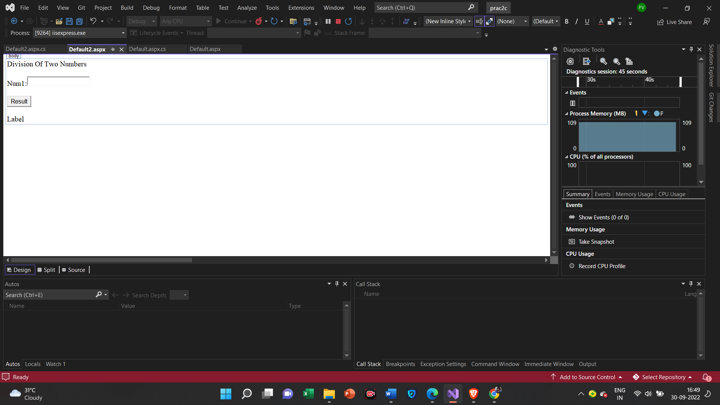

**Default.aspx.cs**

using System;

using System.Collections.Generic;

using System.Linq;

using System.Reflection.Emit;

using System.Web;

using System.Web.UI;

using System.Web.UI.WebControls;

public partial class Default2 : System.Web.UI.Page

{

protected void Page_Load(object sender, EventArgs e)

{

}

protected void Button1_Click(object sender, EventArgs e)

{

try

{

int a = Convert.ToInt32(TextBox1.Text);

int[] b = { 12, 23, 331 };

int result;

result = (b[3] / a);

Label1.Text = "The result is : " + result.ToString();

}

catch (System.DivideByZeroException ex)

{

Label1.Text = ex.ToString();

}

catch (System.IndexOutOfRangeException ex)

{

Label1.Text = ex.ToString();

}

}

}

**Output**

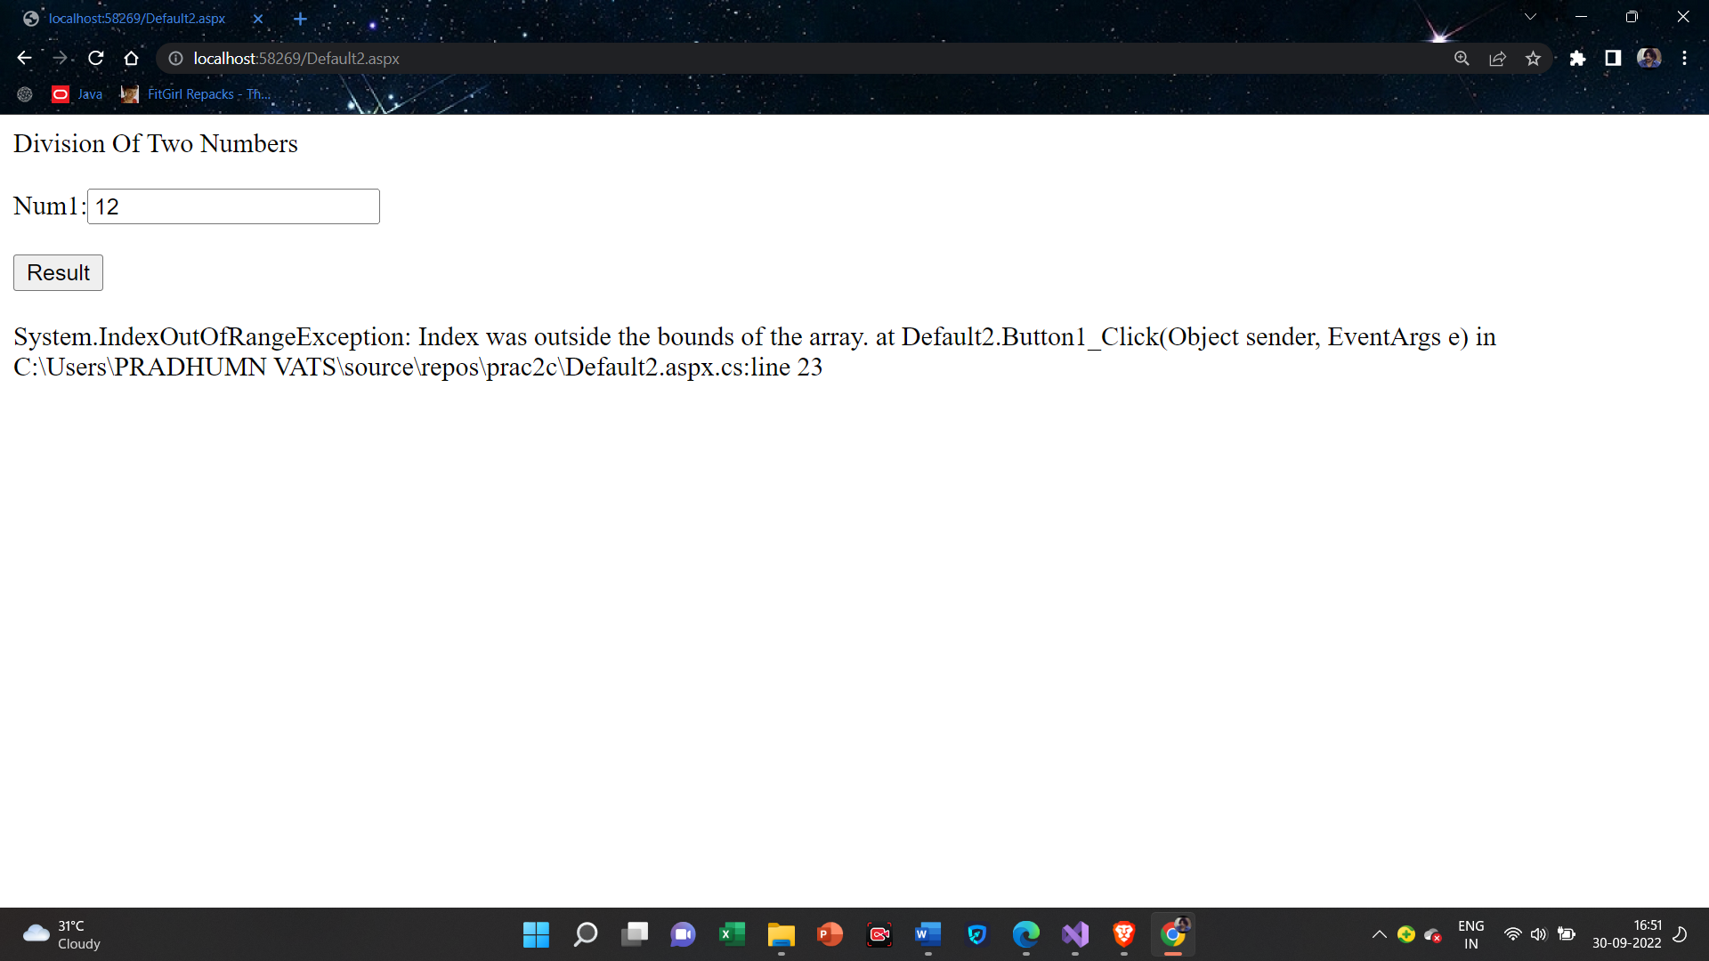

**Practical-3**

**3(A)Create simple web page with various server controls to demonstrate setting and use of their properties. (Example:AutoPostBack) :**

**Default.aspx**

<%@ Page Language="C#" AutoEventWireup="true" CodeFile="Default.aspx.cs" Inherits="_Default" %>

<!DOCTYPE html>

<html xmlns="http://www.w3.org/1999/xhtml">

<head runat="server">

<title></title>

</head>

<body>

<form id="form1" runat="server">

<div>

<asp:ListBox ID="ListBox1" runat="server">

<asp:ListItem Value="c"></asp:ListItem>

<asp:ListItem Value="c++"></asp:ListItem>

<asp:ListItem Value="c#"></asp:ListItem>

<asp:ListItem Value="java"></asp:ListItem>

<asp:ListItem Value="python"></asp:ListItem>

</asp:ListBox>

<asp:Button ID="Button1" runat="server" OnClick="Button1_Click" Text="Show" />

<asp:TextBox ID="TextBox1" runat="server"></asp:TextBox>

<br />

<br />

Selected Color:<asp:RadioButton ID="RadioButton1" runat="server" Text="Red" />

&nbsp;&nbsp;&nbsp;

<asp:RadioButton ID="RadioButton2" runat="server" Text="Green" />

&nbsp;&nbsp;&nbsp;

<asp:RadioButton ID="RadioButton3" runat="server" Text="Blue" />

&nbsp;&nbsp;&nbsp;

<br />

<br />

SelectSpecial Formatting:<asp:CheckBox ID="CheckBox1" runat="server" Text="Bold" />

&nbsp;&nbsp;&nbsp;

<asp:CheckBox ID="CheckBox2" runat="server" Text="Italic" />

&nbsp;&nbsp;&nbsp;

<asp:CheckBox ID="CheckBox3" runat="server" Text="UnderLine" />

<br />

<br />

Select Size:<asp:DropDownList ID="DropDownList1" runat="server">

<asp:ListItem Value="10"></asp:ListItem>

<asp:ListItem Value="12"></asp:ListItem>

<asp:ListItem Value="14"></asp:ListItem>

<asp:ListItem Value="16"></asp:ListItem>

<asp:ListItem></asp:ListItem>

</asp:DropDownList>

<br />

<br />

Select Name:<asp:DropDownList ID="DropDownList2" runat="server">

<asp:ListItem Value="Rahul"></asp:ListItem>

<asp:ListItem Value="Raman"></asp:ListItem>

<asp:ListItem Value="Randy"></asp:ListItem>

<asp:ListItem Value="Ciampa"></asp:ListItem>

</asp:DropDownList>

</div>

</form>

</body>

</html>

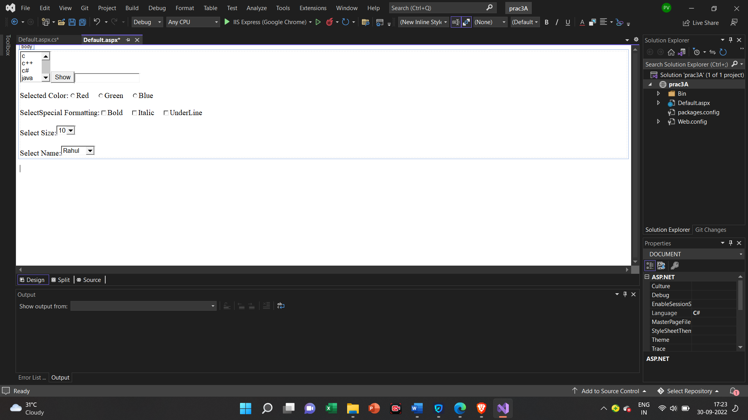

**Default.aspx.cs**

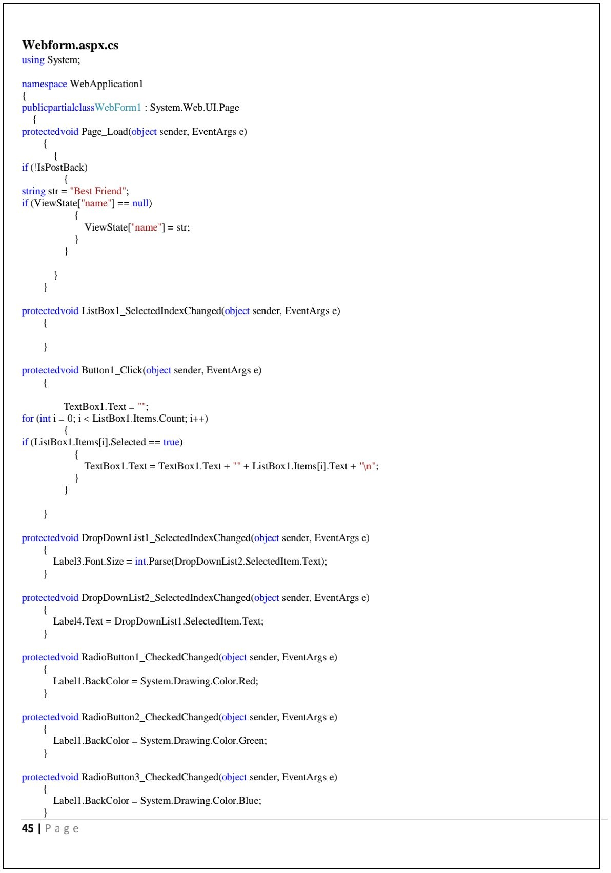

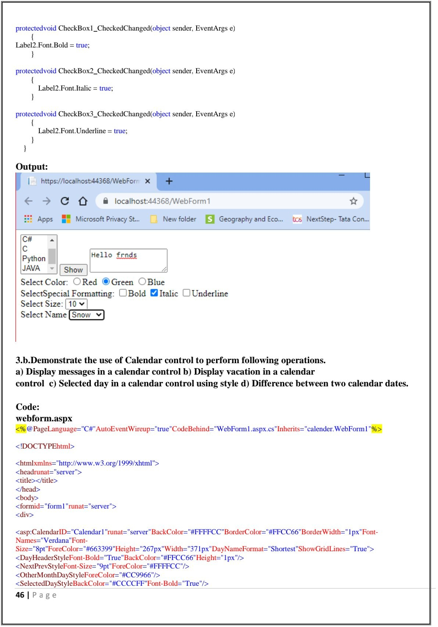

**Output**



**3(B).** **Demonstrate the use of Calendar control to perform following Operations.**

**a) Display messages in a calendar control**

**b) Display vacation in a calendar control**

**c) Selected day in a calendar control using style**

**d) Difference between two calendar dates**

**Default.aspx**

<%@ Page Language="C#" AutoEventWireup="true" CodeFile="Default.aspx.cs" Inherits="_Default" %>

<!DOCTYPE html>

<html xmlns="http://www.w3.org/1999/xhtml">

<head runat="server">

<title></title>

</head>

<body>

<form id="form1" runat="server">

<div>

<asp:Calendar ID="Calendar1" runat="server" BackColor="#FFFFCC" BorderColor="#FFCC66" BorderWidth="1px" DayNameFormat="Shortest" Font-Names="Verdana" Font-Size="8pt" ForeColor="#663399" Height="200px" OnDayRender="Calender1_DayRender" OnSelectionChanged="Calendar1_SelectionChanged" Width="220px" ShowGridLines="True">

<DayHeaderStyle BackColor="#FFCC66" Height="1px" Font-Bold="True" />

<NextPrevStyle Font-Size="9pt" ForeColor="#FFFFCC" />

<OtherMonthDayStyle ForeColor="#CC9966" />

<SelectedDayStyle BackColor="#CCCCFF" Font-Bold="True" />

<SelectorStyle BackColor="#FFCC66" />

<TitleStyle BackColor="#990000" Font-Bold="True" Font-Size="9pt" ForeColor="#FFFFCC" />

<TodayDayStyle BackColor="#FFCC66" ForeColor="White" />

</asp:Calendar>

<br />

Your Selected Date:<asp:Label ID="Label1" runat="server" Text="Label"></asp:Label>

<br />

<br />

Today&#39;s Date:<asp:Label ID="Label2" runat="server" Text="Label"></asp:Label>

<br />

<br />

Ganpati&#39;s Vacation Start:<asp:Label ID="Label3" runat="server" Text="Label"></asp:Label>

<br />

<br />

Days Remaining For Ganpati&#39;s Vacation:<asp:Label ID="Label5" runat="server" Text="Label"></asp:Label>

<br />

<br />

Days Remaining For New Year:<asp:Label ID="Label4" runat="server" Text="Label"></asp:Label>

<br />

<br />

<asp:Button ID="Button1" runat="server" Text="Result" Width="69px" OnClick="Button1_Click" />

&nbsp;&nbsp;&nbsp;

<asp:Button ID="Button2" runat="server" Text="Reset" />

<br />

</div>

</form>

</body>

</html>

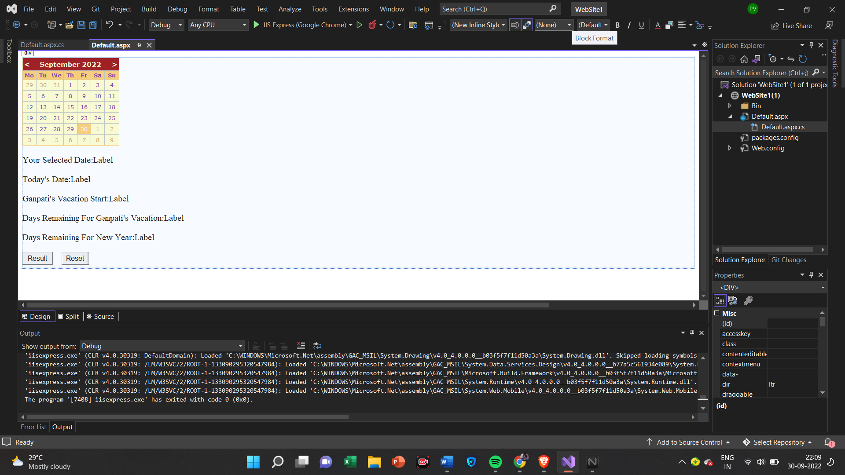

**Default.aspx.cs**

using System;

using System.Collections.Generic;

using System.Globalization;

using System.Linq;

using System.Reflection.Emit;

using System.Web;

using System.Web.UI;

using System.Web.UI.WebControls;

public partial class _Default : System.Web.UI.Page

{

protected void Page_Load(object sender, EventArgs e)

{

}

protected void Button1_Click(object sender, EventArgs e)

{

Calendar1.Caption = "kalnirnay";

Calendar1.FirstDayOfWeek = FirstDayOfWeek.Sunday;

Calendar1.NextPrevFormat = NextPrevFormat.ShortMonth;

Calendar1.TitleFormat = TitleFormat.Month;

Label1.Text = Calendar1.SelectedDate.Date.ToString();

Label2.Text = Calendar1.TodaysDate.ToShortDateString();

Label3.Text = "2-9-2019";

TimeSpan d = new DateTime(2019, 9, 2) - DateTime.Now;

Label4.Text = d.Days.ToString();

TimeSpan d1 = new DateTime(2019, 12, 31) - DateTime.Now;

Label5.Text = d1.Days.ToString();

if (Calendar1.SelectedDate.ToShortDateString() == "2-9-2019")

Label3.Text = "<b>Ganpati Festival start</b>";

if (Calendar1.SelectedDate.ToShortDateString() == "11-9-2019") Label3.Text = "<b>Ganpati Festival end</b>";

}

protected void Calendar1_SelectionChanged(object sender, EventArgs e)

{

if (e.Day.Date.Day = 5 && e.Day.Date.Month = 9)

{

e.Cell.BackColor = System.Drawing.Color.Red;

Label a = new Label();

e.Cell.Controls.Add(a);

a.Text = "<br>Teachers Day";

e.Cell.Controls.Add(a);

}

if (!(e.Day.Date.Day = 2 && e.Day.Date.Month == 9))

{

Calendar1.SelectedDate = new DateTime(2019, 9, 11);

Calendar1.SelectedDates = SelectRange(Calendar1.SelectedDate, Calendar1.SelectedDate.AddDays(10));

Label lbl1 = new Label();

lbl1.Text = "<br>Ganpati";

e.Cell.Controls.Add(lbl1);

}

}

}

**Output**

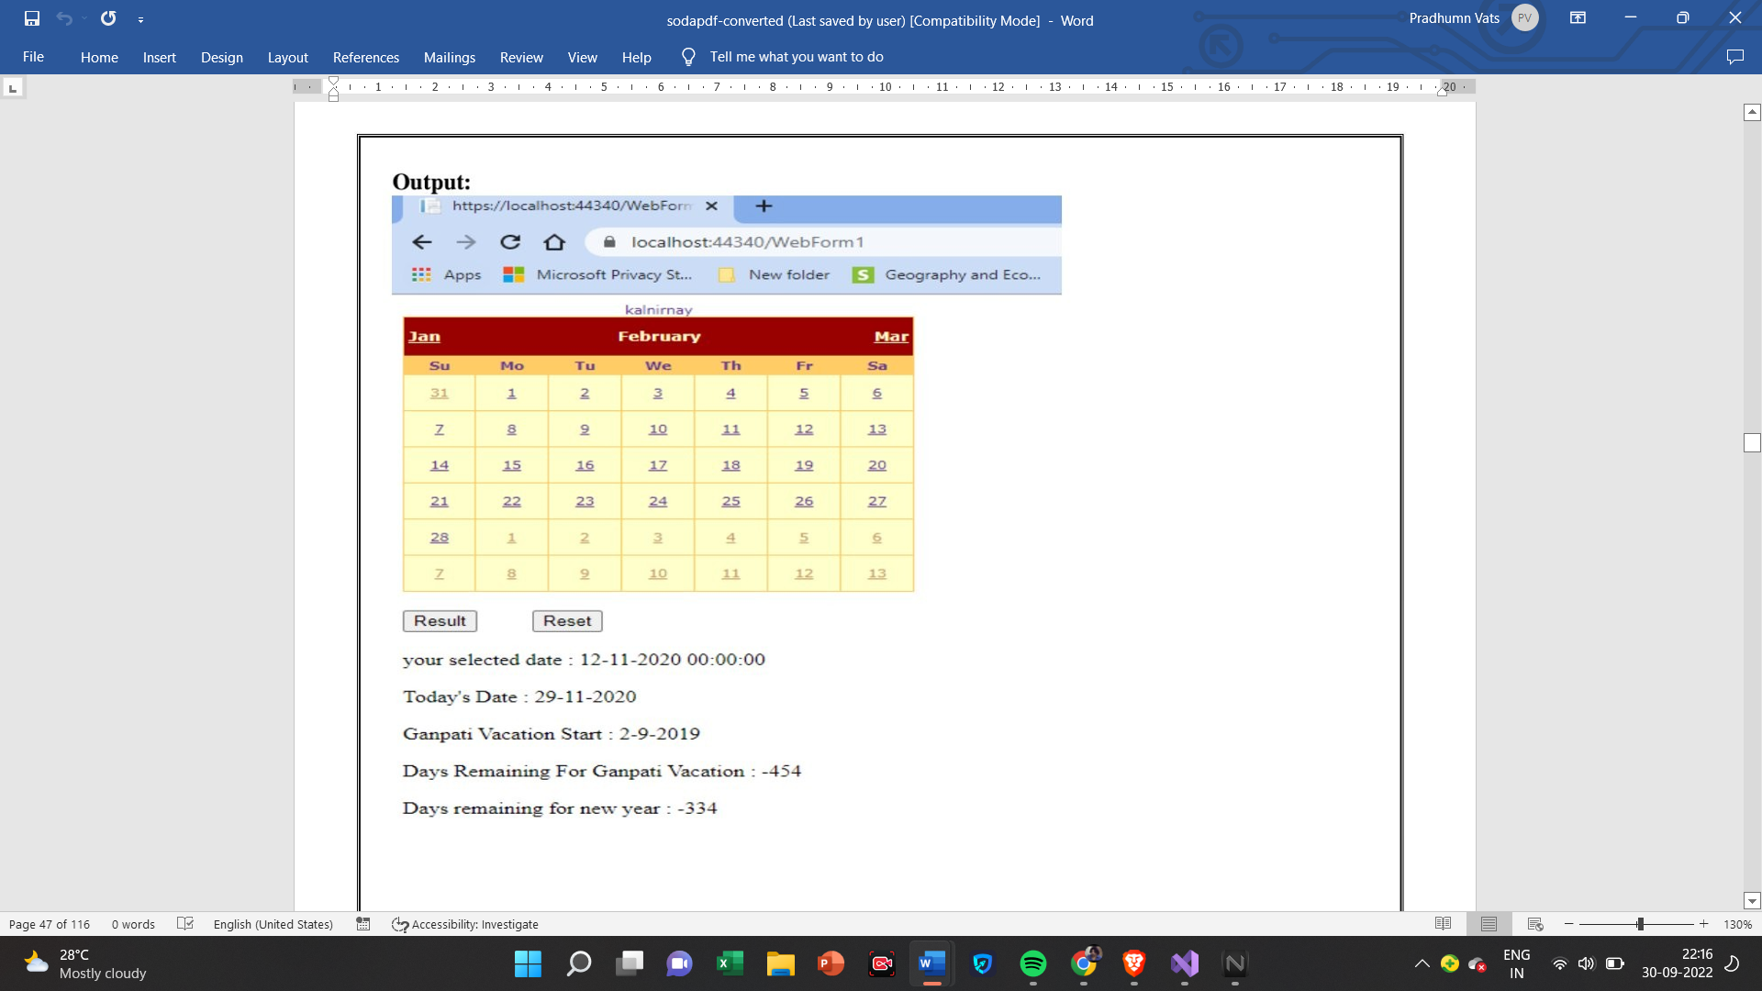

**3(C):Demonstrate the use of Treeview control perform TreeView Operation**

**XML FIlE**

<?xml version="1.0" encoding="utf-8" ?>

<studentdetail>

<student>

<sid>1</sid>

<sname>Tushar</sname>

<sclass>TYIT</sclass>

</student>

<student>

<sid>2</sid>

<sname>Sonali</sname>

<sclass>TYCS</sclass>

</student>

<student>

<sid>3</sid>

<sname>Yashashree</sname>

<sclass>tYIT</sclass>

</student>

<student>

<sid>4</sid>

<sname>Vedshree</sname>

<sclass>TYCS</sclass>

</student>

</studentdetail>

**Default.aspx**

<html xmlns="http://www.w3.org/1999/xhtml">

<head runat="server">

<title></title>

</head>

<body>

Treeview control navigation

<br />

Fetch Datalist Using XML:

<asp:DataList ID="DataList1" runat="server">

<ItemTemplate>

<table class="table" border="1">

<tr>

<td>

Roll Num:<%#Eval("sid") %><br />

Name:<%#Eval("sname") %><br />

Class:<%#Eval("sclass") %><br />

</td>

</tr>

</table>

</ItemTemplate>

</asp:DataList>

<asp:XmlDataSource ID="XmlDataSource1" runat="server" DataFile="~/XMLFile.xml" OnTransforming="XmlDataSource1_Transforming"></asp:XmlDataSource>

</body>

</html>

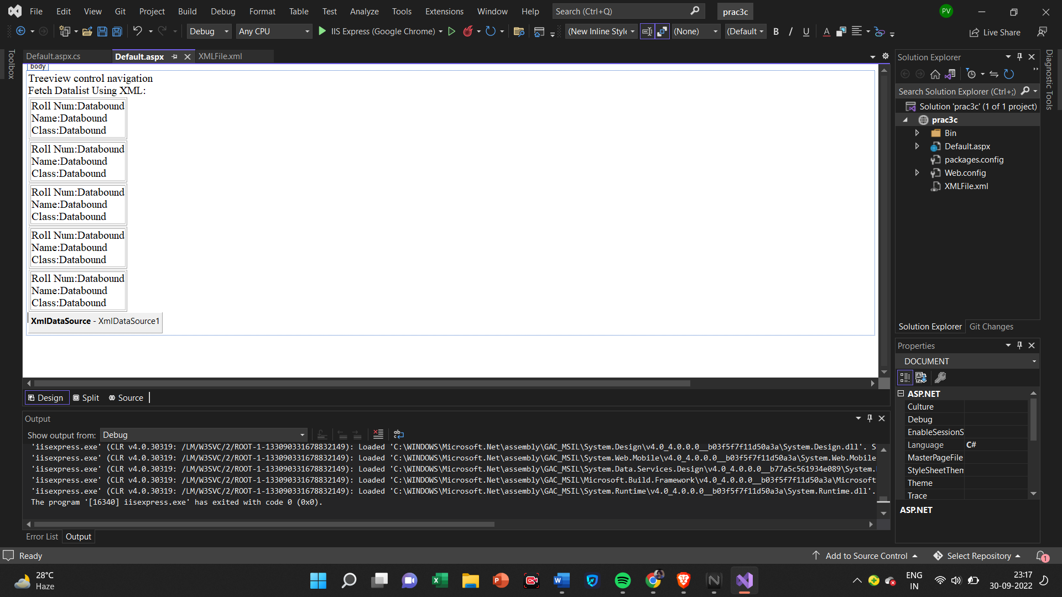

**Default.aspx.cs**

using System;

using System.Collections.Generic;

using System.Data;

using System.Linq;

using System.Web;

using System.Web.UI;

using System.Web.UI.WebControls;

public partial class _Default : System.Web.UI.Page

{

protected void Page_Load(object sender, EventArgs e)

{

if(!IsPostBack)

{

BindData();

}

}

protected void BindData()

{

DataSet ds = new DataSet();

ds.ReadXml(Server.MapPath("XMLFile.xml"));

if (ds != null && ds.HasChanges())

{

DataList1.DataSource = ds;

DataList1.DataBind();

}

else

{

DataList1.DataBind();

}

}

}

**Output**

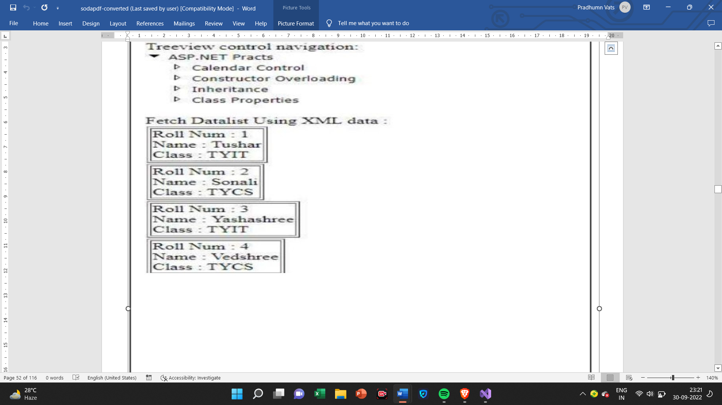

**Practical-4**

**4(A):Create a Registration form to demonstrate use of various Validation Controls.**

**Default.aspx**

<%@ Page Language="C#" AutoEventWireup="true" CodeFile="Default2.aspx.cs" Inherits="Default2" %>

<!DOCTYPE html>

<html xmlns="http://www.w3.org/1999/xhtml">

<head runat="server">

<title></title>

<script runat="server">

void Button1_Click(object sender, EventArgs e)

{

if (Page.IsValid)

{

Label1.Text = "Thank You!";

}

else

{

Label1.Text = "The text must be exactly 8 charcters Long";

}

void ServerValidation(object source,ServerValidateEventArgs e)

{

if(e.Value.Length==8)

{

e.IsValid = true;

}

else

{

e.IsValid = false;

}

}

}

</script>

</head>

<body>

<form id="form1" runat="server">

<div>

Your Name:<asp:TextBox ID="TextBox1" runat="server" Height="26px"></asp:TextBox>

&nbsp;&nbsp;&nbsp;

<asp:RequiredFieldValidator ID="RequiredFieldValidator1" runat="server" ErrorMessage="Please Enter Name!"></asp:RequiredFieldValidator>

<br />

<br />

Enter Age:<asp:TextBox ID="TextBox2" runat="server"></asp:TextBox>

<asp:RangeValidator ID="RangeValidator1" runat="server" ErrorMessage="Not Valid Age"></asp:RangeValidator>

<br />

<br />

Password:<asp:TextBox ID="TextBox3" runat="server"></asp:TextBox>

<br />

<br />

ReEnter Password:<asp:TextBox ID="TextBox4" runat="server"></asp:TextBox>

<br />

<asp:CompareValidator ID="CompareValidator1" runat="server" ErrorMessage="Password Must Mach!"></asp:CompareValidator>

<br />

<br />

Email ID:<asp:TextBox ID="TextBox5" runat="server"></asp:TextBox>

<asp:RegularExpressionValidator ID="RegularExpressionValidator1" runat="server" ErrorMessage="Please Enter Valid Email Address"></asp:RegularExpressionValidator>

<br />

<br />

Custox Text:<asp:TextBox ID="TextBox6" runat="server"></asp:TextBox>

<asp:CustomValidator ID="CustomValidator1" runat="server" ClientValidationFunction="ServerValidation" ErrorMessage="The Text Must be Exactly 8 Characters long!"></asp:CustomValidator>

<br />

<br />

<asp:Button ID="Button1" runat="server" OnClick="Button1_Click" style="height: 29px" Text="Validate" />

<asp:Label ID="Label1" runat="server" Text="Label"></asp:Label>

<asp:ValidationSummary ID="ValidationSummary1" runat="server" />

<br />

</div>

</form>

</body>

</html>

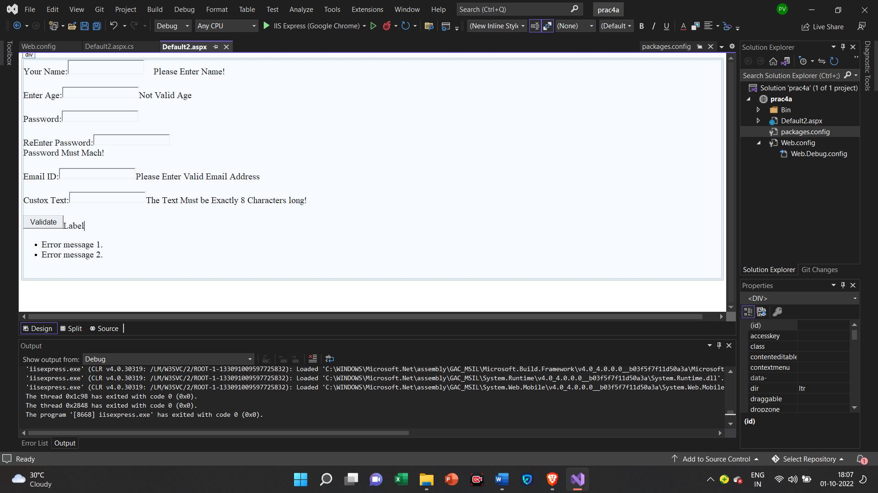

**Web.config**

<?xml version="1.0"?>

<!--

For more information on how to configure your ASP.NET application, please visit

https://go.microsoft.com/fwlink/?LinkId=169433

-->

<configuration>

<appSettings>

<add key="ValidationSettings:UnobtrusiveValidationMode" value="None"/>

</appSettings>

<system.web>

<compilation debug="true" targetFramework="4.7.2" />

<httpRuntime targetFramework="4.7.2" />

</system.web>

<system.codedom>

<compilers>

<compiler language="c#;cs;csharp" extension=".cs" type="Microsoft.CodeDom.Providers.DotNetCompilerPlatform.CSharpCodeProvider, Microsoft.CodeDom.Providers.DotNetCompilerPlatform, Version=2.0.1.0, Culture=neutral, PublicKeyToken=31bf3856ad364e35" warningLevel="4" compilerOptions="/langversion:default /nowarn:1659;1699;1701" />

<compiler language="vb;vbs;visualbasic;vbscript" extension=".vb" type="Microsoft.CodeDom.Providers.DotNetCompilerPlatform.VBCodeProvider, Microsoft.CodeDom.Providers.DotNetCompilerPlatform, Version=2.0.1.0, Culture=neutral, PublicKeyToken=31bf3856ad364e35" warningLevel="4" compilerOptions="/langversion:default /nowarn:41008 /define:_MYTYPE=\&quot;Web\&quot; /optionInfer+" />

</compilers>

</system.codedom>

</configuration>

**Output**

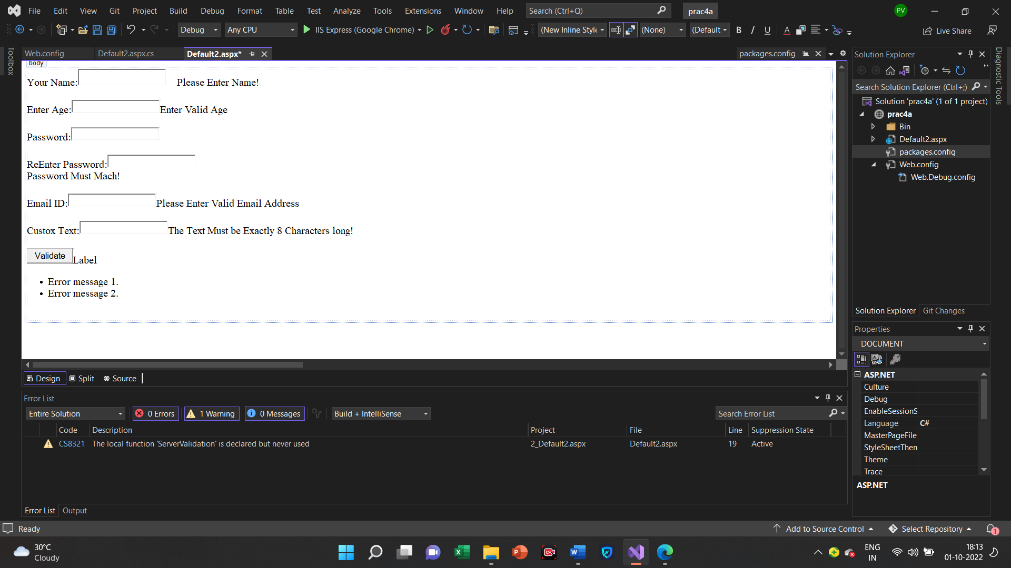

**4(B):Create Web Form to demonstrate use of Adrotator Controls.**

**Default.aspx**

<%@ Page Language="C#" %>

<!DOCTYPE html>

<script runat="server">

</script>

<html xmlns="http://www.w3.org/1999/xhtml">

<head runat="server">

<title></title>

</head>

<body>

<form id="form1" runat="server">

<div>

<asp:AdRotator ID="AdRotator1" runat="server" DataSourceID="XmlDataSource1" />

<asp:XmlDataSource ID="XmlDataSource1" runat="server" DataFile="~/XMLFile.xml"></asp:XmlDataSource>

</div>

</form>

</body>

</html>

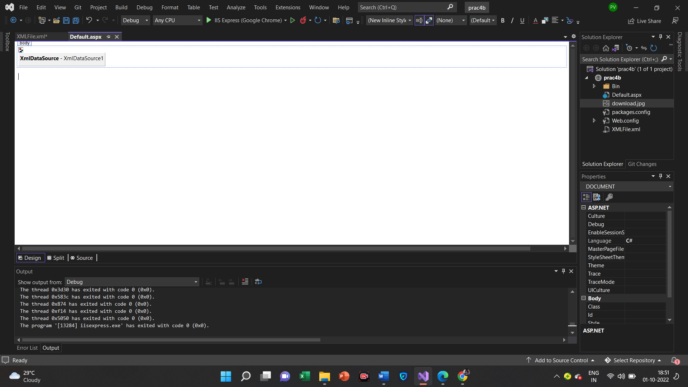

**XMLFILE.xml**

<?xml version="1.0" encoding="utf-8" ?>

<Advertisements>

<Ad>

<ImageUrl>download.jpg</ImageUrl>

<AlternateText>Invalid</AlternateText>

<NavigateUrl></NavigateUrl>

<Keyword>Computer</Keyword>

</Ad>

</Advertisements>

**Output**

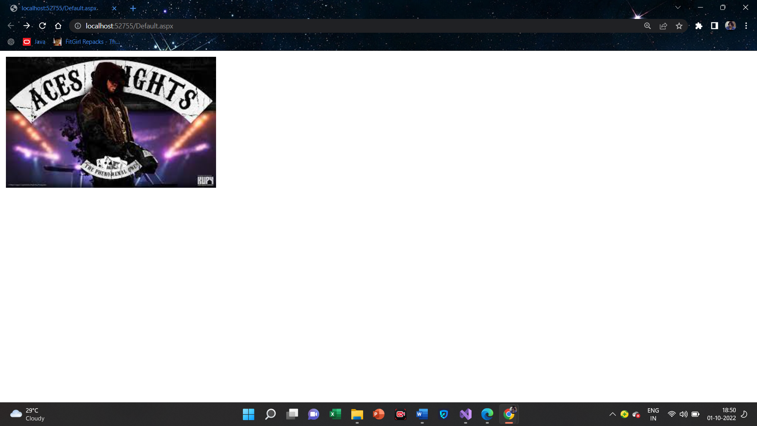

**4(C):Create Web form to demonstrate use user Controls.**

**Default.aspx**

<%@ Control Language="C#" AutoEventWireup="true" CodeFile="footer.ascx.cs" Inherits="footer" %>

<table>

<tr>

<td align="center" style="font-family:Cambria; background-color:#00CCFF; font-size:14px; text-decoration:blink; color:#FF0000; font-weight:bold;">

New User Control</td>

</tr>

</table>

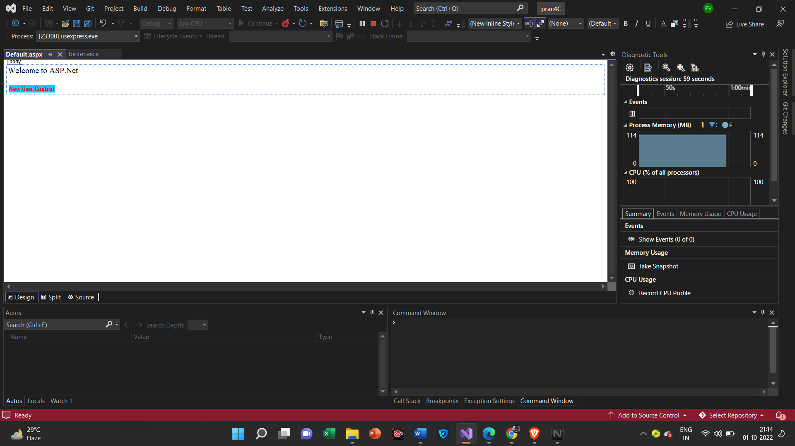

**footer.ascx**

<%@ Control Language="C#" AutoEventWireup="true" CodeFile="footer.ascx.cs" Inherits="footer" %>

<table>

<tr>

<td align="center" style="font-family:Cambria; background-color:#00CCFF; font-size:14px; text-decoration:blink; color:#FF0000; font-weight:bold;">

New User Control</td>

</tr>

</table>

**Output**

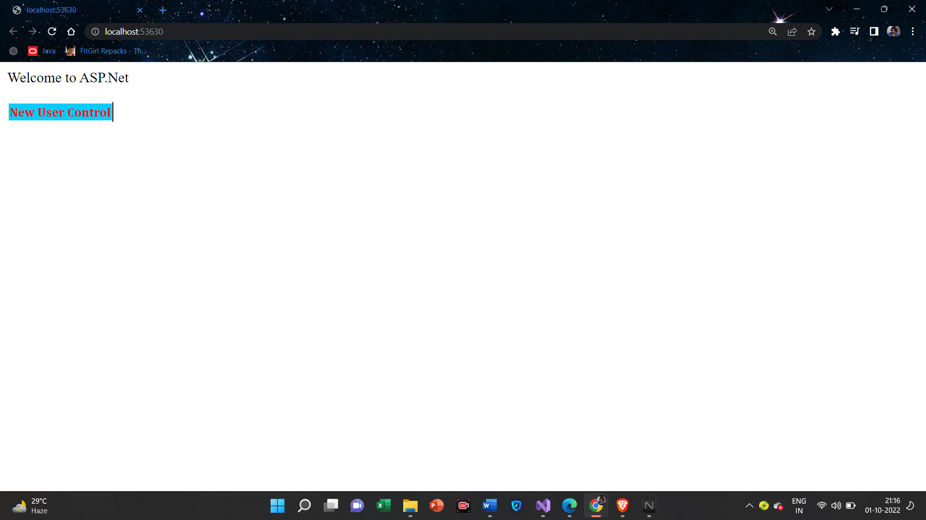

**Practical-5**

**5(A):Create Web form to demonstrate use of Website Navigation controls and Site Map.**

**Web.sitemap**

<?xml version="1.0" encoding="utf-8" ?>

<siteMap xmlns="http://schemas.microsoft.com/AspNet/SiteMap-File-1.0" >

<siteMapNode url="prac5a.aspx" title="Home" description="Homepage of our website">

<siteMapNode url="clsProp.aspx" title="Page2" description="Page2"/>

<siteMapNode url="Default2.aspx" title="Page3" description="Page3"/>

<siteMapNode url="Default3.aspx" title="Page4" description="Page4" />

</siteMapNode>

</siteMap>

**Default3.aspx**

<%@ Page Language="C#" AutoEventWireup="true" CodeFile="Default3.aspx.cs" Inherits="Default3" %>

<!DOCTYPE html>

<html xmlns="http://www.w3.org/1999/xhtml">

<head runat="server">

<title></title>

</head>

<body>

<form id="form1" runat="server">

<div>

<asp:SiteMapDataSource ID="SiteMapDataSource1" runat="server" />

<asp:Menu ID="Menu1" runat="server" DataSourceID="SiteMapDataSource1">

</asp:Menu>

</div>

</form>

</body>

</html>

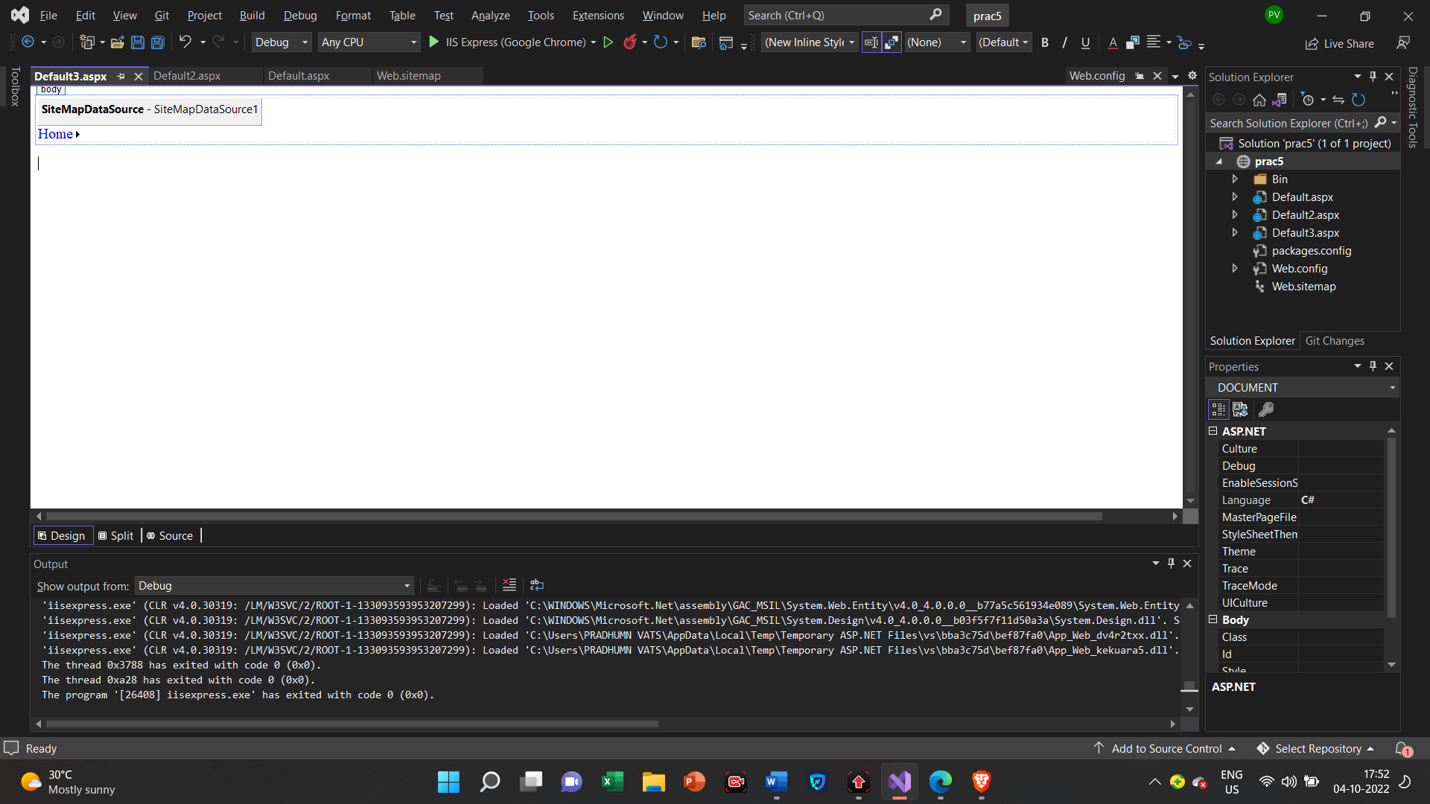

**Output**

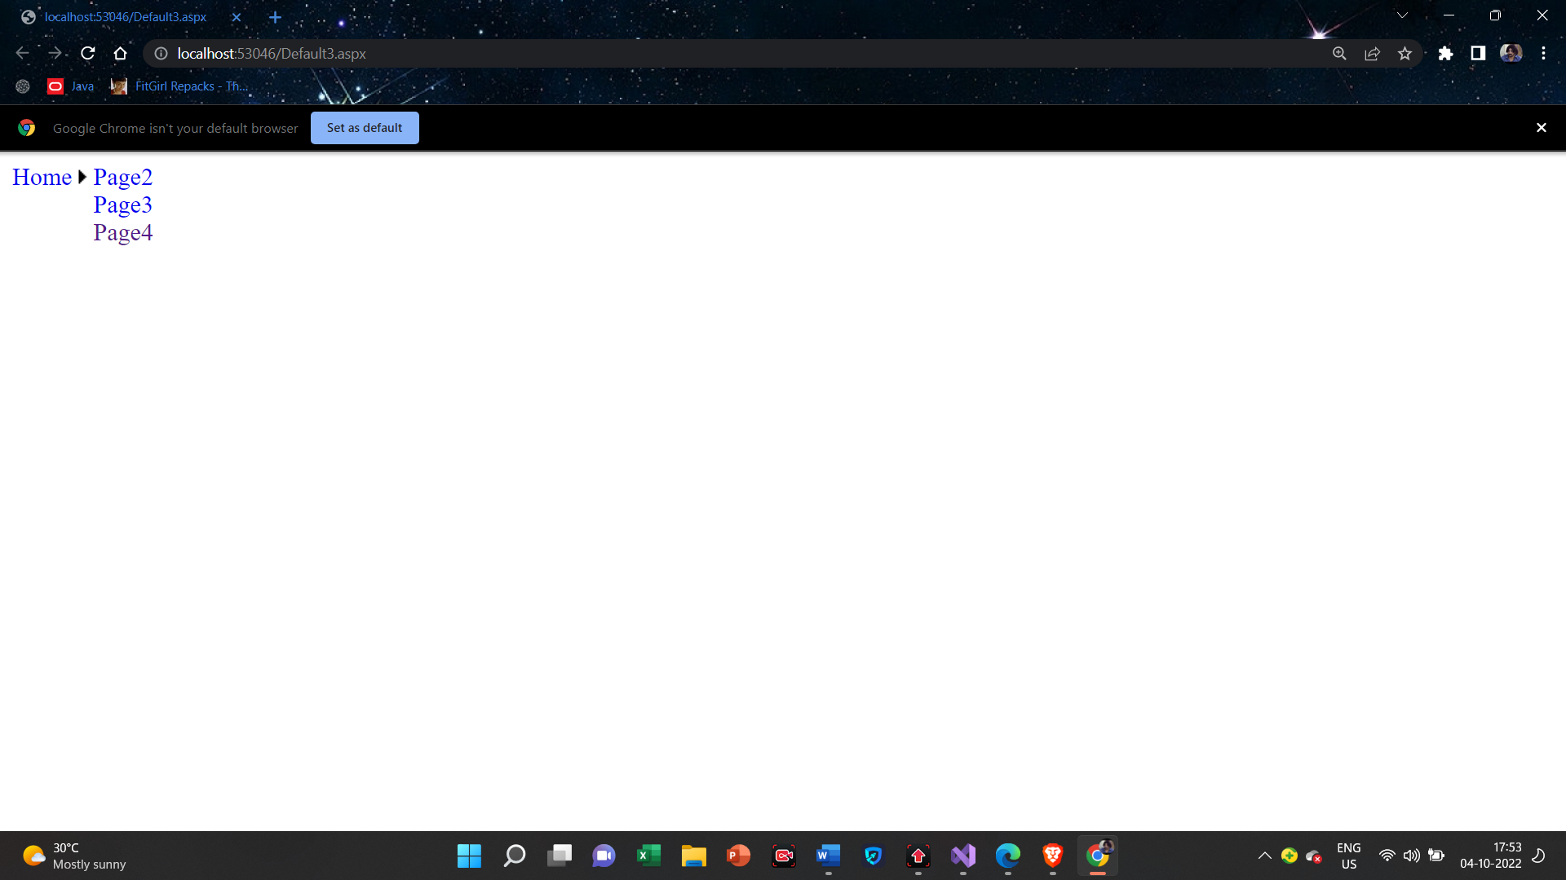

**5(B):Create Web Application to demonstrate use of Master Page with applying Styles and Themes for a page beautification.**

**SkinFile.skin**

<asp:Label runat="server" ForeColor="red" Font-Size="14pt" Font-Names="Verdana"/>

<asp:button runat="server" Borderstyle="Solid" Borderwidth="2px" Bordercolor="Blue" Backcolor="Orange"/>

**StyleSheet.css**

body

{

background-color: Lime;

font-family: Cambria;

font-size: 18px;

}

**MasterPage.master**

<%@ Master Language="C#" AutoEventWireup="true" CodeFile="MasterPage.master.cs" Inherits="MasterPage" %>

<!DOCTYPE html>

<html>

<head runat="server">

<title></title>

<asp:ContentPlaceHolder id="head" runat="server">

</asp:ContentPlaceHolder>

<link href="StyleSheet.css" rel="stylesheet" type="text/css"/>

</head>

<body>

<form id="form1" runat="server">

<div>

<asp:ContentPlaceHolder id="ContentPlaceHolder1" runat="server">

</asp:ContentPlaceHolder>

<asp:ContentPlaceHolder id="ContentPlaceHolder2" runat="server">

</asp:ContentPlaceHolder>

</div>

</form>

</body>

</html>

**Default.aspx**

<%@ Page Theme="Theme1" Title="" Language="C#" MasterPageFile="~/MasterPage.master" AutoEventWireup="true" CodeFile="demo.aspx.cs" Inherits="demo" %>

<asp:Content ID="Content1" ContentPlaceHolderID="head" Runat="Server">

</asp:Content>

<asp:Content ID="Content2" ContentPlaceHolderID="ContentPlaceHolder1" Runat="Server">

<asp:Label ID="Label1" Runat="server" Text="S.M.Shetty College Of Powai"></asp:Label><br/><br/>

</asp:Content>

<asp:Content ID="Content3" ContentPlaceHolderID="ContentPlaceHolder2" Runat="Server">

<asp:Label ID="Label2" Runat="server" Text="T.Y.I.T-A"></asp:Label><br/><br/>

<asp:Label ID="Label3" Runat="server" Text="Label"></asp:Label><br/><br/>

<asp:Button ID="Button1" Runat="server" Text="Demo" OnClick="Button1_Click" />

</asp:Content>

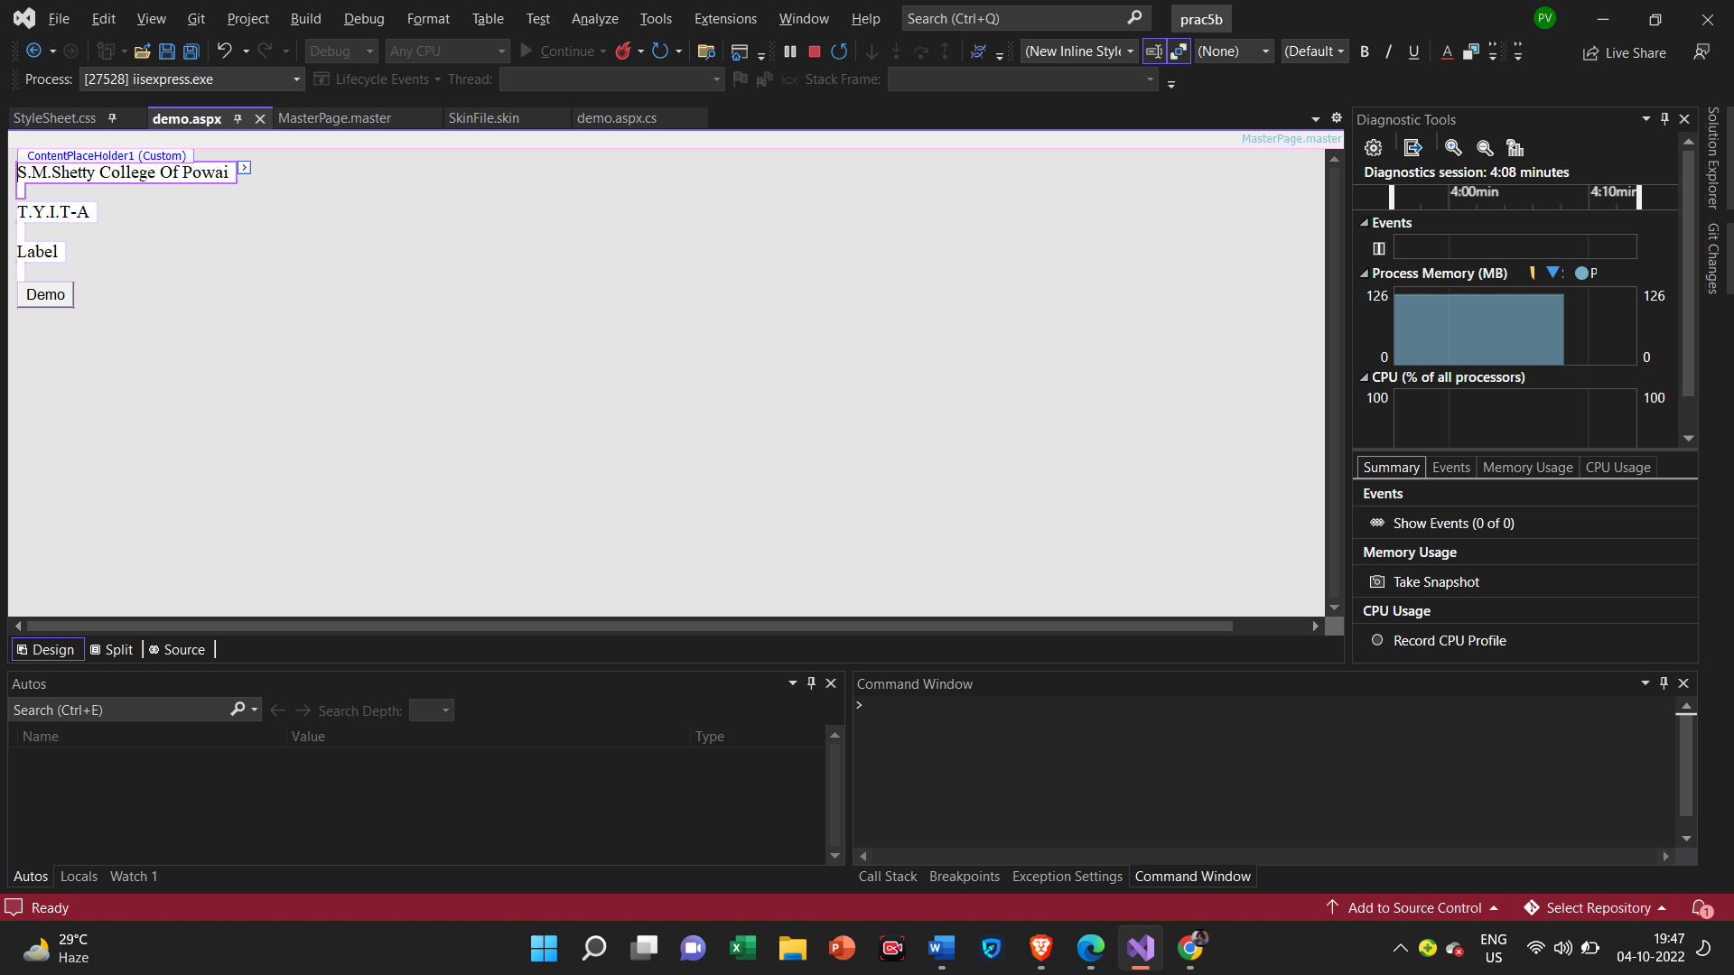

**Default.aspx.cs**

using System;

using System.Collections.Generic;

using System.Linq;

using System.Web;

using System.Web.UI;

using System.Web.UI.WebControls;

public partial class demo : System.Web.UI.Page

{

protected void Page_Load(object sender, EventArgs e)

{

}

protected void Button1_Click(object sender, EventArgs e)

{

Label3.Text = "The Beast Incarnate";

}

}

**Output**

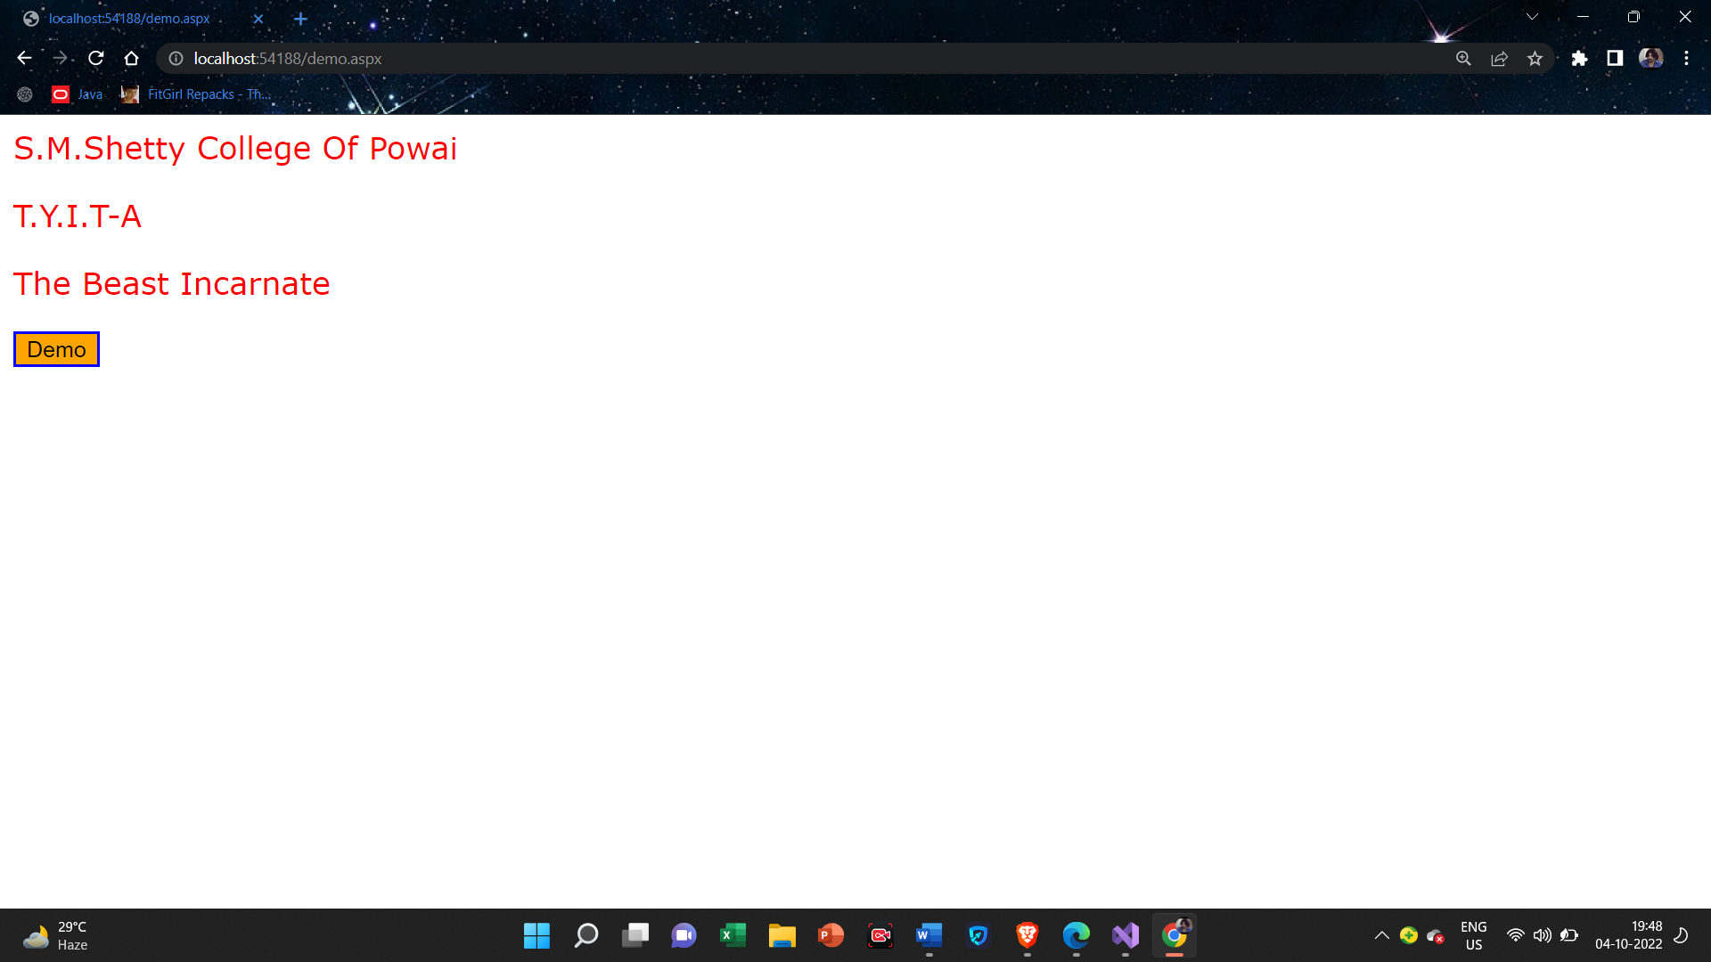

**5(C):Create Web Application to demonstrate various States of ASP.NET Pages.**

**ViewState**

**Default.aspx**

<%@ Page Language="C#" AutoEventWireup="true" CodeFile="Default.aspx.cs" Inherits="_Default" %>

<!DOCTYPE html>

<html xmlns="http://www.w3.org/1999/xhtml">

<head runat="server">

<title></title>

</head>

<body>

<form id="form1" runat="server">

<div>

&nbsp;<asp:Label ID="Label1" runat="server" Text="0"></asp:Label>

<br />

<asp:Label ID="Label2" runat="server" Text="Label"></asp:Label>

<br />

<asp:Button ID="Button1" runat="server" OnClick="Button1_Click" Text="Button" />

</div>

</form>

</body>

</html>

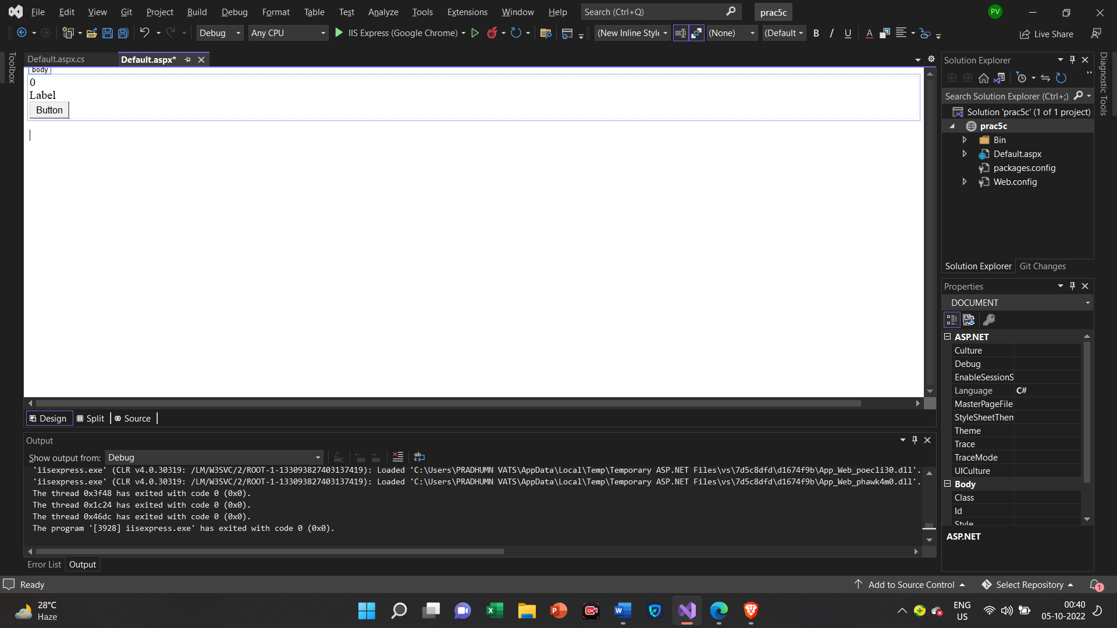

**Default.aspx.cs**

using System;

using System.Collections.Generic;

using System.Linq;

using System.Web;

using System.Web.UI;

using System.Web.UI.WebControls;

public partial class _Default : System.Web.UI.Page

{

protected void Page_Load(object sender, EventArgs e)

{

if(!IsPostBack)

{

string str = "Pradhumn Vats";

if (ViewState["nam"]==null)

{

ViewState["nam"] = str;

}

}

}

protected void Button1_Click(object sender, EventArgs e)

{

Label1.Text = (Convert.ToInt16(Label1.Text)+ 1).ToString();

Label2.Text = ViewState["nam"].ToString();

}

protected void Button2_Click(object sender, EventArgs e)

{

Response.Write(ViewState["username"].ToString());

}

}

**Output**

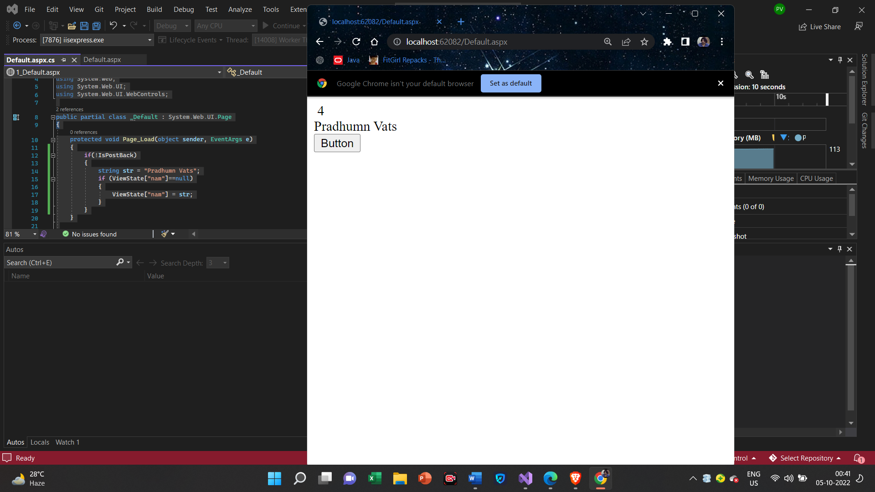

**Query String**

**Default.aspx**

<%@ Page Language="C#" AutoEventWireup="true" CodeFile="Default2.aspx.cs" Inherits="Default2" %>

<!DOCTYPE html>

<html xmlns="http://www.w3.org/1999/xhtml">

<head runat="server">

<title></title>

</head>

<body>

<form id="form1" runat="server">

<div>

Query String Example<br />

<br />

User Id:<asp:TextBox ID="TextBox1" runat="server"></asp:TextBox>

<br />

<br />

User Name:<asp:TextBox ID="TextBox2" runat="server"></asp:TextBox>

<br />

<br />

<asp:Button ID="Button1" runat="server" OnClick="Button1_Click" Text="Button" />

</div>

</form>

</body>

</html>

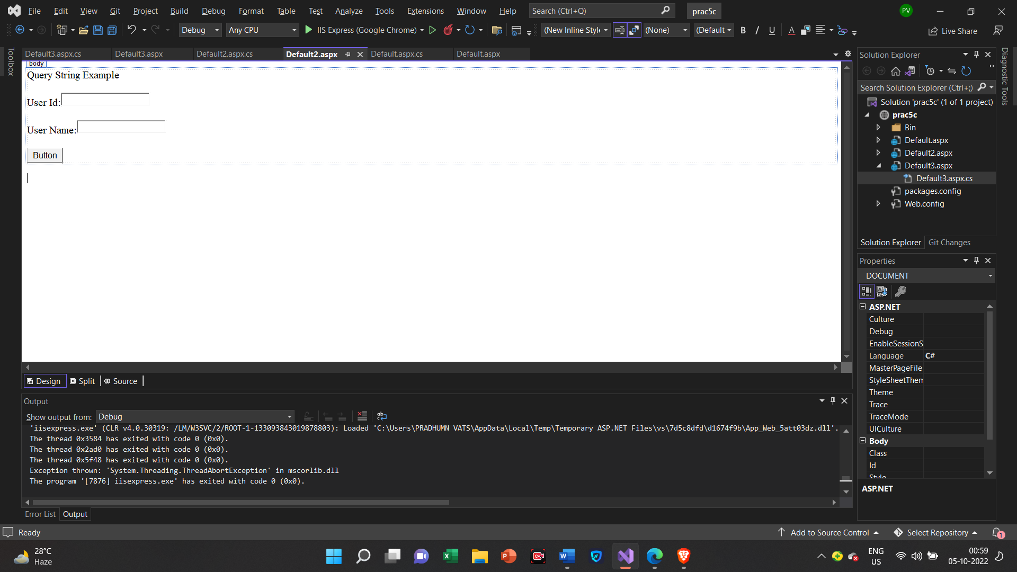

**Default3.aspx.cs**

using System;

using System.Collections.Generic;

using System.Linq;

using System.Web;

using System.Web.UI;

using System.Web.UI.WebControls;

public partial class Default2 : System.Web.UI.Page

{

protected void Page_Load(object sender, EventArgs e)

{

}

protected void Button1_Click(object sender, EventArgs e)

{

Response.Redirect("Default3.aspx?UserId=" + TextBox1.Text + "&UserName=" + TextBox2.Text);

}

}

**Default.aspx**

<%@ Page Language="C#" AutoEventWireup="true" CodeFile="Default3.aspx.cs" Inherits="Default3" %>

<!DOCTYPE html>

<html xmlns="http://www.w3.org/1999/xhtml">

<head runat="server">

<title></title>

</head>

<body>

<form id="form1" runat="server">

<p>

QueryString Parameter Values<br />

<br />

User Id:<asp:Label ID="lblUserId" runat="server" Text="Label"></asp:Label>

<br />

<br />

User Name:<asp:Label ID="lblUserName" runat="server" Text="Label"></asp:Label>

<br />

</p>

<div>

</div>

</form>

</body>

</html>

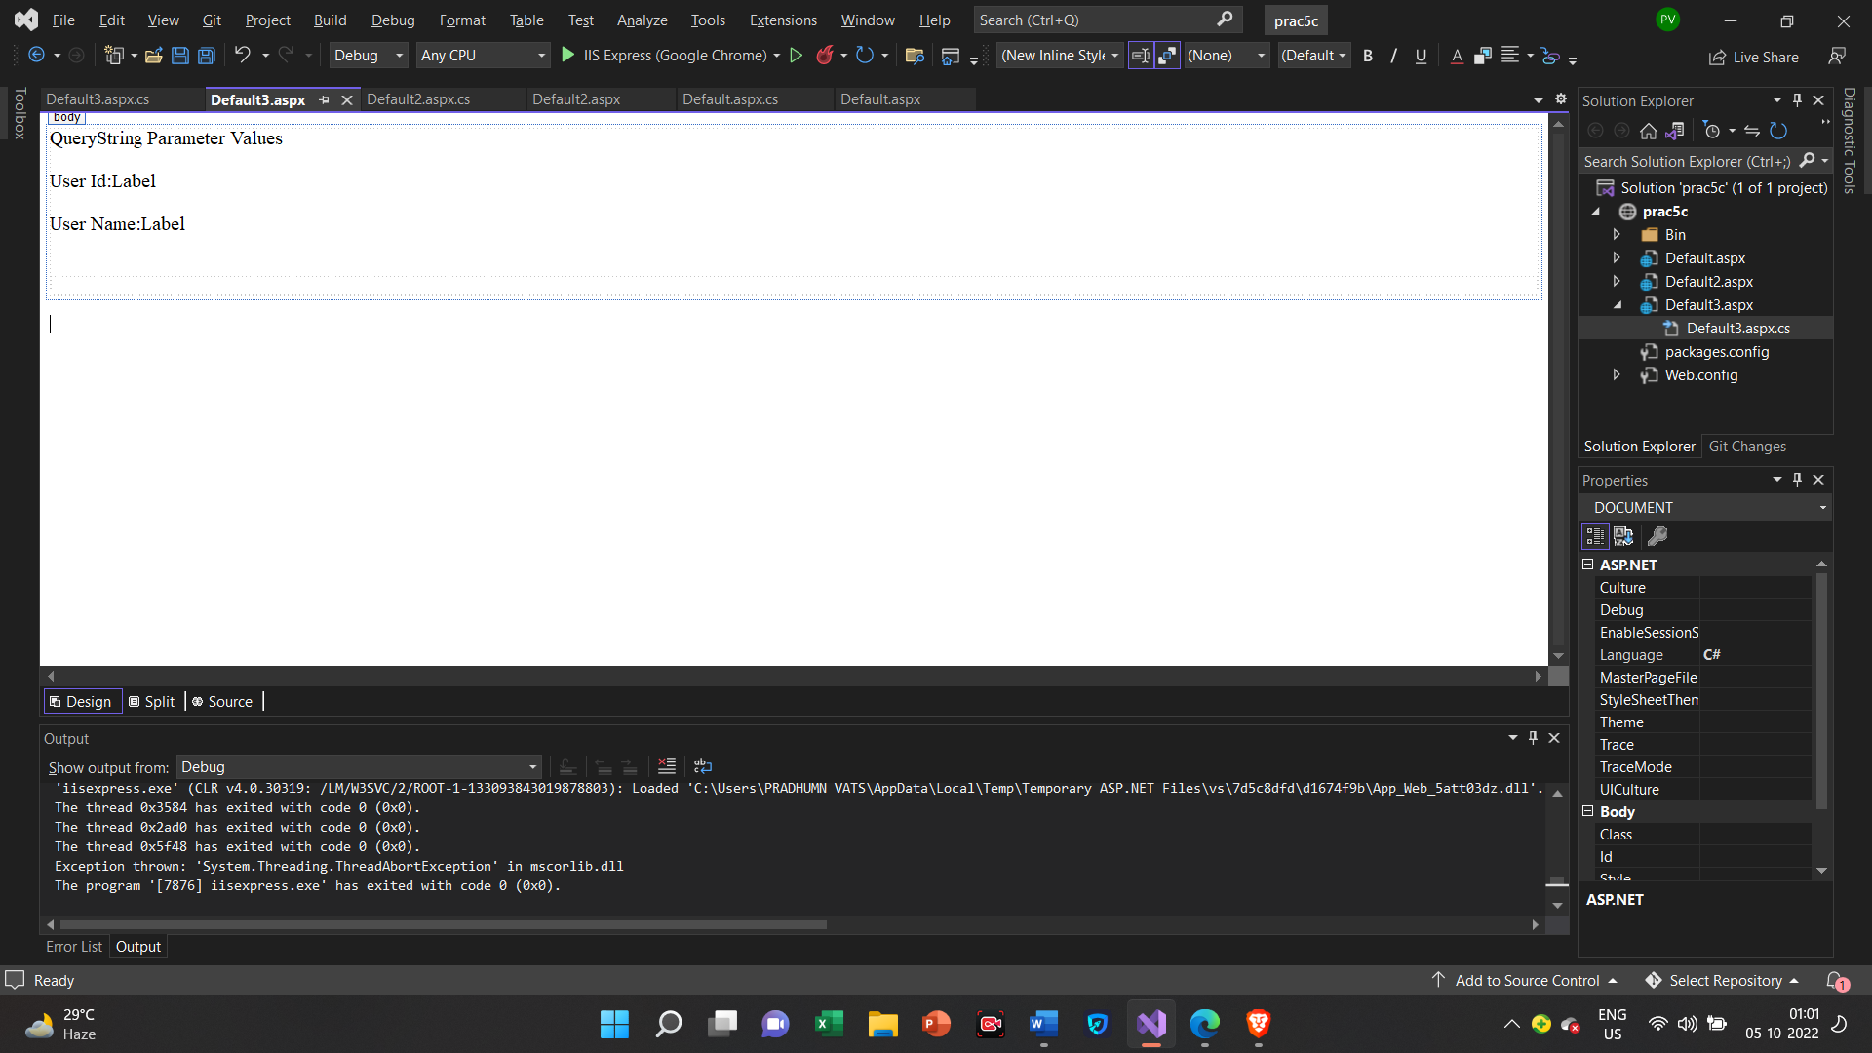

**Default.aspx.cs**

using System;

using System.Collections.Generic;

using System.Linq;

using System.Web;

using System.Web.UI;

using System.Web.UI.WebControls;

public partial class Default3 : System.Web.UI.Page

{

protected void Page_Load(object sender, EventArgs e)

{

if (!IsPostBack)

{

lblUserId.Text = Request.QueryString["UserId"];

lblUserName.Text = Request.QueryString["UserName"];

}

}

}

**Output1 Output2**

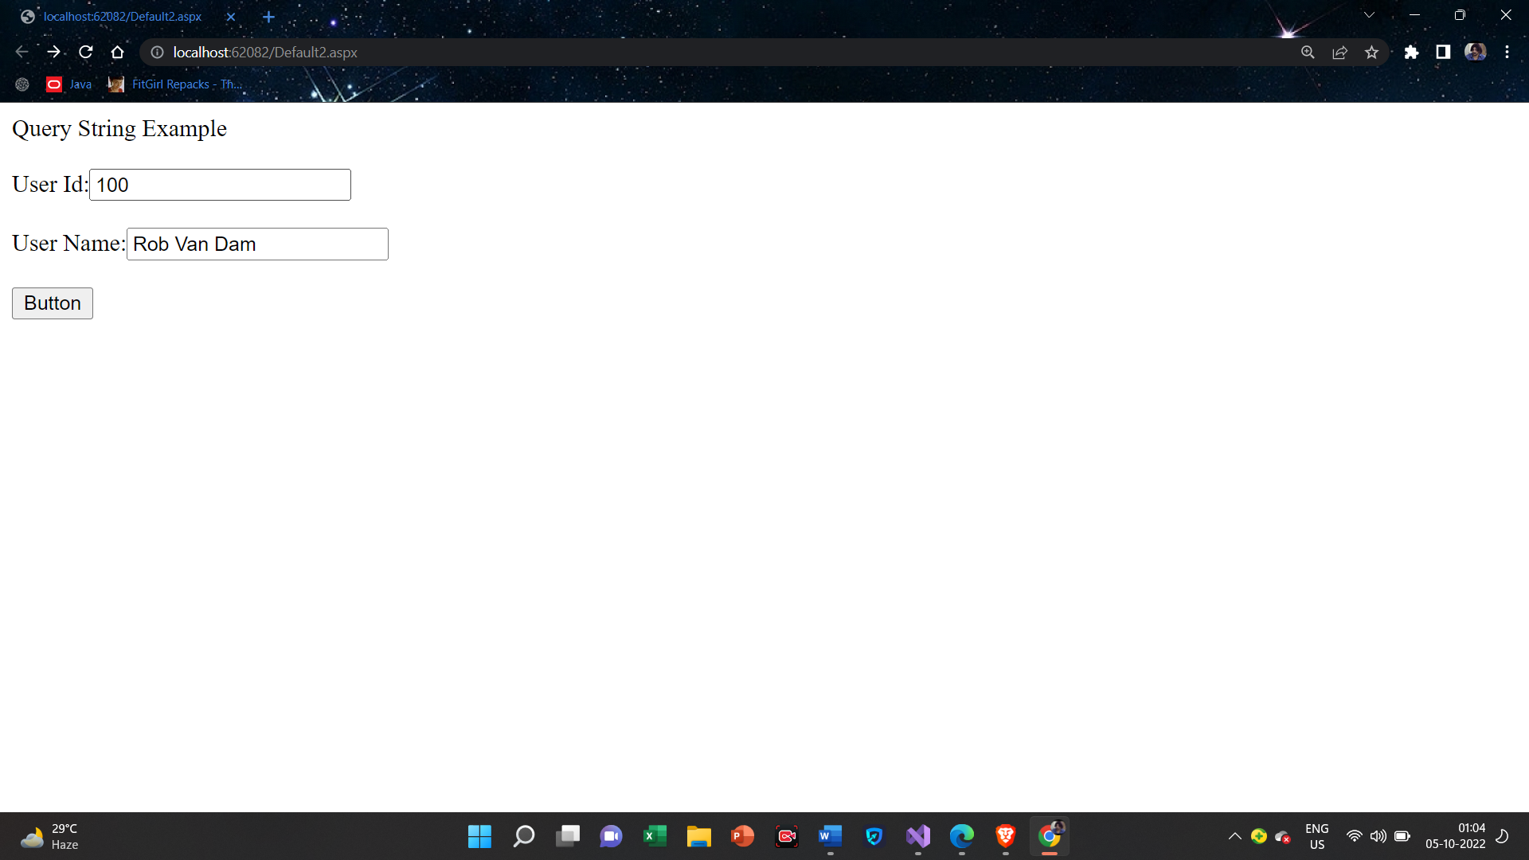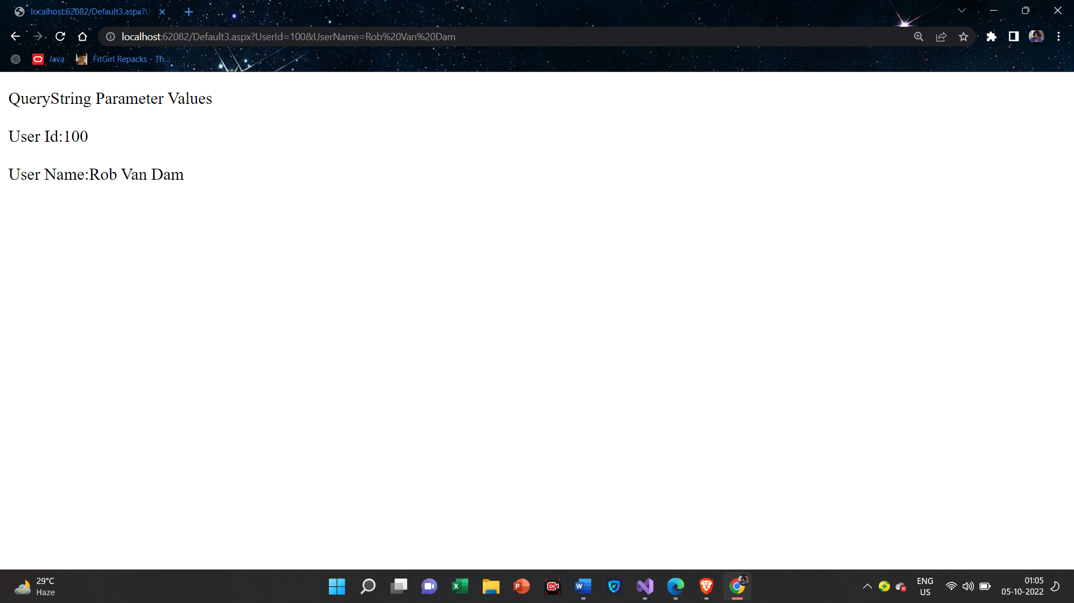

**Cookies**

**Default.aspx**

<%@ Page Language="C#" AutoEventWireup="true" CodeFile="Default4.aspx.cs" Inherits="Default4" %>

<!DOCTYPE html>

<html xmlns="http://www.w3.org/1999/xhtml">

<head runat="server">

<title></title>

</head>

<body>

<form id="form1" runat="server">

<div>

<asp:DropDownList ID="DropDownList1" runat="server" AutoPostBack="true" OnSelectedIndexChanged="ColorSelector_IndexChanged">

<asp:ListItem Selected="True" Value="White"></asp:ListItem>

<asp:ListItem Value="Red"></asp:ListItem>

<asp:ListItem Value="Green"></asp:ListItem>

<asp:ListItem Value="Blue"></asp:ListItem>

</asp:DropDownList>

</div>

</form>

</body>

</html>

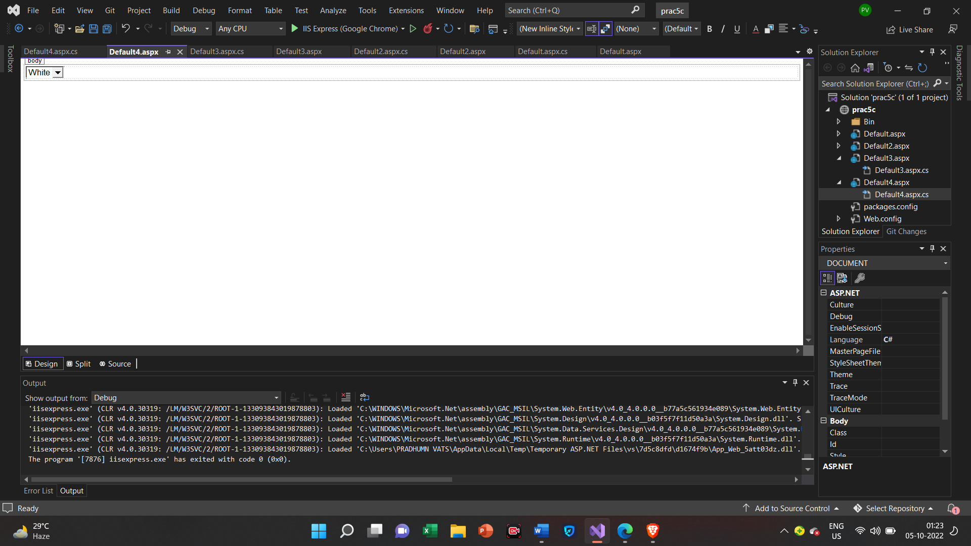

**Default.aspx.cs**

using System;

using System.Collections.Generic;

using System.Linq;

using System.Net;

using System.Web;

using System.Web.UI;

using System.Web.UI.WebControls;

using System.Data;

public partial class Default4 : System.Web.UI.Page

{

protected void Page_Load(object sender, EventArgs e)

{

if (Request.Cookies["BackgroundColor"]!= null)

{

ColorSelector.SelectedValue = Request.Cookies["BackgroundColor"].Value;

BodyTag.Style["background-color"] = ColorSelector.SelectedValue;

}

}

protected void ColorSelector_IndexChanged(object sender, EventArgs e)

{

BodyTag.Style["background-color"] = ColorSelector.SelectedValue;

HttpCookie cookie = new HttpCookie("BackgroundColor");

cookie.Value = ColorSelector.SelectedValue;

cookie.Expires = DateTime.Now.AddMilliseconds(20);

Response.SetCookie(cookie);

}

}

**Output**

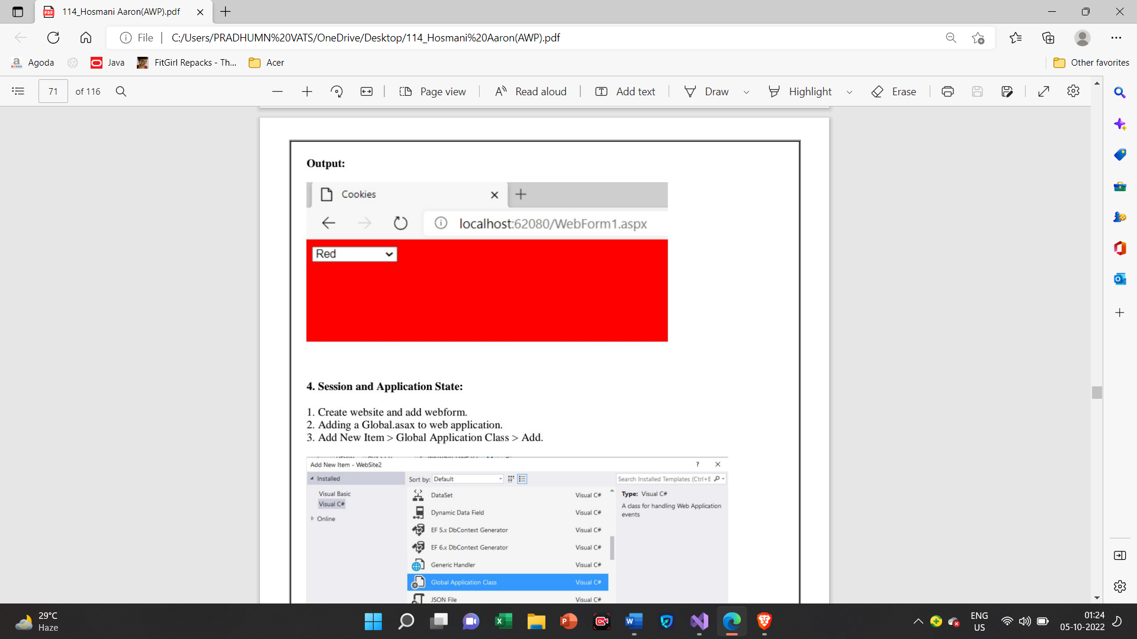

**Session and Application State**

**Global.asax**

<%@ Application Language="C#" %>

<script runat="server">

void Application_Start(object sender, EventArgs e)

{

// Code that runs on application startup

Application["OnlineUsers"] = 0;

}

void Application_End(object sender, EventArgs e)

{

// Code that runs on application shutdown

}

void Application_Error(object sender, EventArgs e)

{

// Code that runs when an unhandled error occurs

}

void Session_Start(object sender, EventArgs e)

{

// Code that runs when a new session is started

Application.Lock();

Application["OnlineUsers"] = (int)Application["OnlineUsers"] + 1;

Application.UnLock();

}

void Session_End(object sender, EventArgs e)

{

// Code that runs when a session ends.

// Note: The Session_End event is raised only when the sessionstate mode

// is set to InProc in the Web.config file. If session mode is set to StateServer

// or SQLServer, the event is not raised.

Application.Lock();

Application["OnlineUsers"] = (int)Application["OnlineUsers"] - 1;

Application.UnLock();

}

</script>

**Web.config**

<?xml version="1.0"?>

<!--

For more information on how to configure your ASP.NET application, please visit

https://go.microsoft.com/fwlink/?LinkId=169433

-->

<configuration>

<system.web>

<sessionState mode="InProc" cookieless="false" timeout="1"/>

<compilation debug="true" targetFramework="4.7.2" />

<httpRuntime targetFramework="4.7.2" />

</system.web>

<system.codedom>

<compilers>

<compiler language="c#;cs;csharp" extension=".cs" type="Microsoft.CodeDom.Providers.DotNetCompilerPlatform.CSharpCodeProvider, Microsoft.CodeDom.Providers.DotNetCompilerPlatform, Version=2.0.1.0, Culture=neutral, PublicKeyToken=31bf3856ad364e35" warningLevel="4" compilerOptions="/langversion:default /nowarn:1659;1699;1701" />

<compiler language="vb;vbs;visualbasic;vbscript" extension=".vb" type="Microsoft.CodeDom.Providers.DotNetCompilerPlatform.VBCodeProvider, Microsoft.CodeDom.Providers.DotNetCompilerPlatform, Version=2.0.1.0, Culture=neutral, PublicKeyToken=31bf3856ad364e35" warningLevel="4" compilerOptions="/langversion:default /nowarn:41008 /define:_MYTYPE=\&quot;Web\&quot; /optionInfer+" />

</compilers>

</system.codedom>

</configuration>

**Default.aspx**

<%@ Page Language="C#" AutoEventWireup="true" CodeFile="Default5.aspx.cs" Inherits="Default5" %>

<!DOCTYPE html>

<html xmlns="http://www.w3.org/1999/xhtml">

<head runat="server">

<title></title>

</head>

<body>

<form id="form1" runat="server">

<div>

Visitors Count:<%=Application["OnlineUsers"].ToString() %>

</div>

</form>

</body>

</html>

**Output**

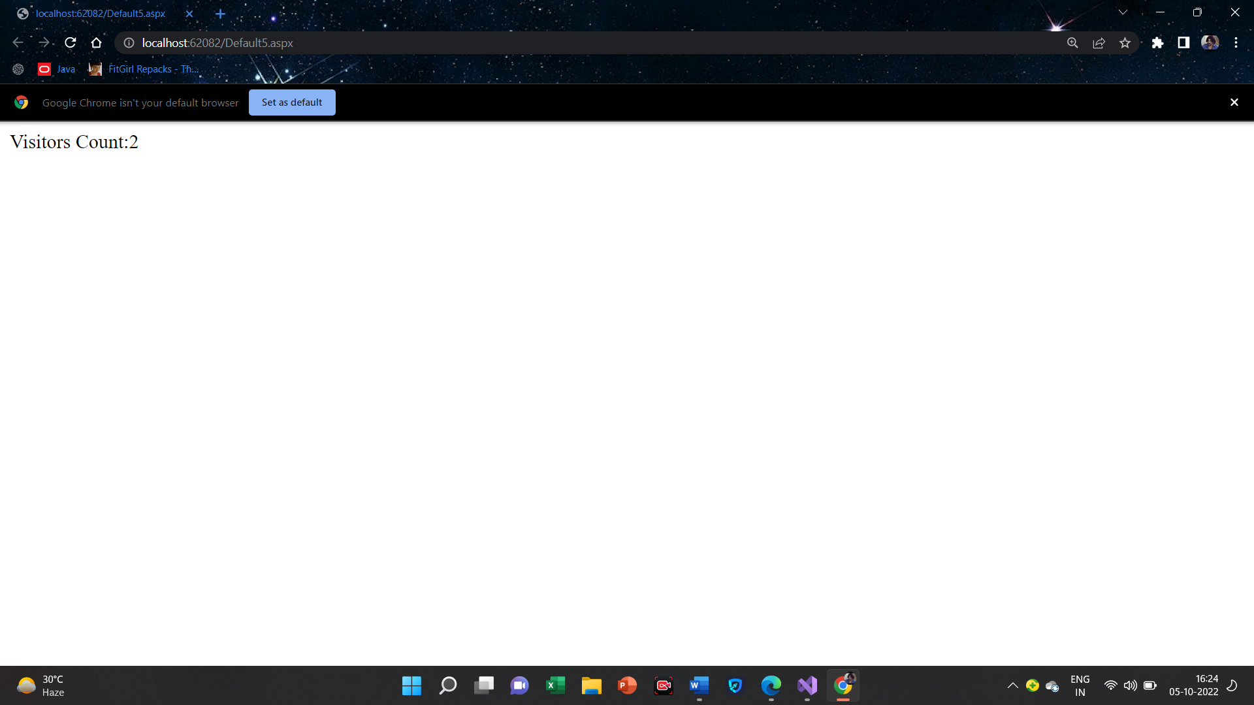

**Practical-6**

**6(A):Create a Web application to bind data in a multiline textbox by querying in another textbox.**

**Creating DataBase**

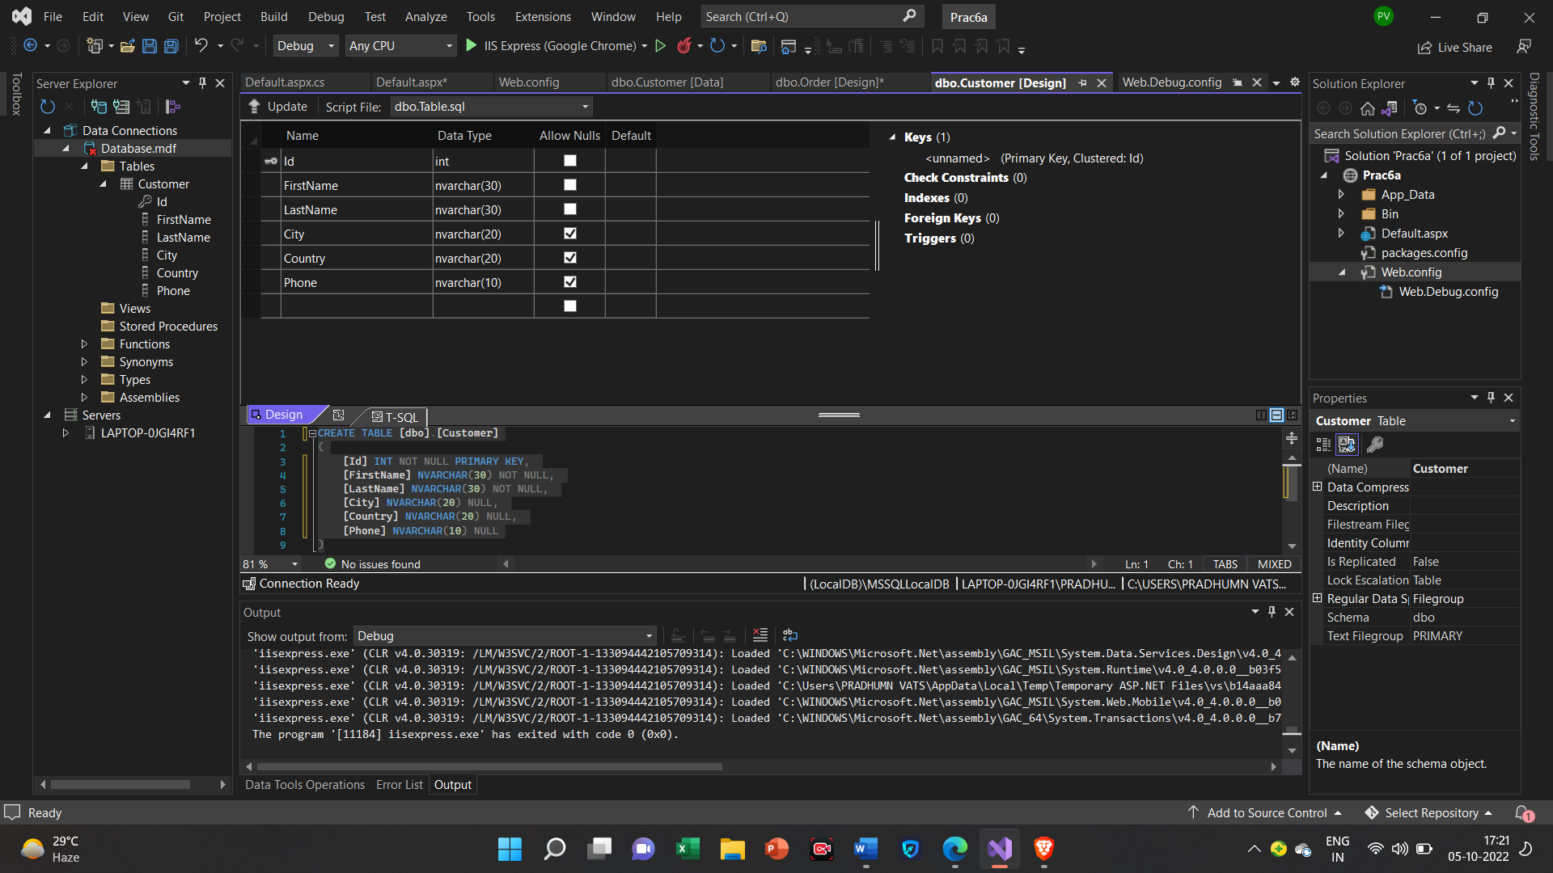

**Creating Table**

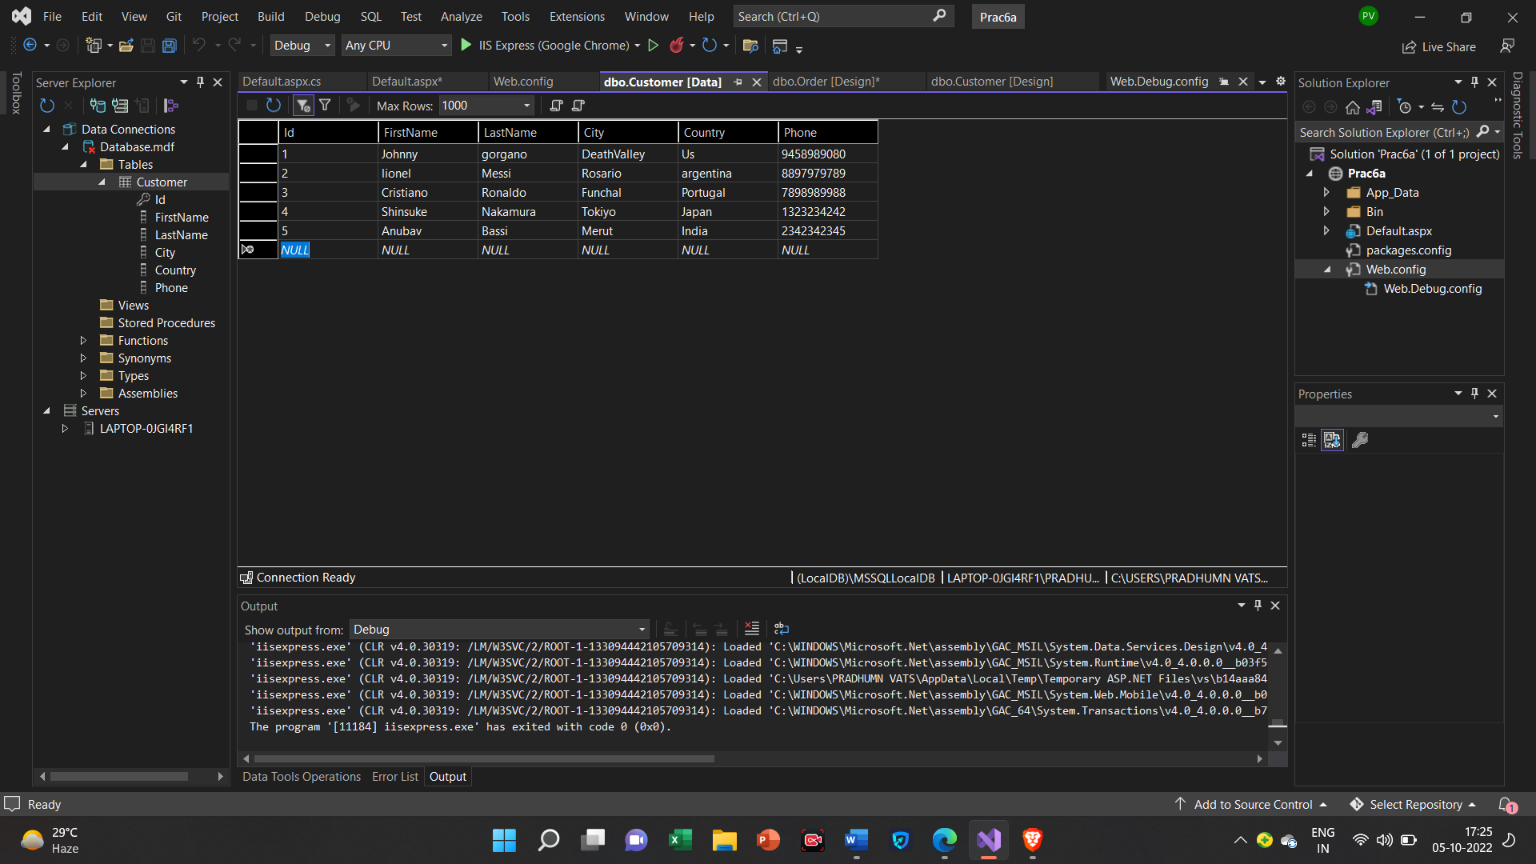

**Web.config**

<?xml version="1.0"?>

<!--

For more information on how to configure your ASP.NET application, please visit

https://go.microsoft.com/fwlink/?LinkId=169433

-->

<configuration>

<system.web>

<compilation debug="true" targetFramework="4.7.2" />

<httpRuntime targetFramework="4.7.2" />

</system.web>

<connectionStrings>

<add name="connStr" connectionString="Data Source=(LocalDB)\MSSQLLocalDB; AttachDbFilename='C:\Users\PRADHUMN VATS\source\repos\Prac6a\App_Data\Database.mdf';Integrated Security=True"/>

</connectionStrings>

<system.codedom>

<compilers>

<compiler language="c#;cs;csharp" extension=".cs" type="Microsoft.CodeDom.Providers.DotNetCompilerPlatform.CSharpCodeProvider, Microsoft.CodeDom.Providers.DotNetCompilerPlatform, Version=2.0.1.0, Culture=neutral, PublicKeyToken=31bf3856ad364e35" warningLevel="4" compilerOptions="/langversion:default /nowarn:1659;1699;1701" />

<compiler language="vb;vbs;visualbasic;vbscript" extension=".vb" type="Microsoft.CodeDom.Providers.DotNetCompilerPlatform.VBCodeProvider, Microsoft.CodeDom.Providers.DotNetCompilerPlatform, Version=2.0.1.0, Culture=neutral, PublicKeyToken=31bf3856ad364e35" warningLevel="4" compilerOptions="/langversion:default /nowarn:41008 /define:_MYTYPE=\&quot;Web\&quot; /optionInfer+" />

</compilers>

</system.codedom>

</configuration>

**Default.aspx**

<%@ Page Language="C#" AutoEventWireup="true" CodeFile="Default.aspx.cs" Inherits="_Default" %>

<!DOCTYPE html>

<html xmlns="http://www.w3.org/1999/xhtml">

<head runat="server">

<title></title>

</head>

<body>

<form id="form1" runat="server">

<div>

<asp:TextBox ID="TextBox1" runat="server" Height="72px" TextMode="MultiLine" Width="295px"></asp:TextBox>

<br />

<br />

<asp:Button ID="Button1" runat="server" OnClick="Button1_Click" Text="Execute Query" />

<br />

<br />

<asp:TextBox ID="TextBox2" runat="server" Height="176px" TextMode="MultiLine" Width="497px"></asp:TextBox>

</div>

</form>

</body>

</html>

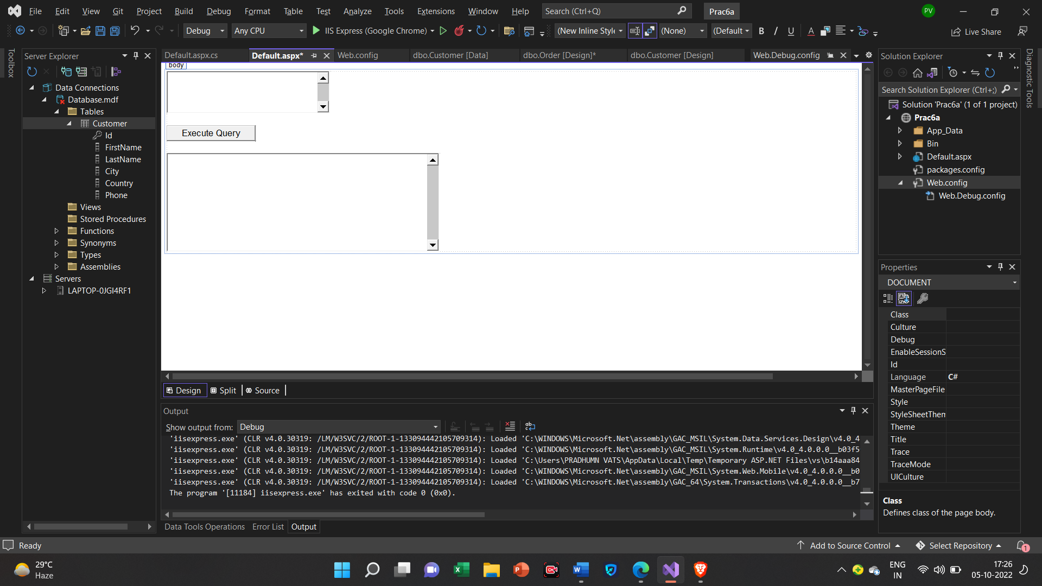

**Default.aspx.cs**

using System;

using System.Collections.Generic;

using System.Configuration;

using System.Data.SqlClient;

using System.Linq;

using System.Web;

using System.Web.UI;

using System.Web.UI.WebControls;

using System.Data;

using System.Data.SqlClient;

using System.Configuration;

public partial class _Default : System.Web.UI.Page

{

protected void Page_Load(object sender, EventArgs e)

{

}

protected void Button1_Click(object sender, EventArgs e)

{

string connStr =ConfigurationManager.ConnectionStrings["connStr"].ConnectionString;

SqlConnection con = new SqlConnection(connStr);

con.Open();

SqlCommand cmd = new SqlCommand(TextBox1.Text, con);

SqlDataReader reader = cmd.ExecuteReader();

TextBox2.Text = "";

while (reader.Read())

{

TextBox2.Text += Environment.NewLine;

for (int i = 0; i < reader.FieldCount - 1; i++)

{

TextBox2.Text += reader[i].ToString().PadLeft(15);

}

}

reader.Close();

con.Close();

}

}

**Output**

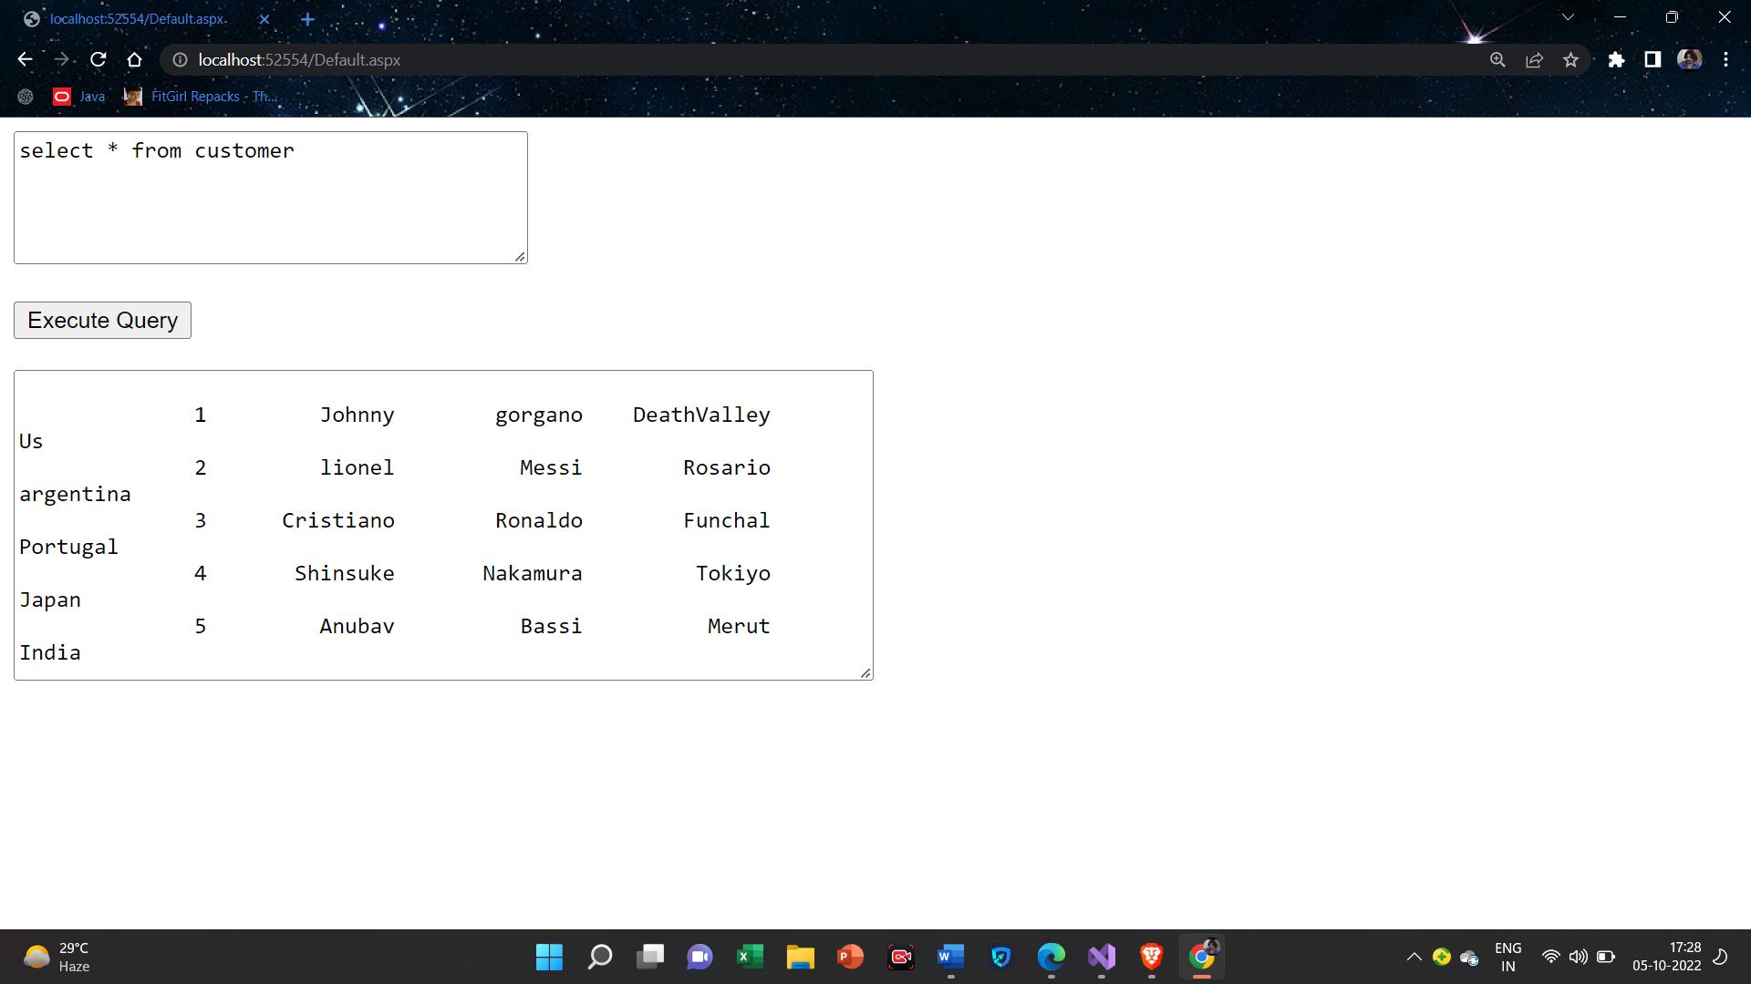

**6(B):Create a Web application to display records by using database.**

**Default.aspx**

<%@ Page Language="C#" AutoEventWireup="true" CodeFile="Default2.aspx.cs" Inherits="Default2" %>

<!DOCTYPE html>

<html xmlns="http://www.w3.org/1999/xhtml">

<head runat="server">

<title></title>

</head>

<body>

<form id="form1" runat="server">

<div>

Customer Details:<asp:Label ID="Label1" runat="server" Text="Label"></asp:Label>

<br />

<br />

<asp:Button ID="Button1" runat="server" OnClick="Button1_Click" Text="Display Records" />

</div>

</form>

</body>

</html>

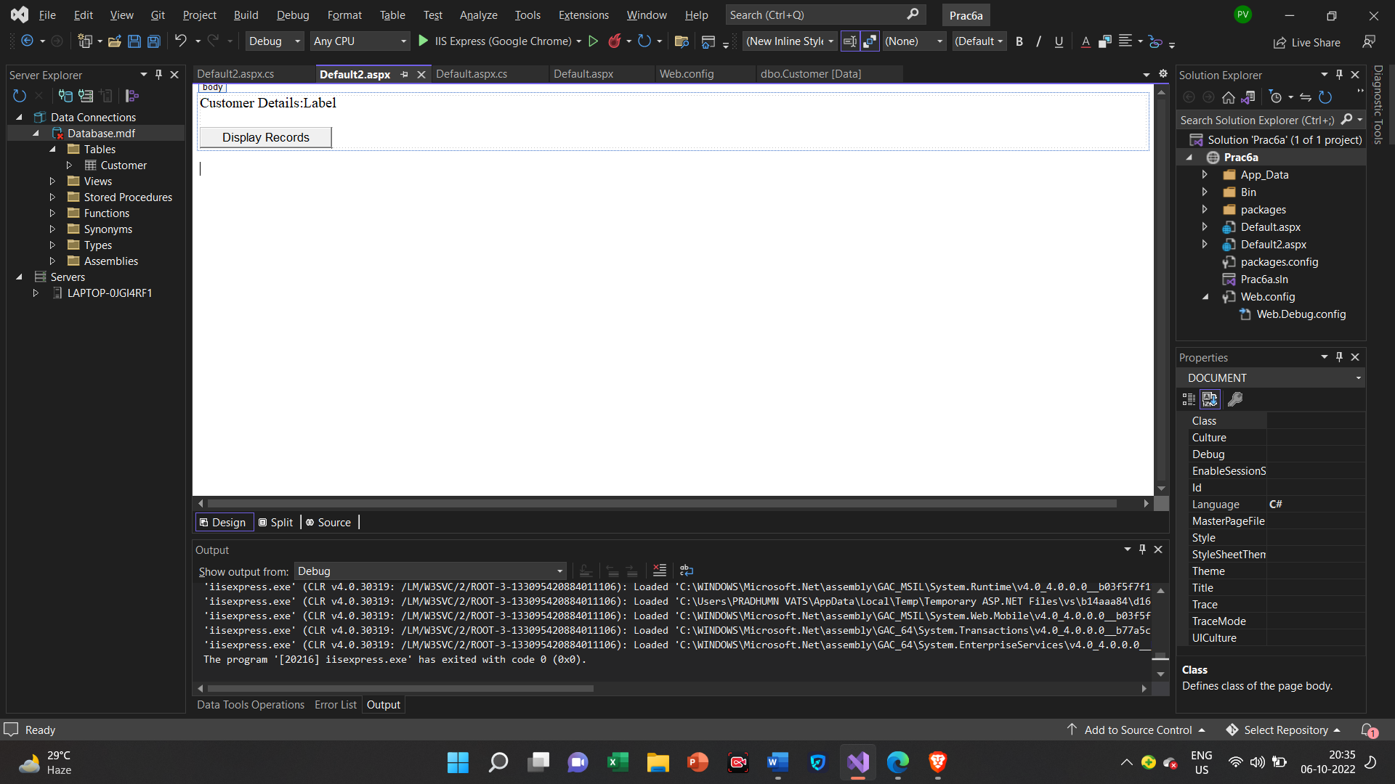

**Default.aspx.cs**

using System;

using System.Collections.Generic;

using System.Configuration;

using System.Data.SqlClient;

using System.Linq;

using System.Web;

using System.Web.UI;

using System.Web.UI.WebControls;

public partial class Default2 : System.Web.UI.Page

{

protected void Page_Load(object sender, EventArgs e)

{

}

protected void Button1_Click(object sender, EventArgs e)

{

string connstr = ConfigurationManager.ConnectionStrings["connstr"].ConnectionString;

SqlConnection con = new SqlConnection(connstr);

SqlCommand cmd = new SqlCommand("Select FirstName, LastName, Country from Customer", con);

con.Open();

SqlDataReader reader = cmd.ExecuteReader();

while(reader.Read())

{

Label1.Text += reader["FirstName"].ToString( )+ " " +reader["LastName"].ToString()+ " " + reader["Country"].ToString()+ "<br>";

}

reader.Close();

con.Close();

}

}

**Output**

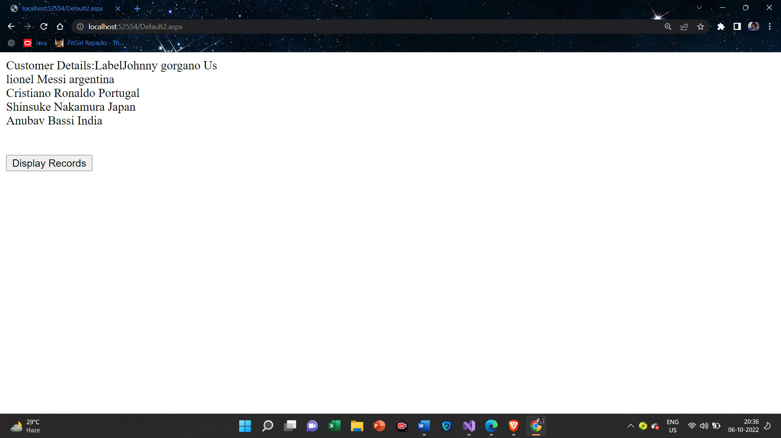

**6(C):Demonstrate the use of Datalist link control.**

**Creating DataBase**

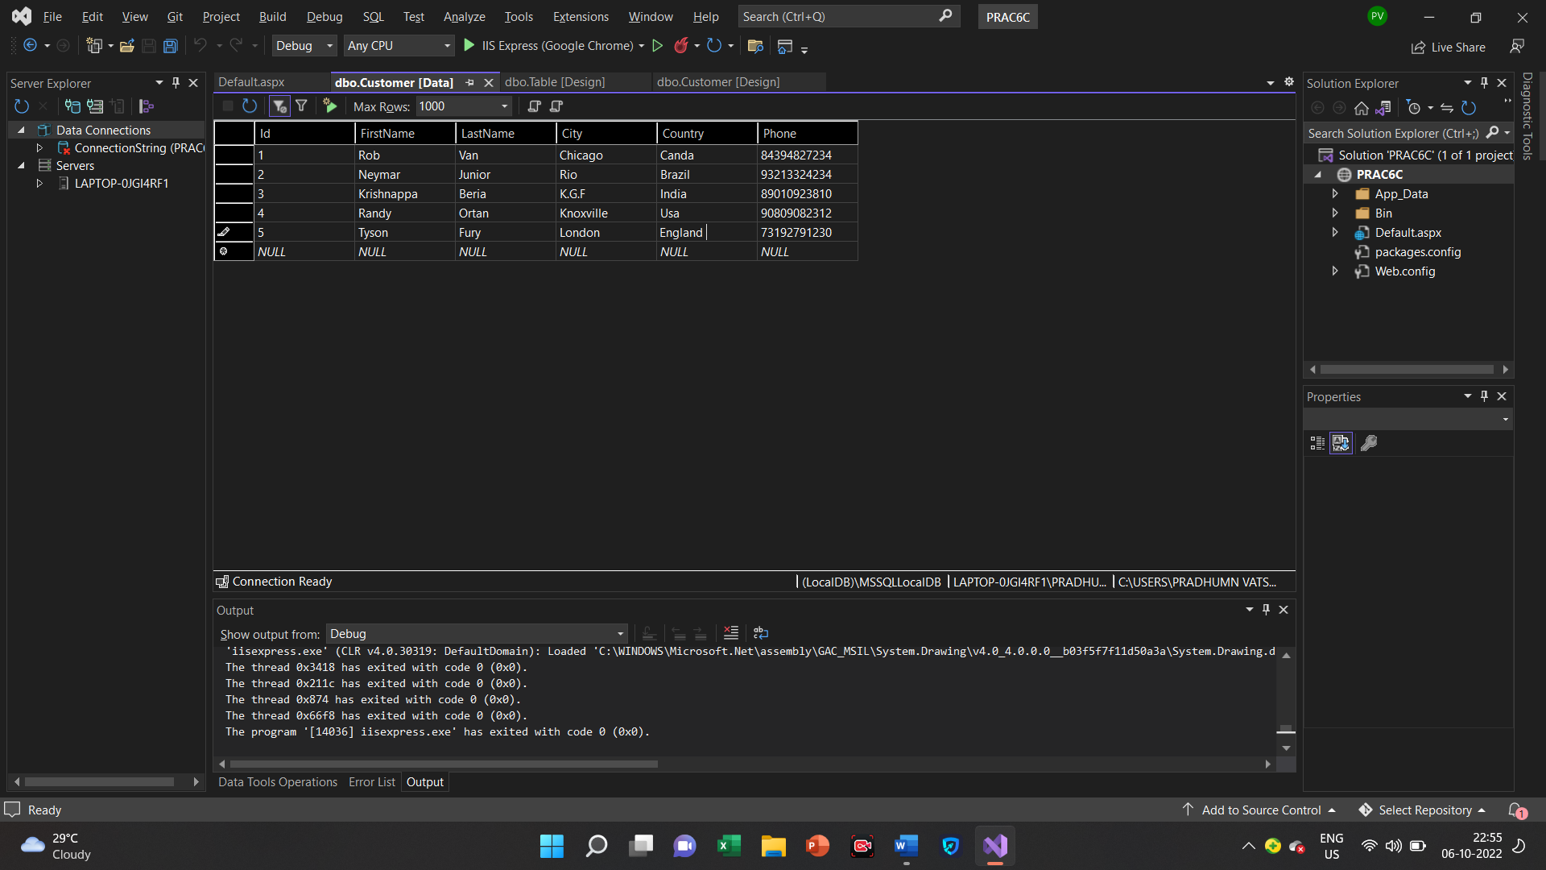

**Default.aspx**

<%@ Page Language="C#" AutoEventWireup="true" CodeFile="Default.aspx.cs" Inherits="_Default" %>

<!DOCTYPE html>

<html xmlns="http://www.w3.org/1999/xhtml">

<head runat="server">

<title></title>

</head>

<body>

<form id="form1" runat="server">

<asp:DataList ID="DataList1" runat="server" DataKeyField="Id" DataSourceID="SqlDataSource1">

<ItemTemplate>

Id:

<asp:Label ID="IdLabel" runat="server" Text='<%# Eval("Id") %>' />

<br />

FirstName:

<asp:Label ID="FirstNameLabel" runat="server" Text='<%# Eval("FirstName") %>' />

<br />

LastName:

<asp:Label ID="LastNameLabel" runat="server" Text='<%# Eval("LastName") %>' />

<br />

City:

<asp:Label ID="CityLabel" runat="server" Text='<%# Eval("City") %>' />

<br />

Country:

<asp:Label ID="CountryLabel" runat="server" Text='<%# Eval("Country") %>' />

<br />

Phone:

<asp:Label ID="PhoneLabel" runat="server" Text='<%# Eval("Phone") %>' />

<br />

<br />

</ItemTemplate>

</asp:DataList>

<asp:SqlDataSource ID="SqlDataSource1" runat="server" ConnectionString="<%$ ConnectionStrings:ConnectionString %>" SelectCommand="SELECT * FROM [Customer]" ConflictDetection="CompareAllValues" DeleteCommand="DELETE FROM [Customer] WHERE [Id] = @original_Id AND (([FirstName] = @original_FirstName) OR ([FirstName] IS NULL AND @original_FirstName IS NULL)) AND (([LastName] = @original_LastName) OR ([LastName] IS NULL AND @original_LastName IS NULL)) AND (([City] = @original_City) OR ([City] IS NULL AND @original_City IS NULL)) AND (([Country] = @original_Country) OR ([Country] IS NULL AND @original_Country IS NULL)) AND (([Phone] = @original_Phone) OR ([Phone] IS NULL AND @original_Phone IS NULL))" InsertCommand="INSERT INTO [Customer] ([Id], [FirstName], [LastName], [City], [Country], [Phone]) VALUES (@Id, @FirstName, @LastName, @City, @Country, @Phone)" OldValuesParameterFormatString="original_{0}" UpdateCommand="UPDATE [Customer] SET [FirstName] = @FirstName, [LastName] = @LastName, [City] = @City, [Country] = @Country, [Phone] = @Phone WHERE [Id] = @original_Id AND (([FirstName] = @original_FirstName) OR ([FirstName] IS NULL AND @original_FirstName IS NULL)) AND (([LastName] = @original_LastName) OR ([LastName] IS NULL AND @original_LastName IS NULL)) AND (([City] = @original_City) OR ([City] IS NULL AND @original_City IS NULL)) AND (([Country] = @original_Country) OR ([Country] IS NULL AND @original_Country IS NULL)) AND (([Phone] = @original_Phone) OR ([Phone] IS NULL AND @original_Phone IS NULL))">

<DeleteParameters>

<asp:Parameter Name="original_Id" Type="Int32" />

<asp:Parameter Name="original_FirstName" Type="String" />

<asp:Parameter Name="original_LastName" Type="String" />

<asp:Parameter Name="original_City" Type="String" />

<asp:Parameter Name="original_Country" Type="String" />

<asp:Parameter Name="original_Phone" Type="String" />

</DeleteParameters>

<InsertParameters>

<asp:Parameter Name="Id" Type="Int32" />

<asp:Parameter Name="FirstName" Type="String" />

<asp:Parameter Name="LastName" Type="String" />

<asp:Parameter Name="City" Type="String" />

<asp:Parameter Name="Country" Type="String" />

<asp:Parameter Name="Phone" Type="String" />

</InsertParameters>

<UpdateParameters>

<asp:Parameter Name="FirstName" Type="String" />

<asp:Parameter Name="LastName" Type="String" />

<asp:Parameter Name="City" Type="String" />

<asp:Parameter Name="Country" Type="String" />

<asp:Parameter Name="Phone" Type="String" />

<asp:Parameter Name="original_Id" Type="Int32" />

<asp:Parameter Name="original_FirstName" Type="String" />

<asp:Parameter Name="original_LastName" Type="String" />

<asp:Parameter Name="original_City" Type="String" />

<asp:Parameter Name="original_Country" Type="String" />

<asp:Parameter Name="original_Phone" Type="String" />

</UpdateParameters>

</asp:SqlDataSource>

<div>

</div>

</form>

</body>

</html>

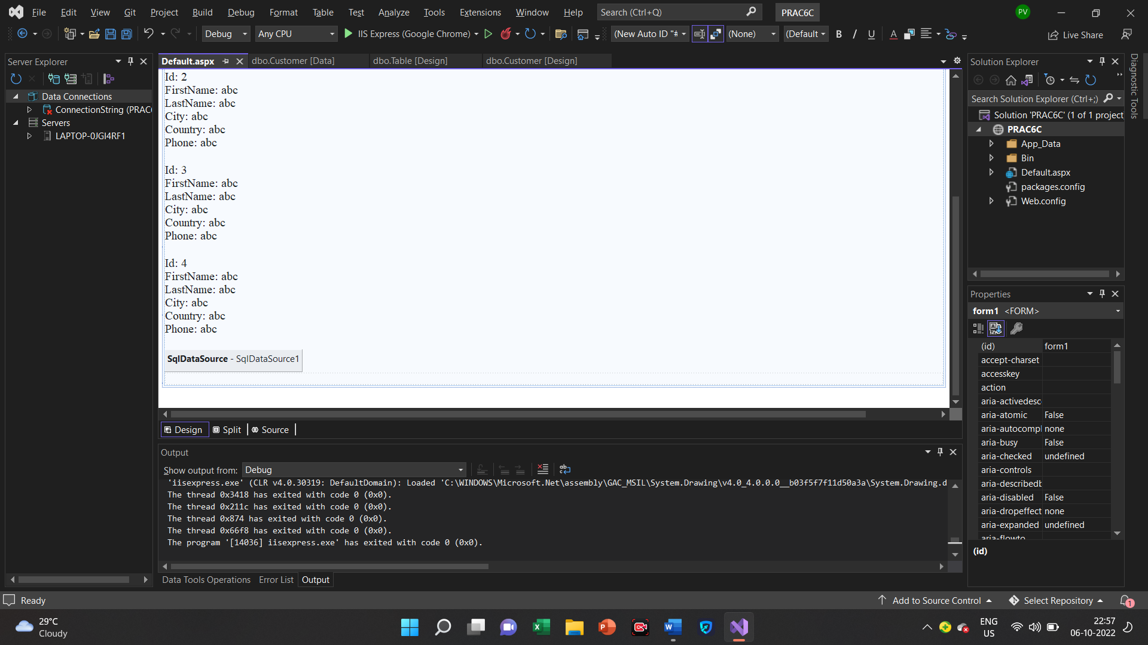

**Output**

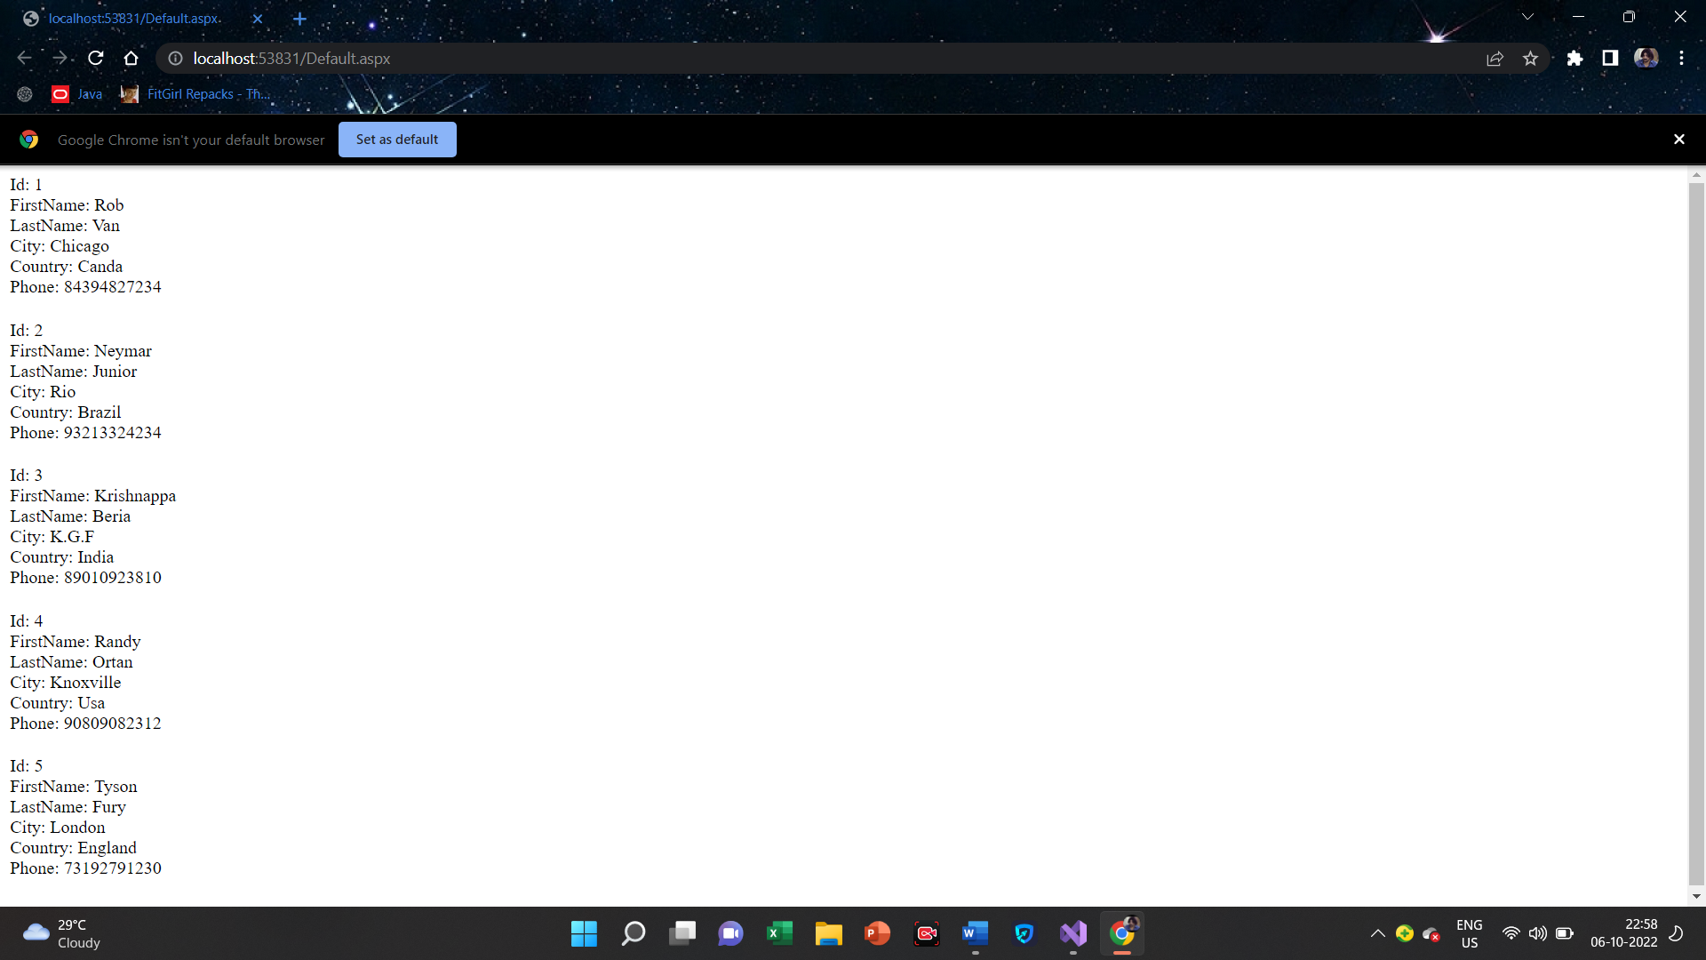

Practical-7

**7(A):Create a Web application to display Databinding using Dropdownlist control.**

**Default.aspx**

<%@ Page Language="C#" AutoEventWireup="true" CodeFile="Default3.aspx.cs" Inherits="Default3" %>

<!DOCTYPE html>

<html xmlns="http://www.w3.org/1999/xhtml">

<head runat="server">

<title></title>

</head>

<body>

<form id="form1" runat="server">

<div>

<asp:DropDownList ID="DropDownList1" runat="server">

</asp:DropDownList>

<br />

<br />

<asp:Label ID="Label1" runat="server" Text="Label"></asp:Label>

<br />

<br />

<asp:Button ID="Button1" runat="server" OnClick="Button1_Click" Text="Button" />

</div>

</form>

</body>

</html>

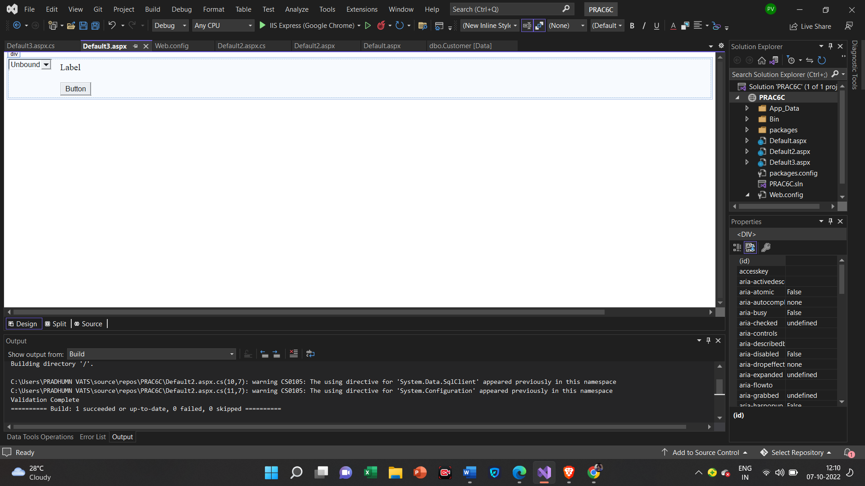

**Default.aspx.cs**

using System;

using System.Collections.Generic;

using System.Configuration;

using System.Data.SqlClient;

using System.Linq;

using System.Web;

using System.Web.UI;

using System.Web.UI.WebControls;

public partial class Default3 : System.Web.UI.Page

{

protected void Page_Load(object sender, EventArgs e)

{

if (IsPostBack == false)

{

string connStr = ConfigurationManager.ConnectionStrings["connStr"].ConnectionString;

SqlConnection con = new SqlConnection(connStr);

SqlCommand cmd = new SqlCommand("Select Distinct Country from Customer", con);

con.Open();

SqlDataReader reader = cmd.ExecuteReader();

DropDownList1.DataSource = reader;

DropDownList1.DataTextField = "Country";

DropDownList1.DataBind();

reader.Close();

con.Close();

}

}

protected void Button1_Click(object sender, EventArgs e)

{

Label1.Text = "The Country You Have Selected is:" + DropDownList1.SelectedValue;

}

}

**Output**

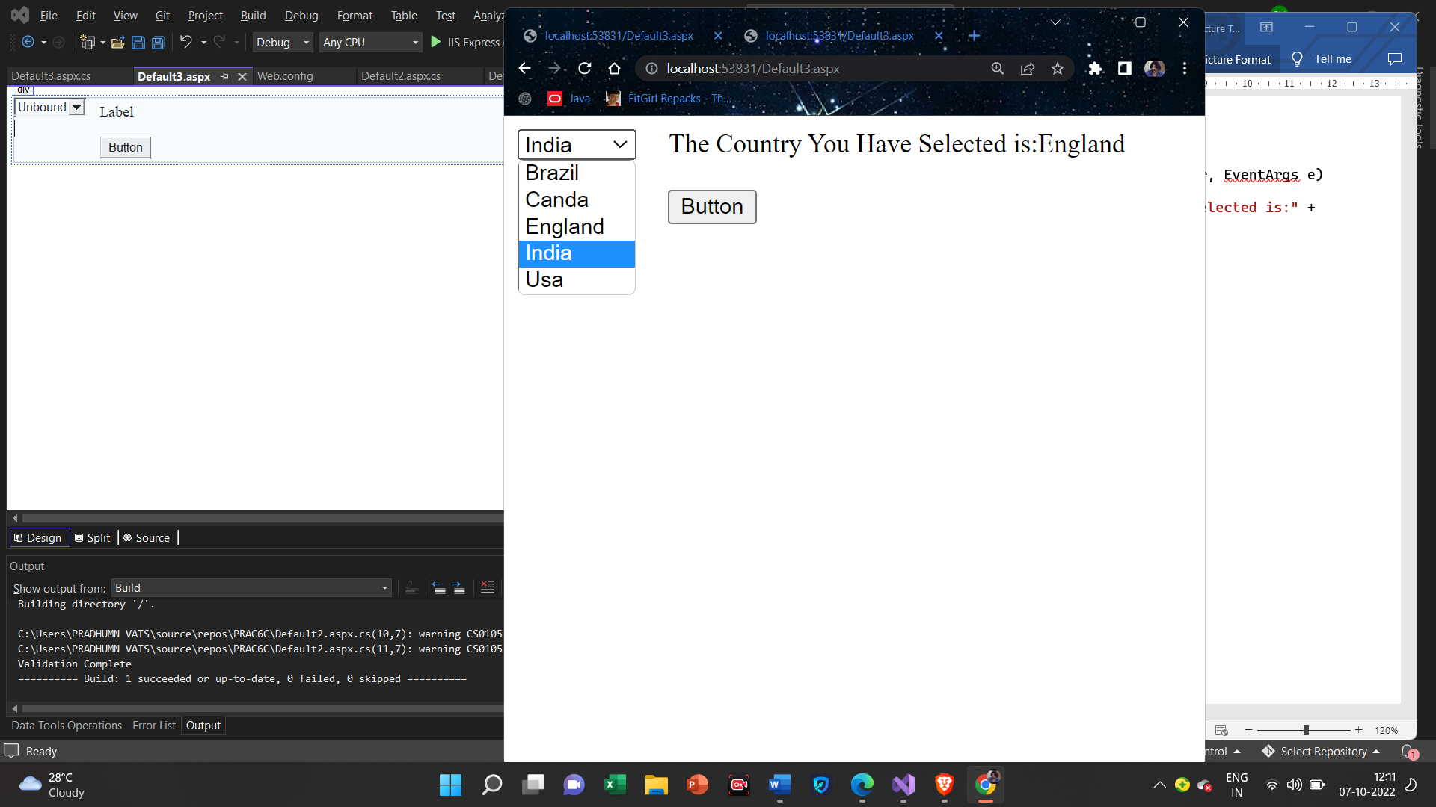

**7(B):Create a Web application to display the Phone No. of Customer using database.**

**Default.aspx**

<%@ Page Language="C#" AutoEventWireup="true" CodeFile="Default4.aspx.cs" Inherits="Default4" %>

<!DOCTYPE html>

<html xmlns="http://www.w3.org/1999/xhtml">

<head runat="server">

<title></title>

</head>

<body>

<form id="form1" runat="server">

<div>

Select Your Name To Get Phone Number.<br />

<asp:DropDownList ID="DropDownList1" runat="server">

</asp:DropDownList>

<br />

<br />

<asp:Button ID="Button1" runat="server" OnClick="Button1_Click" Text="Button" />

<br />

<br />

<asp:Label ID="Label1" runat="server" Text="Your Phone Number is "></asp:Label>

</div>

</form>

</body>

</html>

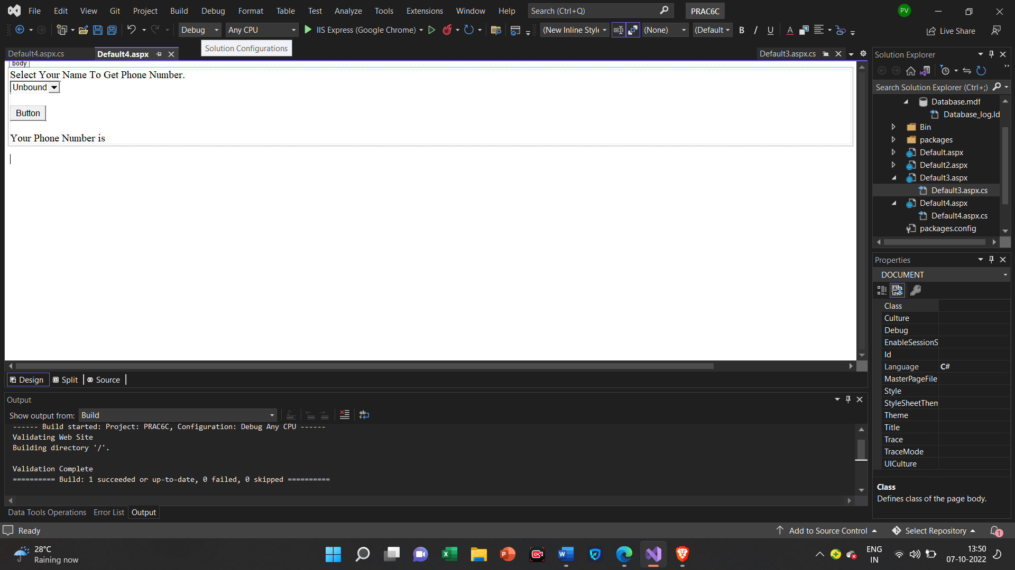

**Default.aspx.cs**

using System;

using System.Collections.Generic;

using System.Linq;

using System.Web;

using System.Web.UI;

using System.Web.UI.WebControls;

using System.Configuration;

using System.Data.SqlClient;

using System.Data;

public partial class Default4 : System.Web.UI.Page

{

protected void Page_Load(object sender, EventArgs e)

{

if (IsPostBack == false)

{

string connStr = ConfigurationManager.ConnectionStrings["connStr"].ConnectionString;

SqlConnection con = new SqlConnection(connStr);

SqlCommand cmd = new SqlCommand("Select Distinct FirstName,LastName,Phone from Customer", con);

con.Open();

SqlDataReader reader = cmd.ExecuteReader();

DropDownList1.DataSource = reader;

DropDownList1.DataTextField = "FirstName";

DropDownList1.DataValueField = "Phone";

DropDownList1.DataBind();

reader.Close();

con.Close();

}

}

protected void Button1_Click(object sender, EventArgs e)

{

Label1.Text = "Your Phone Number is:" + DropDownList1.SelectedValue;

}

}

**Output**

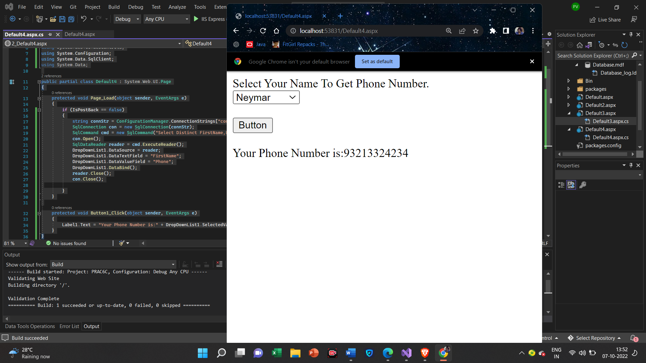

**7(C):Create a Web application for inserting and deleting record from a database.**

**Default.aspx**

<%@ Page Language="C#" AutoEventWireup="true" CodeFile="Default5.aspx.cs" Inherits="Default5" %>

<!DOCTYPE html>

<html xmlns="http://www.w3.org/1999/xhtml">

<head runat="server">

<title></title>

</head>

<body>

<form id="form1" runat="server">

<div>

Enter Customer First Name:<asp:TextBox ID="TextBox1" runat="server"></asp:TextBox>

<br />

Enter Customer Last Name:<asp:TextBox ID="TextBox2" runat="server"></asp:TextBox>

<br />

Enter Customer City:<asp:TextBox ID="TextBox3" runat="server"></asp:TextBox>

<br />

Enter Customer Country:<asp:TextBox ID="TextBox4" runat="server"></asp:TextBox>

<br />

Enter Customer Phone Number:<asp:TextBox ID="TextBox5" runat="server"></asp:TextBox>

<br />

<br />

<asp:Button ID="Button1" runat="server" OnClick="Button1_Click" Text="Insert Record" />

&nbsp;&nbsp;&nbsp;&nbsp;&nbsp;&nbsp;&nbsp;&nbsp;&nbsp;&nbsp;&nbsp;&nbsp;&nbsp;&nbsp;&nbsp;

<asp:Button ID="Button2" runat="server" OnClick="Button2_Click" Text="Delete Record" />

<br />

<br />

<asp:Label ID="Label1" runat="server" Text="Label"></asp:Label>

</div>

</form>

</body>

</html>

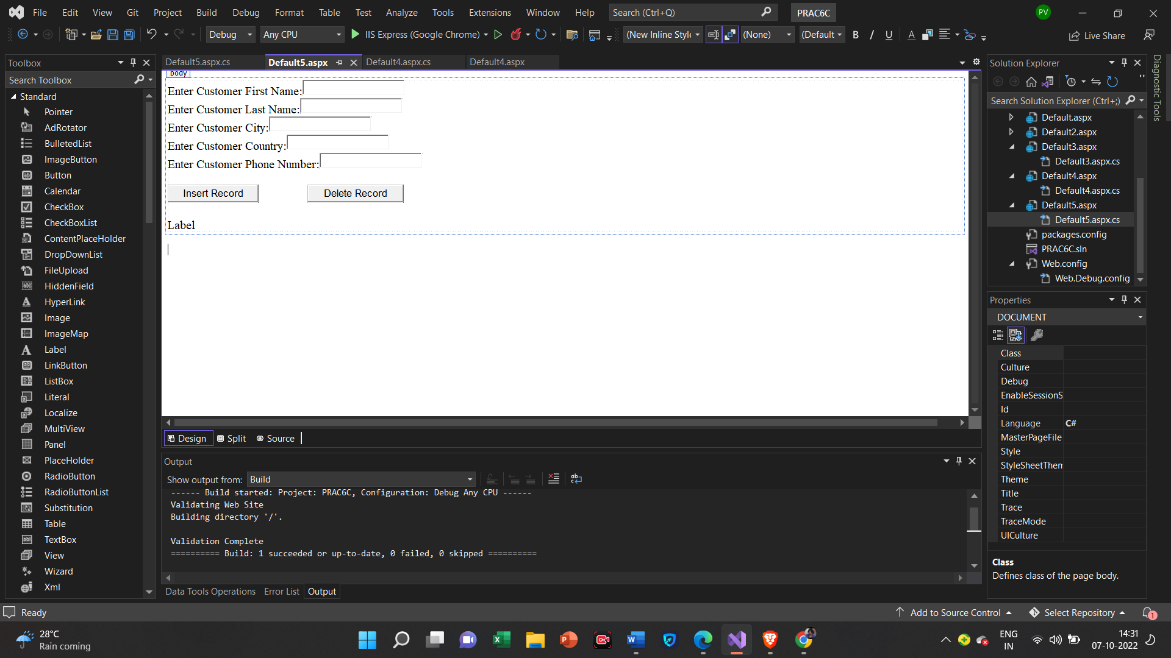

**Default.aspx.cs**

using System;

using System.Collections.Generic;

using System.Configuration;

using System.Data.SqlClient;

using System.Drawing;

using System.Linq;

using System.Reflection.Emit;

using System.Security.Policy;

using System.Web;

using System.Web.UI;

using System.Web.UI.WebControls;

public partial class Default5 : System.Web.UI.Page

{

protected void Page_Load(object sender, EventArgs e)

{

}

protected void Button2_Click(object sender, EventArgs e)

{

string connStr = ConfigurationManager.ConnectionStrings["connStr"].ConnectionString;

SqlConnection con = new SqlConnection(connStr);

string InsertQuery = "delete from customer where FirstName=@fname";

SqlCommand cmd = new SqlCommand(InsertQuery, con);

cmd.Parameters.AddWithValue("@fname", TextBox1.Text);

con.Open();

cmd.ExecuteNonQuery();

Label1.Text = "Record Deleted Successfuly.";

con.Close();

}

protected void Button1_Click(object sender, EventArgs e)

{

string connStr = ConfigurationManager.ConnectionStrings["connStr"].ConnectionString;

SqlConnection con = new SqlConnection(connStr);

string InsertQuery = "insert into customer values(@fname, @lname, @city, @country,@phone)";

SqlCommand cmd = new SqlCommand(InsertQuery, con);

cmd.Parameters.AddWithValue("@fname", TextBox1.Text);

cmd.Parameters.AddWithValue("@lname", TextBox2.Text);

cmd.Parameters.AddWithValue("@city", TextBox3.Text);

cmd.Parameters.AddWithValue("@country", TextBox4.Text);

cmd.Parameters.AddWithValue("@phone", TextBox5.Text);

con.Open();

Label1.Text = "Record Inserted Successfuly.";

con.Close();

}

}

**Output**

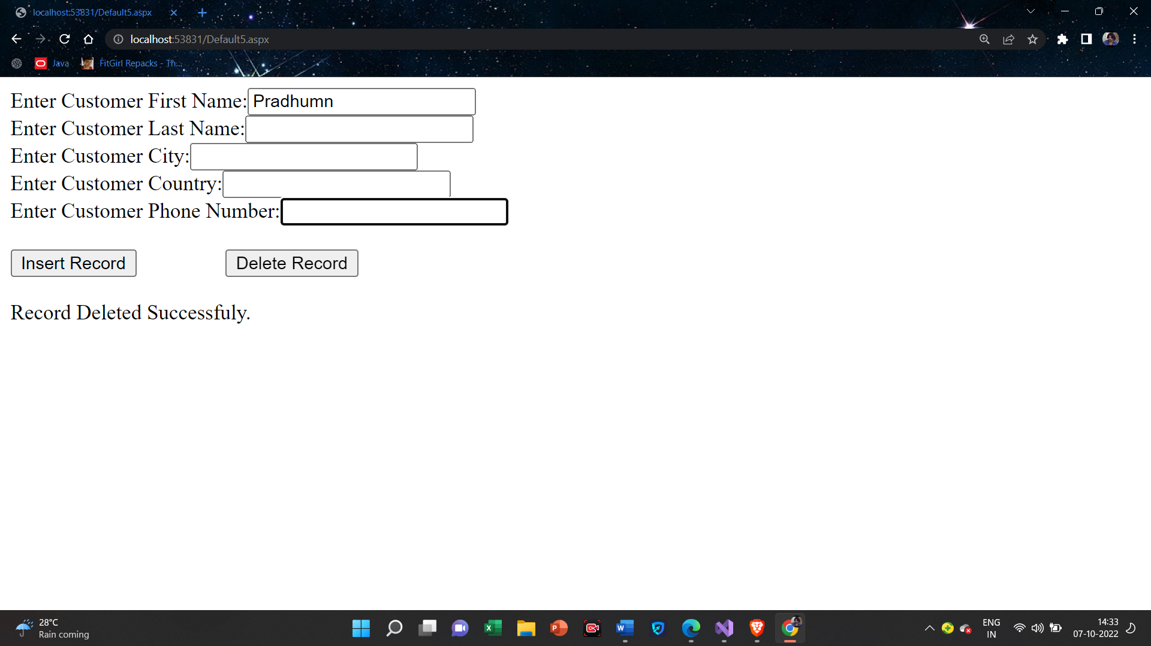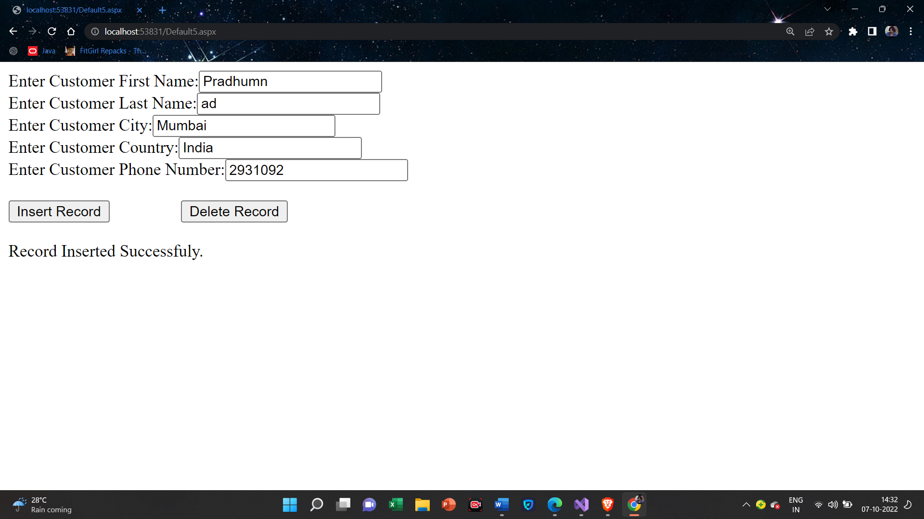

Practical-8

**8(A):Create a Web application to demonstrate various uses and properties of SqlDataSource.**

**Creating DataBase**

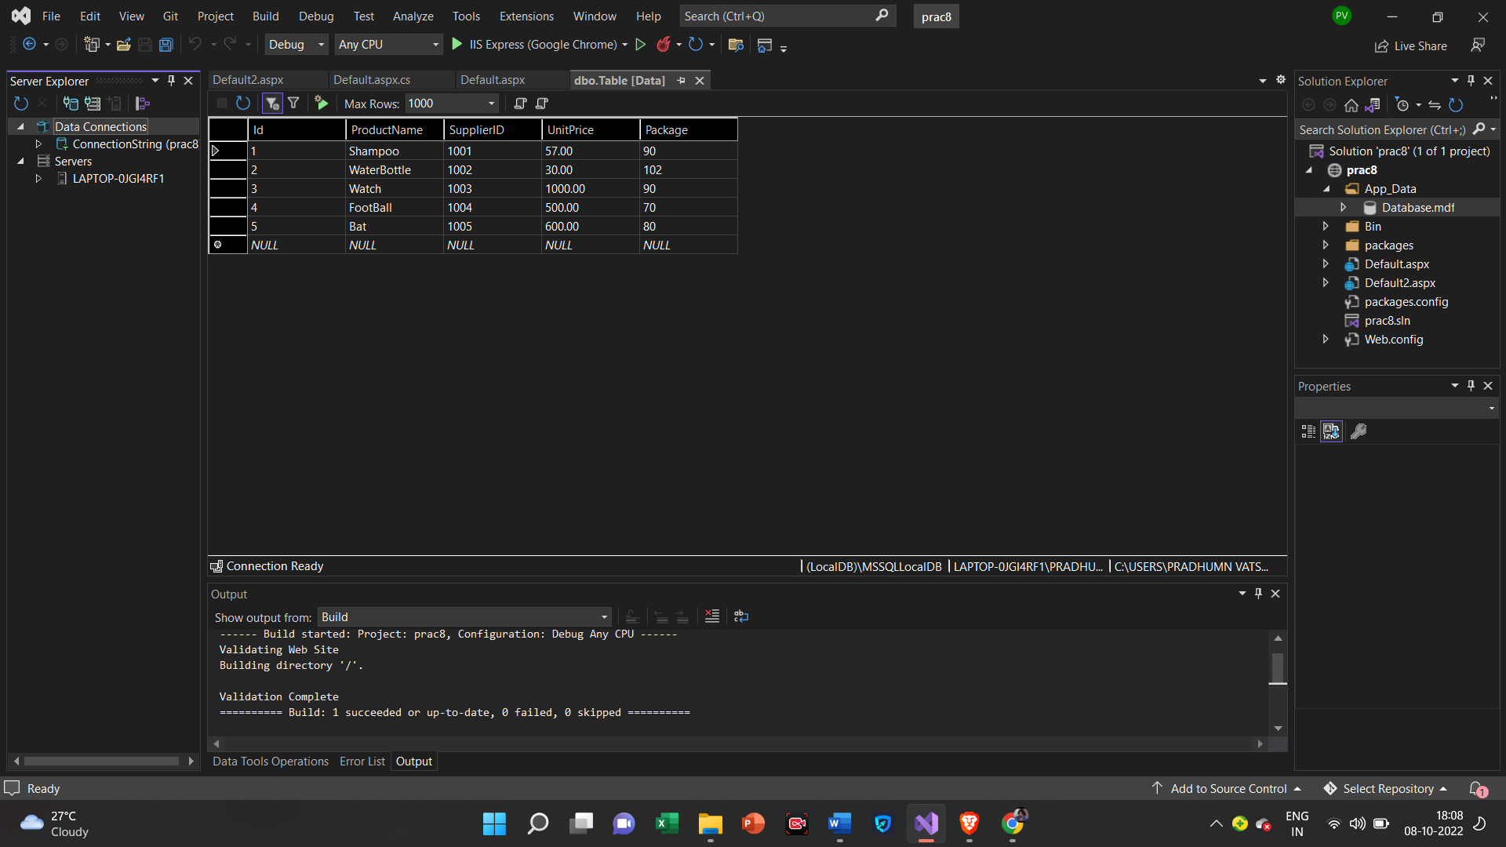

**Default.aspx**

<%@ Page Language="C#" AutoEventWireup="true" CodeFile="Default.aspx.cs" Inherits="_Default" %>

<!DOCTYPE html>

<html xmlns="http://www.w3.org/1999/xhtml">

<head runat="server">

<title></title>

</head>

<body>

<form id="form1" runat="server">

<div>

<asp:DropDownList ID="DropDownList1" runat="server" AutoPostBack="True" DataSourceID="SqlDataSource1" DataTextField="ProductName" DataValueField="ProductName" OnSelectedIndexChanged="DropDownList1_SelectedIndexChanged1">

</asp:DropDownList>

<asp:SqlDataSource ID="SqlDataSource1" runat="server" ConnectionString="<%$ ConnectionStrings:ConnectionString %>" SelectCommand="SELECT [ProductName] FROM [Table]"></asp:SqlDataSource>

<br />

<asp:DetailsView ID="DetailsView1" runat="server" AllowPaging="True" AutoGenerateRows="False" DataKeyNames="Id" DataSourceID="SqlDataSource2" Height="50px" Width="125px">

<Fields>

<asp:BoundField DataField="Id" HeaderText="Id" ReadOnly="True" SortExpression="Id" />

<asp:BoundField DataField="ProductName" HeaderText="ProductName" SortExpression="ProductName" />

<asp:BoundField DataField="SupplierID" HeaderText="SupplierID" SortExpression="SupplierID" />

<asp:BoundField DataField="UnitPrice" HeaderText="UnitPrice" SortExpression="UnitPrice" />

<asp:BoundField DataField="Package" HeaderText="Package" SortExpression="Package" />

</Fields>

</asp:DetailsView>

<asp:SqlDataSource ID="SqlDataSource2" runat="server" ConnectionString="<%$ ConnectionStrings:ConnectionString %>" SelectCommand="SELECT * FROM [Table]"></asp:SqlDataSource>

<br />

</div>

</form>

</body>

</html>

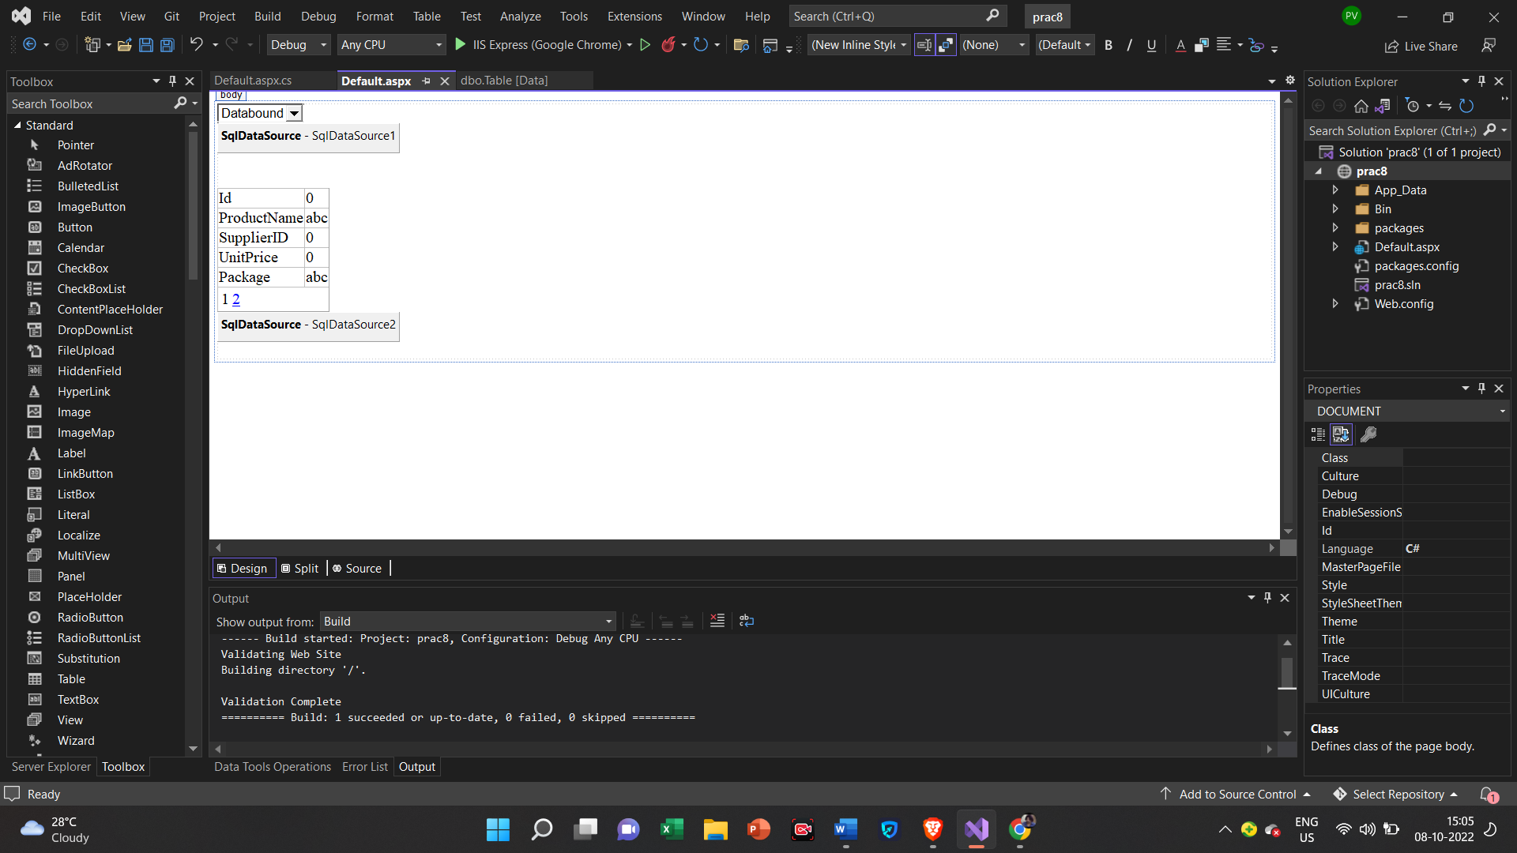

**Default.aspx.cs**

using System;

using System.Collections.Generic;

using System.Linq;

using System.Web;

using System.Web.UI;

using System.Web.UI.WebControls;

public partial class _Default : System.Web.UI.Page

{

protected void Page_Load(object sender, EventArgs e)

{

}

protected void DropDownList1_SelectedIndexChanged1(object sender, EventArgs e)

{

SqlDataSource2.SelectCommand = "Select * from Tables where ProductName" + DropDownList1.SelectedValue;

}

}

**Output**

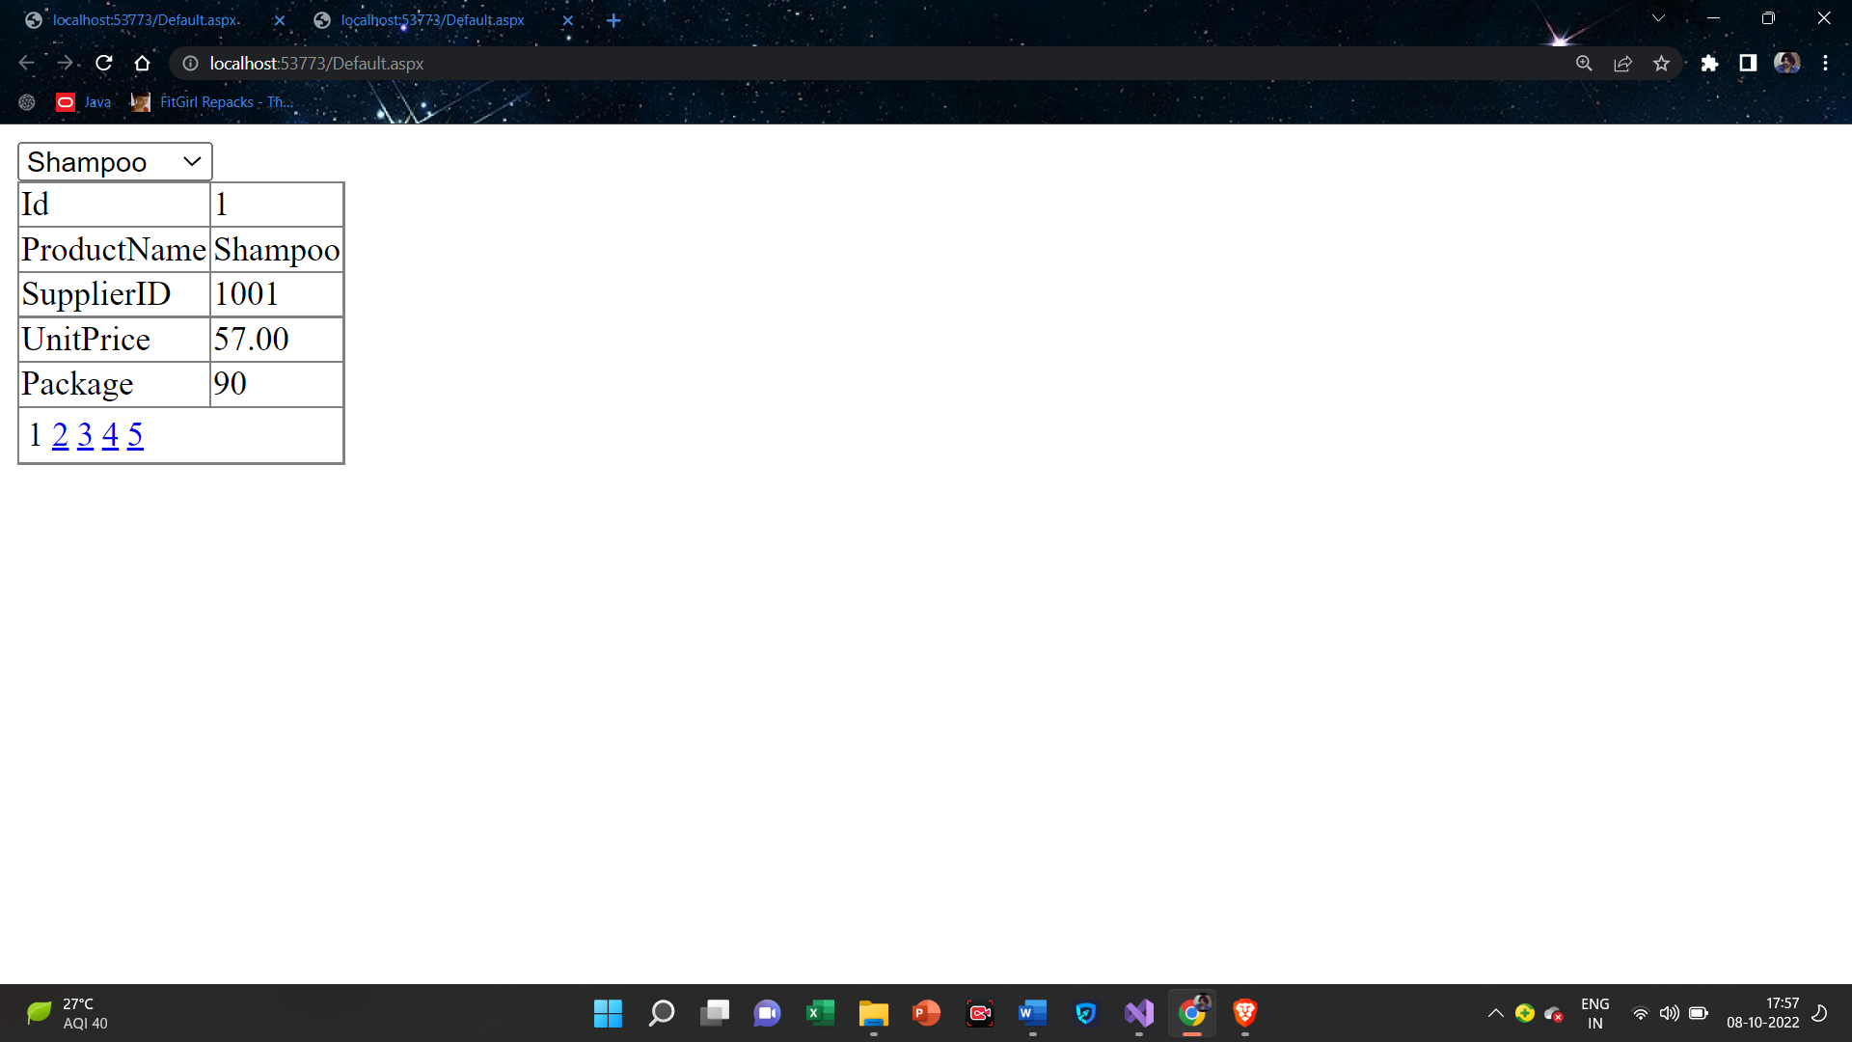

**8(B):Create a Web application to demonstrate various uses and properties of SqlDataSource.**

**Default.aspx**

<%@ Page Language="C#" AutoEventWireup="true" CodeFile="Default2.aspx.cs" Inherits="Default2" %>

<!DOCTYPE html>

<html xmlns="http://www.w3.org/1999/xhtml">

<head runat="server">

<title></title>

</head>

<body>

<form id="form1" runat="server">

<div>

<asp:DetailsView ID="DetailsView1" runat="server" AllowPaging="True" AutoGenerateRows="False" DataKeyNames="Id" DataSourceID="SqlDataSource1" Height="50px" Width="125px">

<Fields>

<asp:BoundField DataField="Id" HeaderText="Id" ReadOnly="True" SortExpression="Id" />

<asp:BoundField DataField="ProductName" HeaderText="ProductName" SortExpression="ProductName" />

<asp:BoundField DataField="SupplierID" HeaderText="SupplierID" SortExpression="SupplierID" />

<asp:BoundField DataField="UnitPrice" HeaderText="UnitPrice" SortExpression="UnitPrice" />

<asp:BoundField DataField="Package" HeaderText="Package" SortExpression="Package" />

</Fields>

</asp:DetailsView>

<asp:SqlDataSource ID="SqlDataSource1" runat="server" ConnectionString="<%$ ConnectionStrings:ConnectionString %>" SelectCommand="SELECT * FROM [Table]"></asp:SqlDataSource>

<asp:FormView ID="FormView1" runat="server" AllowPaging="True" DataKeyNames="Id" DataSourceID="SqlDataSource1">

<EditItemTemplate>

Id:

<asp:Label ID="IdLabel1" runat="server" Text='<%# Eval("Id") %>' />

<br />

ProductName:

<asp:TextBox ID="ProductNameTextBox" runat="server" Text='<%# Bind("ProductName") %>' />

<br />

SupplierID:

<asp:TextBox ID="SupplierIDTextBox" runat="server" Text='<%# Bind("SupplierID") %>' />

<br />

UnitPrice:

<asp:TextBox ID="UnitPriceTextBox" runat="server" Text='<%# Bind("UnitPrice") %>' />

<br />

Package:

<asp:TextBox ID="PackageTextBox" runat="server" Text='<%# Bind("Package") %>' />

<br />

<asp:LinkButton ID="UpdateButton" runat="server" CausesValidation="True" CommandName="Update" Text="Update" />

&nbsp;<asp:LinkButton ID="UpdateCancelButton" runat="server" CausesValidation="False" CommandName="Cancel" Text="Cancel" />

</EditItemTemplate>

<InsertItemTemplate>

Id:

<asp:TextBox ID="IdTextBox" runat="server" Text='<%# Bind("Id") %>' />

<br />

ProductName:

<asp:TextBox ID="ProductNameTextBox" runat="server" Text='<%# Bind("ProductName") %>' />

<br />

SupplierID:

<asp:TextBox ID="SupplierIDTextBox" runat="server" Text='<%# Bind("SupplierID") %>' />

<br />

UnitPrice:

<asp:TextBox ID="UnitPriceTextBox" runat="server" Text='<%# Bind("UnitPrice") %>' />

<br />

Package:

<asp:TextBox ID="PackageTextBox" runat="server" Text='<%# Bind("Package") %>' />

<br />

<asp:LinkButton ID="InsertButton" runat="server" CausesValidation="True" CommandName="Insert" Text="Insert" />

&nbsp;<asp:LinkButton ID="InsertCancelButton" runat="server" CausesValidation="False" CommandName="Cancel" Text="Cancel" />

</InsertItemTemplate>

<ItemTemplate>

Id:

<asp:Label ID="IdLabel" runat="server" Text='<%# Eval("Id") %>' />

<br />

ProductName:

<asp:Label ID="ProductNameLabel" runat="server" Text='<%# Bind("ProductName") %>' />

<br />

SupplierID:

<asp:Label ID="SupplierIDLabel" runat="server" Text='<%# Bind("SupplierID") %>' />

<br />

UnitPrice:

<asp:Label ID="UnitPriceLabel" runat="server" Text='<%# Bind("UnitPrice") %>' />

<br />

Package:

<asp:Label ID="PackageLabel" runat="server" Text='<%# Bind("Package") %>' />

<br />

</ItemTemplate>

</asp:FormView>

</div>

</form>

</body>

</html>

**Output**

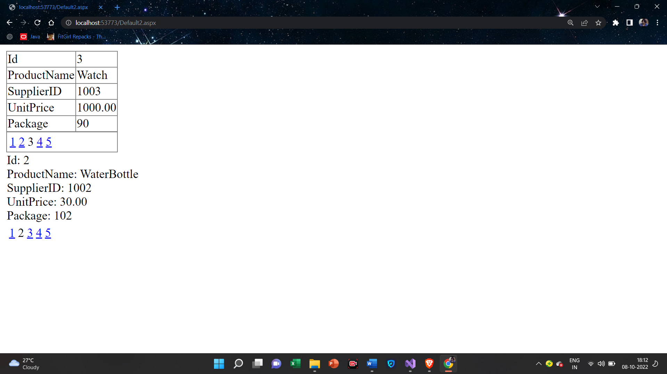

**8(C):Create a Web application to display Using Disconnected Data Access and Databinding using GridView.**

**Default.aspx**

<%@ Page Language="C#" AutoEventWireup="true" CodeFile="Default4.aspx.cs" Inherits="Default4" %>

<!DOCTYPE html>

<html xmlns="http://www.w3.org/1999/xhtml">

<head runat="server">

<title></title>

</head>

<body>

<form id="form1" runat="server">

<div>

<asp:GridView ID="GridView1" runat="server">

</asp:GridView>

<br />

<asp:Button ID="Button1" runat="server" OnClick="Button1_Click" Text="Show Disconnected Fetched Data" />

</div>

</form>

</body>

</html>

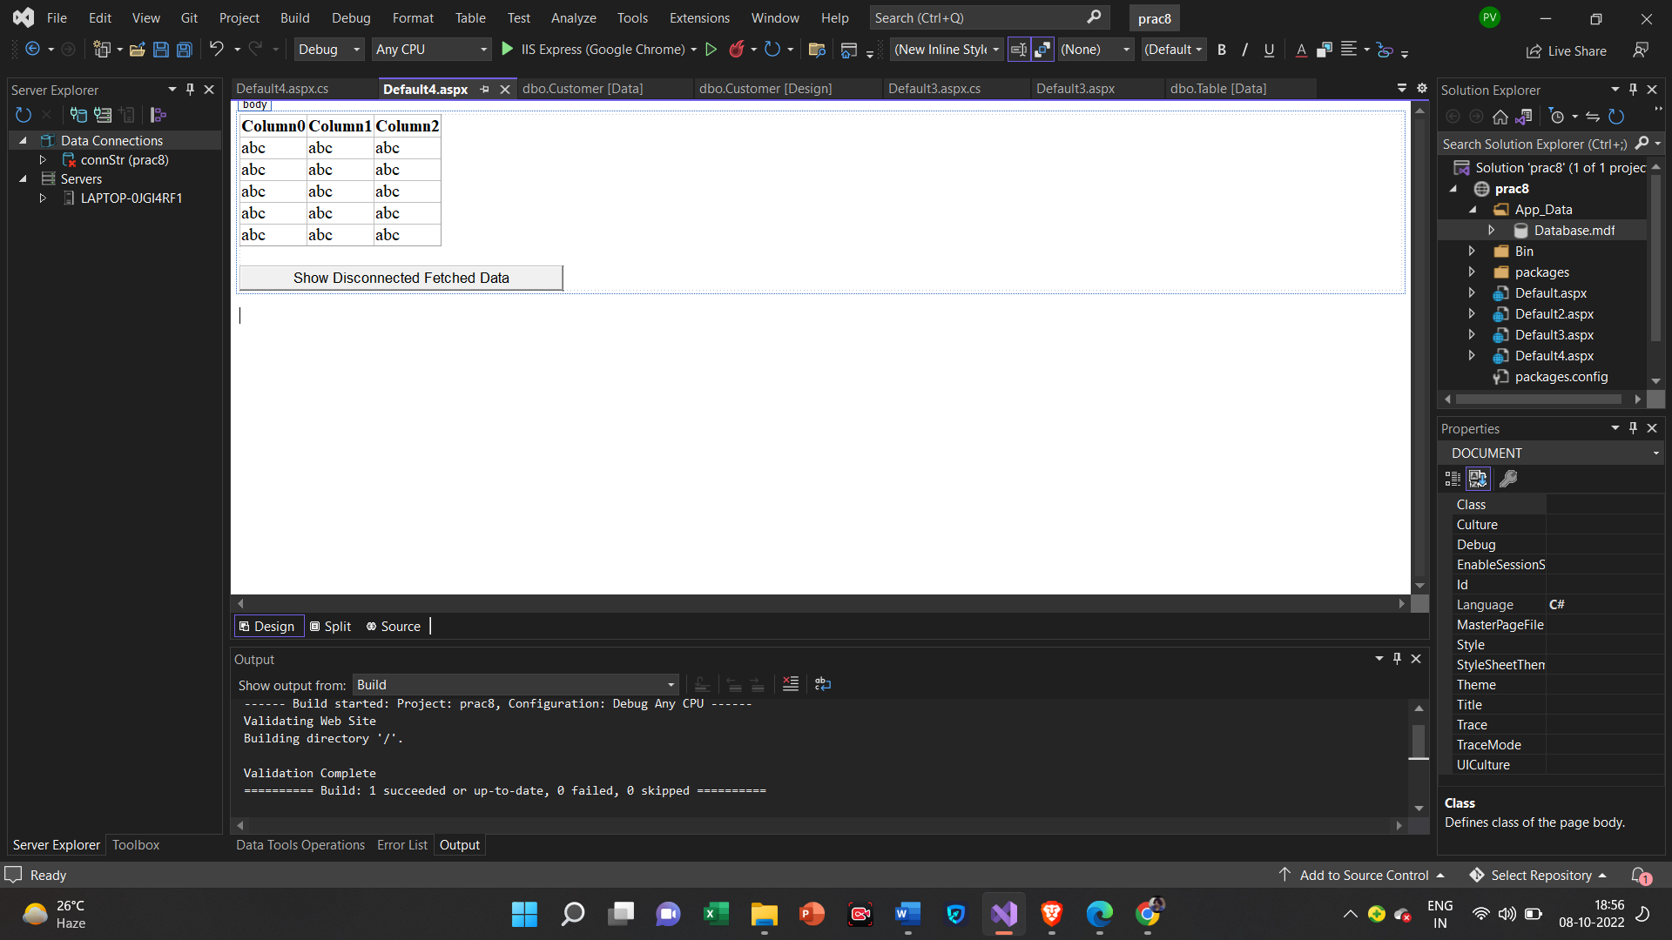

**Default.aspx.cs**

using System;

using System.Collections.Generic;

using System.Configuration;

using System.Data.SqlClient;

using System.Data;

using System.Linq;

using System.Web;

using System.Web.UI;

using System.Web.UI.WebControls;

public partial class Default4 : System.Web.UI.Page

{

protected void Page_Load(object sender, EventArgs e)

{

}

protected void Button1_Click(object sender, EventArgs e)

{

string connStr = ConfigurationManager.ConnectionStrings["connStr"].ConnectionString;

SqlConnection con = new SqlConnection(connStr);

SqlDataAdapter objDa = new SqlDataAdapter();

DataSet objDs = new DataSet();

using (SqlConnection objConn = new SqlConnection(connStr))

{

SqlCommand objCmd = new SqlCommand("Select * from Customer", objConn);

objCmd.CommandType = CommandType.Text;

objDa.SelectCommand = objCmd;

objDa.Fill(objDs, "City");

GridView1.DataSource = objDs.Tables[0];

GridView1.DataBind();

}

}

}

**Output**

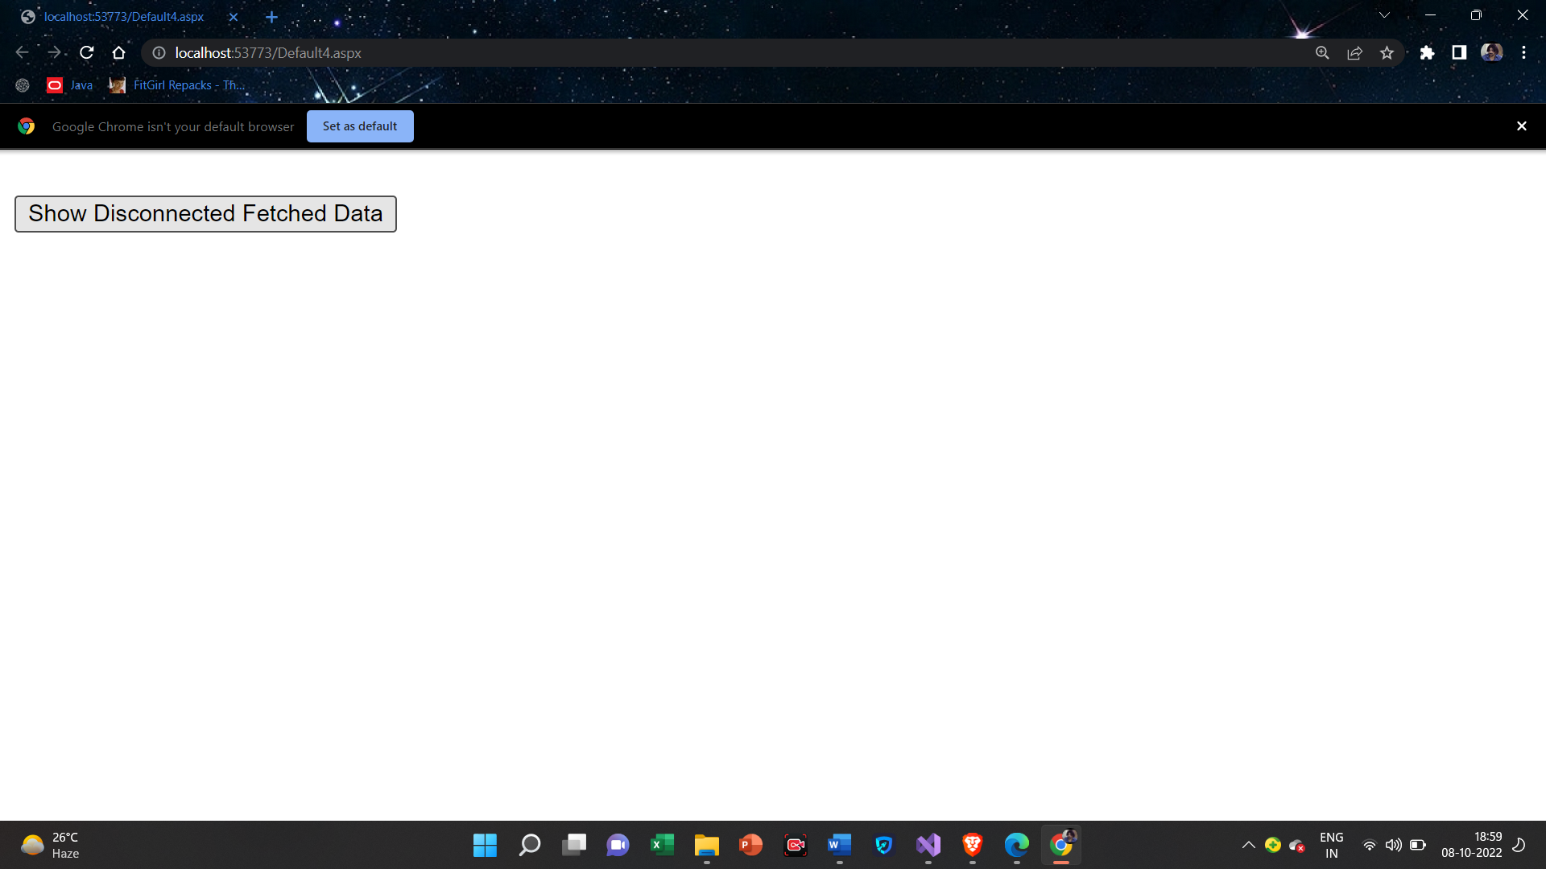

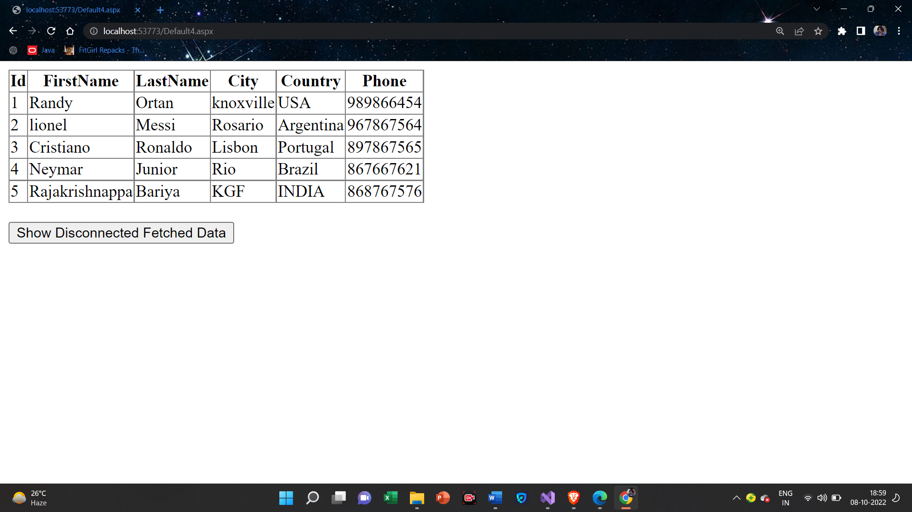

Practical-9

**9(A):Create a Web application to demonstrate use of GridView control template and GridView Hyperlink.**

**Default.aspx**

<%@ Page Language="C#" AutoEventWireup="true" CodeFile="Default6.aspx.cs" Inherits="Default6" %>

<!DOCTYPE html>

<html xmlns="http://www.w3.org/1999/xhtml">

<head runat="server">

<title></title>

</head>

<body>

<form id="form1" runat="server">

<asp:GridView ID="GridView1" runat="server" AutoGenerateColumns="False" BackColor="#DEBA84" BorderColor="#DEBA84" BorderStyle="None" BorderWidth="1px" CellPadding="3" CellSpacing="2" DataKeyNames="Id" DataSourceID="SqlDataSource1">

<Columns>

<asp:HyperLinkField DataNavigateUrlFields="Id" DataTextField="Id" />

<asp:BoundField DataField="FirstName" HeaderText="FirstName" SortExpression="FirstName" />

<asp:BoundField DataField="LastName" HeaderText="LastName" SortExpression="LastName" />

<asp:BoundField DataField="Country" HeaderText="Country" SortExpression="Country" />

<asp:BoundField DataField="Phone" HeaderText="Phone" SortExpression="Phone" />

</Columns>

<FooterStyle BackColor="#F7DFB5" ForeColor="#8C4510" />

<HeaderStyle BackColor="#A55129" Font-Bold="True" ForeColor="White" />

<PagerStyle ForeColor="#8C4510" HorizontalAlign="Center" />

<RowStyle BackColor="#FFF7E7" ForeColor="#8C4510" />

<SelectedRowStyle BackColor="#738A9C" Font-Bold="True" ForeColor="White" />

<SortedAscendingCellStyle BackColor="#FFF1D4" />

<SortedAscendingHeaderStyle BackColor="#B95C30" />

<SortedDescendingCellStyle BackColor="#F1E5CE" />

<SortedDescendingHeaderStyle BackColor="#93451F" />

</asp:GridView>

<asp:SqlDataSource ID="SqlDataSource1" runat="server" ConnectionString="<%$ ConnectionStrings:ConnectionString %>" SelectCommand="SELECT * FROM [Customer]"></asp:SqlDataSource>

<div>

</div>

</form>

</body>

</html>

**Output**

